

PERIOD :2025-2026(EVEN) | BATCH:2023-2027
DEPARTMENT:ECE | YEAR/SEM: III/VI
REGULATION/SUB CODE/NAME: REG-23/U23ECV22/ IMAGE PROCESSING
QUESTION BANK PART-A
UNIT-I DIGITAL IMAGE FUNDAMENTALS
- Define sampling and quantization [N/D20] [A/M17] [N/D23]
  - Sampling means digitizing the co-ordinate value (x, y).
  - Sampling means digitizing the co-ordinate value (x,y) of the image. Sampling is the primary factor that determines the spatial resolution of the image.
  - Quantization means digitizing the amplitude value of the image. Quantization is the primary factor that determines the gray level resolution of the image.
  - Quantization means digitizing the amplitude value.

List the various color Models and give its applications [N/D22] [N/D21]
  - RGB model--- used for color monitor & color video camera
  - CMY model---used for color printing
  - HIS model used for color image processing
  - YIQ model used for color picture transmission

Define spatial resolution. how it is represented quantitatively? [A/M24]
  - Spatial resolution states that the clarity of an image cannot be determined by the pixel resolution. The number of pixels in an image does not matter.
  - Spatial resolution can be defined as the smallest discernible detail in an image (or) in other way we can define spatial resolution as the number of independent pixels values per inch.

What is memory required to store 512*512 RGB image of 8 bit resolution? [A/M20]
  - Number of bits Required to store image is
o b=N*M*k (N=512; M=512; k=8)
  - RGB Image 8 Bit resolution for each
    - 2^k= 256 range from [0,255] for R,G and B
    - 1 Byte=8 Bits
  - Number of bits=> 512*512*8*8*8= 134217728 bits
  - Number of Bytes=> 134217728/8= 16777216 bytes

Differentiate photopic and scotopic vision [N/D18] [N/D17]
Photopic vision | Scotopic vision
The human being can resolve the fine details with these cones because each cone is connected to its own nerve  end. | Several rods are connected to one nerve  end. So it gives the overall picture of the image.
This is also known as bright light vision. | This is also known as dim light vision.
- Elucidate on Quantization [A/M18] [N/D17]
Digitizing the amplitude values is called Quantization. Quality of digital image is determined to a large degree by the number of samples and discrete gray levels used in sampling and quantization.

List color models involved in hardware. [A/M18] [A/M20]
The hardware oriented color models are as follows,
- RGB model
- CMY model
- YIQ model
- HSI model

When is fine sampling and coarse sampling used [A/M17] [M/J19]
  - Fine sampling =>required in the neighborhood of sharp gray-level transitions.
  - coarse sampling => utilized in relatively smooth regions.

What is the function of an image sensor [A/M22]
An image sensor or imager is a sensor that detects and conveys information used to make an image. It does so by converting the variable attenuation of light waves (as they pass through or reflect off objects) into signals, small bursts of current that convey the information. The waves can be light or other electromagnetic radiation.
Image sensors are used in electronic imaging devices of both analog and digital types

Define Mach band effect.[N/D16] [A/M15] [N/D15] [A/M14] [A/M23]
  - The spatial interaction of Luminance from an object and its surround creates a phenomenon called the mach band effect.
  - Mach band effect means the intensity of the stripes is constant. Therefore it preserves the brightness pattern near the boundaries, these bands is called as mach band effect.
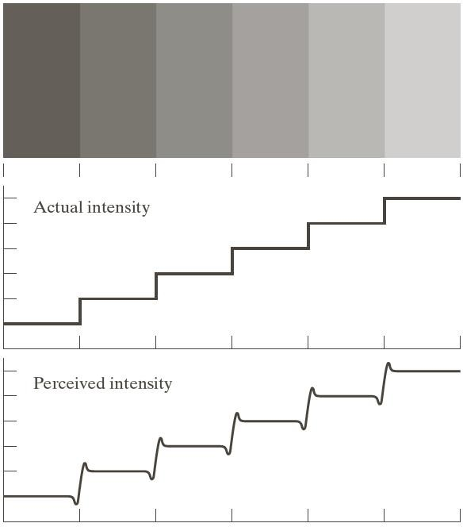

Define checker board effect [N/D16] [M/J23]
Checkerboard pattern or effect is a degradation that results due to the reduction is spatial resolution. When lower resolution images are replicated to larger size, the pixel values are replicated to fill the display area leading to checkerboard effect.

What is simultaneous contrast? [A/M24]
This phenomenon is related to the fact that a region’s perceived brightness does not depend simply on its intensity. However, they appear to become darker as the background gets
lighter 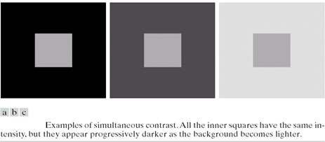

Define Brightness.[A/M15] [N/D22]
Brightness of an object is the perceived luminance of the surround. Two objects with different surroundings would have identical luminance but different brightness.

Define Contrast .[A/M15] [N/D12]
This is the difference in light intensity between black and white parts of the picture over and above the average brightness level.

Define Brightness (or) Subjective brightness.[A/M15]
Brightness is a subjective descriptor that is practically impossible to measure. Subjective brightness of an object is the luminance or intensity as perceived by the Human Visual System (HVS).

What is monochrome image and gray image? [N/D14] [N/D13]
  - Black and white photography is the most prominent example
of monochrome photography, as it represents subjects in varying shades of neutral gray, but includes no other colors. In monochrome photography, tones of a single color are used to represent all the different colors within an image.
  - A grayscale (or graylevel) image is simply one in which the only colors are shades of gray Often, the grayscale intensity is stored as an 8-bit integer giving 256
possible different shades of gray from black to white.

Define hue, saturation and Contrast. [M/24]
  - Hue represents dominant color as perceived by an observer.
  - Saturation refers to relative purity or the amount of white light mixed with a hue.

Define False contouring [M/J13]
If the number of quantization levels is not sufficient a phenomenon called false contouring becomes visible. When groups of neighboring pixels are quantized to the same value, regions of constant gray levels are formed , whose boundaries are called contours.

Define subjective brightness and brightness adaptation [M/J22]
  - Subjective brightness means intensity as preserved by the human visual system.
  - Brightness adaptation means the human visual system can operate only from scotopic to glare limit. It cannot operate over the range simultaneously. It accomplishes this large variation by changes in its overall intensity.

Justify that KLT is an optimal transform. [N/D12]
Since mean square error of reconstructed image and original image is minimum and the mean value of transformed image is zero so that uncorrelated.

Describe Elements of visual Perception? [N/D21]
  - The cornea and sclera
  - The choroid and
  - The retina

What do you mean by zooming and shrinking? [A/M23]
  - Zooming may be viewed as over sampling. It involves the creation of new pixel locations and the assignment of gray levels to those new locations.
  - Shrinking may be viewed as under sampling. To shrink an image by one half, we delete every row and column. To reduce possible aliasing effect, it is a good idea to blue an image slightly before shrinking it.

List out Properties of two-dimensional DFT. [N/D08]
The properties of two-dimensional DFT are, i.Symmetric
ii.Periodic extensions iii.Sampled Fourier transform iv.Conjugate symmetry

What is Weber Ratio? [M/J09]
The ratio of increment of illumination to background of illumination is called as Weber ratio.(ie) ∆i/i
- If the ratio (∆i/i) is small, then small percentage of change in intensity is needed (ie) good brightness adaptation.
- If the ratio (∆i/i) is large, then large percentage of change in intensity is needed (ie) poor brightness adaptation.
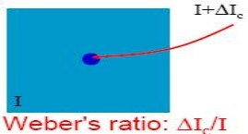

Define 4 and 8 neighbors of the pixel. [N/D08]
  - The pixel p at co-ordinates (x, y) has 4 neighbors (ie) 2 horizontal and 2 vertical neighbors whose co-ordinates is given by (x+1, y), (x-1,y), (x,y-1), (x, y+1). This is called as direct neighbors. It is denoted by N4(P)
  - Four diagonal neighbors of p have co-ordinates (x+1, y+1), (x+1,y-1), (x-1, y-1), (x-1, y+1). It is denoted by ND(4).
  - Eight neighbors of p denoted by N8(P) is a combination of 4 direct neighbors and 4 diagonal neighbors.

UNIT II IMAGE ENHANCEMENT
- How do you eliminate aliasing problem [N/D22]
Aliasing is generally avoided by applying low pass filters or anti-aliasing filters (AAF) to the input signal before sampling and when converting a signal from a higher to a lower sampling rate.

What is Histogram ? How is it generated for an image [A/M19]
  - Histogram of an image represents the relative frequency of occurrence of the various gray levels in the image.
  - Histogram modeling techniques modify an image so that its histogram has a desired shape. This is useful in stretching the low contrast levels of images with narrow
histograms.
  - Thus histogram is used to either increase or decrease, the intensity level of the pixels by any kind of transformation.
The histogram of a digital image with gray levels in the image [0,L-1] is a discrete function given as,
h(rk ) = nk , where rk is the kth grey level, k = 0,1,…,L −1
n k is the number of pixels in the image with grey level r k

How negative of an image is obtained? [A/M24]
A negative image can be obtained by reversing the intensity levels of an image, according
to the transformation,
, when the gray level range is [0,L-1]
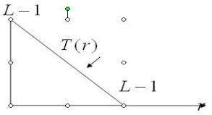
  - Digital negatives are useful in the display of medical images and to produce negative prints of image.
  - It is also used for enhancing white or gray details embedded in dark region of an image.

What is the purpose of image averaging? [N/D18]
An important application of image averaging is in the field of astronomy, where imaging with very low light levels is routine, causing sensor noise frequently to render single images virtually useless for analysis.

Define Masking [N/D18]
Mask is the small 2-D array in which the values of mask co-efficient determines the nature of process. The enhancement technique based on this type of approach is referred to as mask processing.

Necessitate the need for transform [A/M18]
An image transform can be applied to an image to convert it from one domain to another. Viewing an image in domains such as frequency or Hough space enables the identification of features that may not be as easily detected in the spatial domain

Name the different types of derivative filter in DIP[A/M18] [N/D21]
- Perwitt operators
- Roberts cross gradient operators
- Sobel operators

- Whether two different images have same histogram?Justify [N/D22] Histogram is not unique representation of images. That means it is possible that two or more different images can have same Histogram.The below three images have same Histogram.
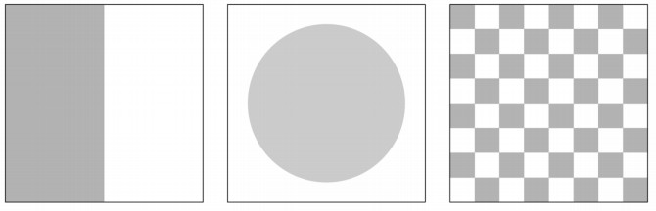

For an 8 bit image, write the expression for obtaining the negative of the input image[N/D17]
L= 2^8 = 256 s=L-1-r
s =255-r
Apply this transform to each pixel to find the negative

Differentiate between image enhancement and restoration? [A/M17] [N/D15]
- Enhancement technique is based primarily on the pleasing aspects it might present to the viewer. For example: Contrast Stretching.
- Whereas Removal of image blur by applying a deblurrings function is considered a restoration technique

if all the pixels in an image are shuffled will there be any change in the histogram ? justify your answer [A/M17]
Histogram is not changed, only the covariance of the image is change if all the pixels were shuffled

What is meant by bit plane slicing? [N/D16]
Instead of highlighting gray level ranges, highlighting the contribution made to total image appearance by specific bits might be desired. Suppose that each pixel in an image is represented by 8 bits. Imagine that the image is composed of eight 1-bit planes, ranging from bit plane 0 for LSB to bit plane-7 for MSB.

What is meant by unsharp masking? [N/D16]
The process of subtracting a blurred version of an image from the image itself is called as unsharp masking which is expressed as
fs(x,y) = f(x,y) − f(x,y)

Define directional smoothing filter [N/D24]
A directional averaging filter can be used to prevent edges from blurring while smoothing by computing a spatial average in several directions and using all the averages to determine the new image values.

What is meant by histogram equalization? [N/D15] [M/J12]
It is a technique used to obtain linear histogram . It is also known as histogram linearization. Condition for uniform histogram is Ps(s) = 1

Define spatial averaging. [M/J14]
Filtering operations that are performed directly on the pixels of an image is called as spatial filtering

What is contrast stretching? [N/D13] [A/M09]
Contrast stretching reduces an image of higher contrast than the original by darkening the levels below m and brightening the levels above m in the image.

What is a Median filter? [N/D13]
The median filter replaces the value of a pixel by the median of the gray levels in the neighborhood of that pixel.

What are the properties of unitary transform? [N/D13]
- Determinant and the Eigen values of a unitary matrix have unity magnitude
- the entropy of a random vector is preserved under a unitary Transformation
- Since the entropy is a measure of average information, this means information is preserved under a unitary transformation.

Give the PDF of Gaussian noise and plot it [M/J25]
Guassian noise:
The PDF guassian random variable Z is given by P(Z)=e-(Z-μ)2/2σ2/√2πσ
Z->Gray level value σ->standard deviation σ2 ->varianze of Z
μ->mean of the graylevel value Z
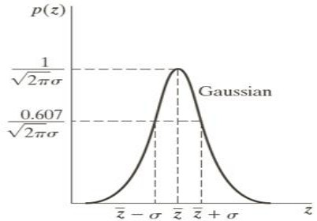

Define and give the transfer function of contraharmonic filter [M/J13]
The contra harmonic mean filter operation is given by the expression
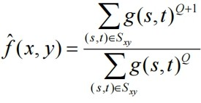
Where Q is called the order of the filter. This filter is well suited for reducing or virtually eliminating the effects of salt-and-pepper noise.

Explain the 2 categories of image enhancement.[N/D12]
The categories of Image Enhancement are, i.Spatial domain
ii.Frequency domain
Spatial domain: It refers to the image plane and it is based on direct manipulation of pixels of an image.
Frequency domain techniques are based on modifying the Fourier transform of an image.

What are the types of image enhancement available? [N/D12]
- Point operations or basic gray level transformations
a) Contrast stretching b) Noise clipping c) Window slicing d) Histogram modeling

Spatial domain methods
a) Noise smoothing b) Median filtering c) LP,HP,BP filtering d) Zooming e)
Unsharp masking

Frequency domain methods
a) Linear filtering b) Homomorphic filtering c) Root filtering

Pseudo coloring
a) False coloring b) Pseudo coloring
- What are image sharpening filters? mention Various types of it [N/D22] Sharpening an image increases the contrast between bright and dark regions to bring out features.
The sharpening process is basically the application of a high pass filter to an image.
Various types :spatial based and frequency based techniques

What is inverse filtering [N/D11]
The simplest approach to restoration is direct inverse filtering, an estimate F^(u,v) of the transform of the original image simply by dividing the transform of the degraded
image G^(u,v) by the degradation function.
F^ (u,v) = G^(u,v)/H(u,v)

Define mask or kernals [A/M21]
A Mask is a small two-dimensional array, in which the value of the mask coefficient determines the nature of the process, such as image sharpening.

what are image negatives [A/M10]
The negative of an image with gray levels in the range [0, L-1] is obtained by using the negative transformation, which is given by the expression.
s = L-1- r ,Where s is output pixel, r is input pixel

Write the transfer function for butterworth filter [A/M22]
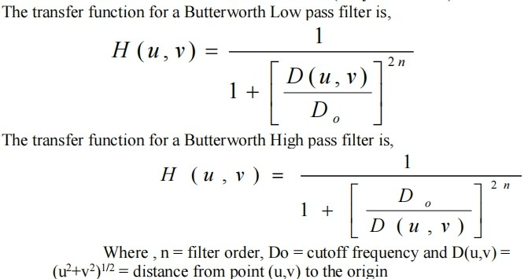
- Define Histogram [N/D08]
The histogram of a digital image with gray levels in the range [0, L-1] is a discrete function h (rk) = nk, where rk is the kth gray level and nk is the number of pixels in the image having gray level rk

Compare spatial and frequency domain filter [N/D08]
Spatial domain | Frequency domain
deals with image plane itself | deals with the rate of pixel change.
works based on direct manipulation of pixels | works based on modifying fourier transform.
more easier to understand | less easier to understand.
more cheaper | less cheaper.
takes less time to compute | takes more time to compute.
- What are the effects of applying butterworth lowpass filter to the noisy image [N/D24]
- To eliminate ringing effect we have to remove the sharp cut offs in frequency domain. So Butterworth filter are used they remove the ringing effect but up to a certain limit
- Removing unwanted noise from the image

UNIT III IMAGE RESTORATION
- What is blind image Restoration? [N/D19] [M/J24]
Degradation may be difficult to measure or may be time varying in an unpredictable manner. In such cases information about the degradation must be extracted from the observed image either explicitly or implicitly. This task is called blind image restoration.

Mention two drawbacks of inverse filtering? [N/D17]
  - Doesn’t perform well when used on noisy images
  - In the presence of noise, when H(u,v) is small, then the noise η(u,v) dominates

Which filter will be effective in minimizing the impact of “salt and pepper” noise in an image? [N/D17]
Bipolar impulse noise is called as Salt and Pepper Noise. Median filter is the most suitable filter to remove salt and pepper noise in images.

Why the restoration is called as unconstrained restoration? [A/M17] [M/J09]
In the absence of any knowledge about the noise ‘n’, a meaningful criterion function is to seek an f^ such that H f^ approximates of in a least square sense by assuming the noise term is as small as possible.
Where H = system operator. f^ = estimated input image. g = degraded image.

State the causes of degradation in an image? [N/D24]
The degradations may be in the form of
- sensor noise
- blur due to camera misfocus
- relative object-camera motion(motion blur)
- random atmospheric turbulence and so on.

What do you understand by Mexican hat function? [N/D16]
To overcome the disadvantages of laplacian operator it is combined with smoothing as precursor to find edges via zero crossings. Due to its shape, LoG is sometimes called as Mexican hat function.

What is geometric transformation? [A/M15] [M/J23]
Geometric transformations modify the spatial relationships between pixels in an image. Geometric transformation often are called rubber-sheet transformations

What is meant by least mean square filter or wiener filter? [D] (Dec’22)
Weiner filter is a method of restoring images in the presence of blur as well as noise

How a degradation process is modeled? Or Define degradation model and sketch it. [A/M15] [A/M13]
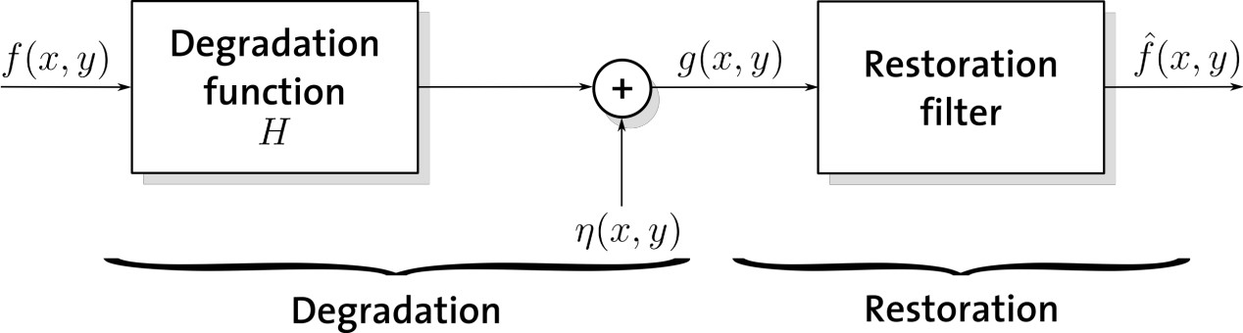
- What is meant by bit plane slicing? [D] (Dec’13)
Instead of highlighting gray level ranges, highlighting the contribution made to total image appearance by specific bits might be desired. Suppose that each pixel in an image is represented by 8 bits. Imagine that the image is composed of eight 1-bit planes, ranging from bit plane 0 for LSB to bit plane-7 for MSB.

Give the relation for Uniform noise and Impulse noise. [A/M15]
Uniform noise | Impulse noise
The gray level values of the noise are evenly distributed across a specific range Quantization noise has an approximately  uniform distribution | Positive impulse-white Negative impulse -Black
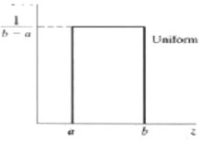 | 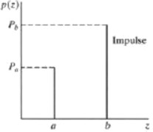
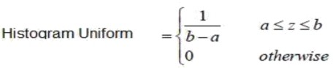 | 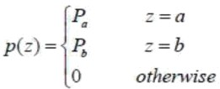
- What is the principle of inverse filtering? [D] (May’14)
The simplest approach to restoration is direct inverse filtering, an estimate F^(u,v) of thetransform of the original image simply by dividing the transform of the degraded image
G^(u,v) by the degradation function. F^ (u,v) = G^(u,v)/H(u,v)

What is Lagrange multiplier? Where it is used? [D] (Dec’22)
Lagrange multiplier is a method to find maximum or minimum value of a function subject to some constrains (side conditions) on the domain of the function.

Examples:
Maximize or minimize f(x,y) subject to condition g(x,y) = c.
Maximize or minimize f(x,y,z) subject to condition g(x,y,z) = c.
Maximize or minimize f(x,y,z) subject to conditions g(x,y,z) = c1,and h(x,y,z) = c2.

Give the difference between Enhancement and Restoration [D]
Image Enhancement | Image Restoration
Image enhancement is a subjective process i.e., it is a heuristic procedure designed to manipulate an image in order to please the viewer. Modeling of degradation process is not required.  Apriori knowledge of the degradation is not required.  Ex: Contrast stretching | Restoration techniques are oriented towards modeling the degradation and applying the inverse process in order to recover the original image. Modeling of degradation is a must Apriori knowledge of the degradation function is required to model the degradation function.  Ex: Removal of motion blur
- What is pseudo inverse filter? [D] (Dec’13)
The Pseudo-inverse filter is a stabilized version of the inverse filter. For a linear shift invariant system with frequency response H(ω1, ω2), the pseudo inverse filter.
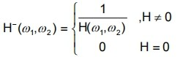

- Compare constrained and unconstrained restoration[D] (Dec’22)
Constrained Restoration | Unconstrained Restoration
In the absence of any knowledge about the noise „n‟, based on Lagrange multiplier and linear operator, a meaningful criterion function is to seek an such that H approximates of in a least square sense by assuming the noise term is as small as possible.  Where H=system operator. =estimated input image.  g=degraded image. | In the absence of any knowledge about the noise „n‟, a meaningful  criterion function is to seek an  such that H approximates of in a least square sense by assuming the noise term is as small as possible.  Where H =system operator. = estimated input image.  g=degraded image.
- Give the relation between Gaussian noise and Rayleigh noise [ID] (May ’13)
Gaussian noise | Rayleigh noise
Gaussian (normal) noise is very attractive from a mathematical point of view since  its DFT is another Gaussian process. | Radar range and velocity images typically contain noise that can be modeled by the Rayleigh distribution.
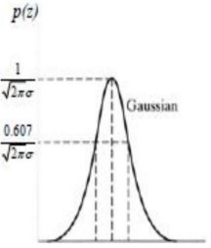 | 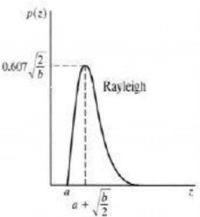
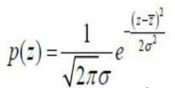 | 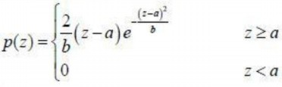
- Define rubber sheet transformation. [M/J13]
Geometric transformations may be viewed as the process of printing an image on a rubber sheet and then stretching the sheet according to some predefined set of rules .Therefore they are also called as rubber sheet transformations.

Why blur is to be removed from images? [D] [N/D24]
The blur is caused by lens that is improper manner, relative motion between camera and scene and atmospheric turbulence. It will introduce bandwidth reduction and make the image analysis as complex. To prevent the issues, blur is removed from the images.

Define harmonic mean filter and contrast harmonic filter. [D] (May’14) (May’13)
- Harmonic filters
The harmonic mean filtering operation is given by the expression ƒ ^(x,y) = mn/∑(1/g(s,t))

Contra harmonic mean filter
Contra harmonic mean filtering operation yields a restored image based on the expression
Q+1 Q
f^(x,y)=∑g(x,t) /∑g(s,t)
where Q is called the order of the filter.This filter is well suited for reducing or virtually eliminating the effect of salt and pepper noise.

What are possible ways for adding noise in images? [ID] (Dec’14)
Gaussian noise.
Salt-and-pepper noise. Shot noise.
Quantization noise (uniform noise) Film grain.
Anisotropic noise. Periodic noise.
- Give the relation of Gamma noise and Exponential Noise [N/D18]
Gamma noise | Exponential Noise
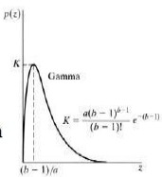 | 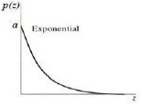
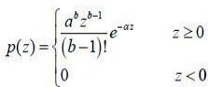 | 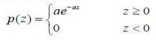
- Give 3x3 mask line to detect horizontal line in an image [N/D24]
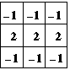
- Classify Image restoration techniques.
Image restorations are classified as following:
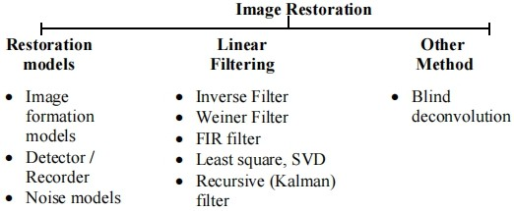

UNIT IV IMAGE SEGMENTATION
  - How an image is segmented using thresholding [N/D24]
Thresholding is a type of image segmentation, where we change the pixels of an image to make the image easier to analyze. This divides all the pixels of the
input image into 2 groups: Pixels having intensity value lower than threshold. Pixels having intensity value greater than threshold

What is segmentation?
Segmentation subdivides on image in to its constitute regions or objects. The level to which the subdivision is carried depends on the problem being solved .That is segmentation should stop when the objects of interest in application have been isolated.

Write the applications of segmentation[N/D18] [N/D13]
Segmentation is the foremost step for all the detection and recognition applications. The applications of segmentation are,
    - Detection of cancerous cells from medical images
    - Segmentation of roads from satellite images
    - Vehicle Number Plate recognition
    - Handwritten character recognition

How the discontinuity is detected in an image using segmentation? [A/M18]
Points, lines and edges

What is Local threshold and dynamic or adaptive threshold, global thresholding? [A/M15]
When Threshold T depends only on f(x,y) then the threshold is called global . If T depends both on f(x,y) and p(x,y) is called local. If T depends on the spatial coordinates x and y the threshold is called dynamic or adaptive where f(x,y) is the original image.
  - What are factors affecting the accuracy of region growing? [ID] (May’14) The factors affecting the accuracy of region growing are like lightning variations,pixel’s intensity value.

State the problems in region splitting and merging based image segmentation. [N/D14]
- Initial seed points – different set of initial seed point cause different segmented result.
- Time consuming problem
- This method is not suitable for color images and produce fault colors sometime.
Region growth may stop at any time when no more pixel satisfy the criteria.

Specify the steps involved in splitting and merging [M/J14] [M/J13]
    - Split any region Ri into 4 disjoint quadrants for which P(Ri)=FALSE.
    - Merge any adjacent regions Rj and Rk for which P(RjURk)=TRUE.
    - Stop when no further merging or splitting is possible.

Define region splitting and merging. [M/J13]
Region splitting and merging is a segmentation process in which an image is initially subdivided into a set of arbitrary ,disjoint regions and then the regions are merger and
/or splitted to satisfy the basic conditions.

What are the two properties used for establishing similarity of edge pixels? [N/D13]
An edge is a set of connected pixels that lie on the boundary between two regions.
- The strength of the response of the gradient operator used to produce the edge pixel.
- The direction of the gradient.
  - Distinguish between Pattern and Pattern Class [N/D24]Pattern: an arrangement of descriptors (or features).
Pattern class: a family of patterns sharing some common properties

What is thresholding ? What are its types ? (R) (NOV-DEC 2015)
Thresholding is the process of segmenting an image based on a threshold value that separates the object and background of the image. Certain images will contain mutilple objects, which can be segmented using multiple thresholds.

Types of Thresholding
- Global Thresholding
- Variable Thresholding
- Regional (or) Local Thresholding
- Dynamic or adaptive thresholding

What is edge? [A/M23]
An edge isa set of connected pixels that lie on the boundary between two regions edges are more closely modeled as having a ramplike profile. The slope of the ramp is inversely proportional to the degree of blurring in the edge.
  - Define region growing .Give the principle of region growing. [A/M23] [N/D15] Region growing is a procedure that groups pixels or subregions in to layer regions based on predefined criteria. The basic approach is to start with a set of seed points and from there grow regions by appending to each seed the neighbouring pixels that have properties similar to the seed.

How the derivatives are obtained in edge detection during formulation? [A/M18]
Derivatives are used to detect the edges in images.
- First order derivative filters are used to detect the presence of edge. Example:
  - Robert’s Cross Gradient Operator
  - Prewitt’s Operator
  - Sobel’s Operator
- Second order derivative filters are used to detect the thin edges that is the fine details in the image.
Example : Laplacian

How do you identify the discontinuities in Digital image [N/D19]
Detection of Discontinuities: There are 3 basic types of discontinuities: points, lines and edges. The detection is based on convoluting the image with a spatial mask

Write sobel horizontal and vertical edge detection masks.[A/M13]
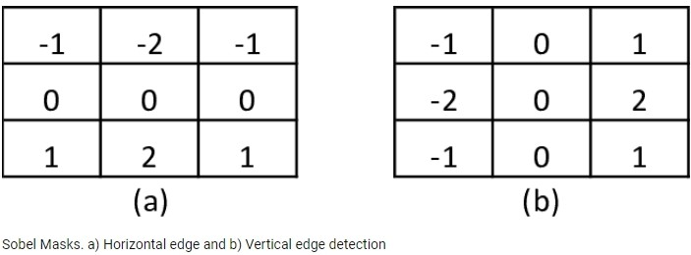
  - How edges are linked through hough transform?[N/D14]
The edges are linked through hough transform by using intersecting of 2 lines equations. The straight line equation is y=mx+b. In polar coordinates ρ=xcosθ+ysinθ where ρ & θ are the coordinates of parameter space. The hough transform of a straight line in the x,y space is a single point in ρ,θ space.

What is pattern and pattern class? [N/D17] [ A/M17]
A pattern is a quantitative or structural description of an objective or some other entity of interest in an image
A pattern class is a family of patterns that share some common properties .Pattern classes are denoted w1,w2, wm, where M is the number of classes

Define Sobel operator [N/D12]
The Sobel operator, sometimes called the Sobel–Feldman operator or Sobel filter, is used in image processing and computer vision, particularly within edge detection algorithms where it creates an image emphasising edges.

UNIT V IMAGE COMPRESSION AND RECOGNITION
- What is the significance of lossy and lossless compression? [A/M23]
Lossless compression can recover the exact original data after compression. It is used mainly for compressing database records, spreadsheets or word processing files, where exact replication of the original is essential.
Lossy compression will result in a certain loss of accuracy in exchange for a substantial increase in compression. Lossy compression is more effective when used to compress graphic images and digitized voice where losses outside visual or aural perception can be tolerated.
Lossless Compression | Lossy Compression
Lossless compression can recover the exact original data after compression | Lossy compression will result loss of data in exchange for a substantial  increase in compression
It is reversible | It is irreversible
Compression rate achieved is low | Higher compression rate can be achieved
It is used mainly for compressing database records, spreadsheets or word processing files, where exact  replication of the original is essential | It is used to compress images, video and audio

What is signature? [N/D19]
A signature is a 1-D representation of a boundary (which is a 2-D thing): it should be easier to describe. E.g.: distance from the centroid vs angle.

What is image compression [N/D18]
Image compression refers to the process of redundancy amount of data required to represent the given quantity of information for digital image. The basis of reduction process is removal of redundant data.

Mention the Demerits of chain code ? [N/D18]
The demerits of chain code are,
  - The resulting chain code tends to be quite long.
  - Any small disturbance along the boundary due to noise cause changes in the code that may not be related to the shape of the boundary

What are two main types of Data compression in DIP?[A/M18]
The two main types of data compression are lossless compression and lossy compression

What is run length coding? [A/M17] [N/D15] [M/J14]
Run-length Encoding, or RLE is a technique used to reduce the size of a repeating string of characters. This repeating string is called a run; typically RLE encodes a run of symbols into two bytes, a count and a symbol. RLE can compress any type of data regardless of its information content, but the content of data to be compressed affects the compression ratio. Compression is normally measured with the compression ratio:

What are the operation performed by error free compression? [A/M23]

Error free compression
- Devising an alternative representation of the image in which its inter pixel redundant are reduced.
- Coding the representation to eliminate coding redundancy

What is an image pyramid?[N/D16]
Image pyramid is a powerful structure for representing images at more than one resolution. In an image pyramid, a collection of decreasing resolution images are arranged in the shape of a pyramid. The base of the pyramid contains a high resolution approximation and the apex contains a low resolution approximation.

What are different Compression Methods in image coding? [A/M23]
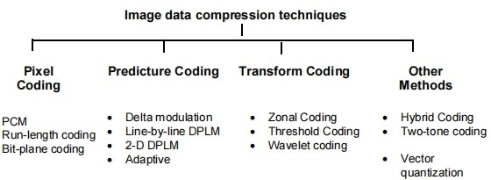
- What is thinning or skeletonizing algorithm? [N/D16]
An important approach to represent the structural shape of a plane region is to reduce it to a graph. This reduction may be accomplished by obtaining the skeletonising algorithm. It play a central role in a broad range of problems in image processing, ranging from automated inspection of printed circuit boards to counting of asbestos fibres in air filter.

Define texture. [A/M23]
Texture is one of the regional descriptors. It provides the measure of properties such as smoothness, coarseness and regularity.
The approaches to describe the texture of a region of are:
- Statistical approach.
- Structural approach
- Spectural approach

What is the need for Compression? Compare lossy and lossless compression technique [M/J15] [M/J14] [M/J13]
In terms of storage, the capacity of a storage device can be effectively increased with methods that compress a body of data on its way to a storage device and decompress it when it is retrieved.
- In terms of communications, the bandwidth of a digital communication link can be effectively increased by compressing data at the sending end and decompressing data at the receiving end.
- At any given time, the ability of the Internet to transfer data is fixed. Thus, if data can effectively be compressed wherever possible, significant improvements of data throughput can be achieved. Many files can be combined into one compressed document making sending easier.

Define the procedure for Huffman shift coding [D] (Dec’12) (May’13)
List all the source symbols along with its probabilities in descending order. Divide the total number of symbols into block of equal size. Sum the probabilities of all the source symbols outside the reference block. Now apply the procedure for reference block, including the prefix source symbol. The code words for the remaining symbols can be constructed by means of one or more prefix code followed by the reference block as in the case of binary shift code.

Define Huffman coding and mention its limitation [D] (June’12 & (Dec’13))
Huffman coding is a popular technique for removing coding redundancy.
When coding the symbols of an information source the Huffman code yields the smallest possible number of code words, code symbols per source symbol.Limitation: For equi probable symbols, Huffman coding produces variable code words.

What is bit plane Decomposition? [D] [A/M23]
An effective technique for reducing an image‟s inter pixel redundancies is to process the image‟s bit plane individually. This technique is based on the concept of decomposing multilevel images into a series of binary images and compressing each binary image via one of several well-known binary compression methods.

What is shift code? [D] ( Dec’14)
The two variable length codes (Binary shift, Huffman Shift) are referred to as shift codes.
A shift code is generated by
- Arranging probabilities of the source symbols are monotonically decreasing.
- Dividing the total number of symbols into symbol blocks of equal size.
- Coding the individual elements within all blocks identically.
- Adding special shift up/down symbols to identify each block.

Define compression ratio. [D] (June’12)
Compression ratio is defined as the ratio of original size of the image to compressed size of the image .It is given as
Compression Ratio = original size / compressed size: 1

What are the coding systems in JPEG? [ID] (Dec’12)
- A lossy baseline coding system, which is based on the DCT and is adequate for most compression application.
- An extended coding system for greater compression, higher precision or progressive reconstruction applications.
- A lossless independent coding system for reversible compression.

What are the uses of chain code? [N/D19]
Chain codes have been used for
- autoradiographic brain and neural tissue analysis,
- quantification of the nuclear contour of cervical cells],
- analysis of single and overlapping lymphocytes ,
- quantification of nerve fibers ,
- recognition of abnormal pap smear cells ,
- region coding in volumetric data

Define the object fidelity criteria used for assessment in image compression [A/M019]
Objective fidelity Criteria: When the level of information loss can be expressed as a function of the original or input image and the compressed and subsequently decompressed output image is said to be based on an Objective fidelity criteria

What is Euler number? [A/M19]
The number e, known as Euler's number, is a mathematical constant approximately equal to 2.71828, and can be characterized in many ways. It is the base of the natural logarithm. It is the limit of (1 + 1/n)^{n} as n approaches infinity

Define training pattern and training set [A/M23]
Training patterns are the input and target output values used to begin training a neural network, whether in a supervised or unsupervised role Training patters are the goals of
the training process and not to be confused with the training set, which is the data set used for training.

Enumerate topological feature [A/M18]
Topology is the study of properties that are unaffected by any deformation. – Rubber-sheet distortions.
- No tearings or joinings of the region.
- These properties do not depend on the notion of distance or a distance measure. – Number of connected components C.
– Number of holes H.

When a code is said to be “prefix code”? Mention one advantage of prefix code.[N/D17]
A prefix code is a type of code system distinguished by its possession of the
"prefix property", which requires that there is no whole code word in the system that is a prefix (initial segment) of any other code word in the system.

- A message can be transmitted as a sequence of concatenated code words
- The recipient can decode the message unambiguously
- same code word lengths

Obtain 4 directional chain code for the shape shown in fig 1. The dot in the figure represents the chain code [N/D17]
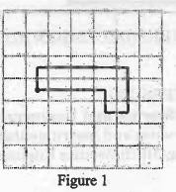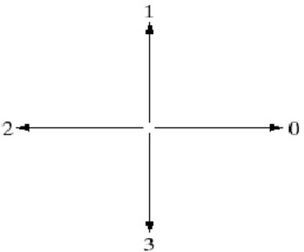
Chain code sequence : 103212

Define coding redundancy [A/M23]
Coding redundancy is associated with the representation of information. The information is represented in the form of codes. If the gray levels of an image are coded in a way that uses more code symbols than absolutely necessary to represent each gray level then the resulting image is said to contain coding redundancy.

