DHANALAKSHMI SRINIVASAN ENGINEERING COLLEGE (AUTONOMOUS)

PERAMBALUR - 621212

U23ECP51 –PROCESSORS AND CONTROLLERS LABORATORY

MANUAL

PREPARED BY

T.BOOPATHY, AP / ECE

EXP. 1 BASIC ARITHMETIC USING 8086 PROGRAMMING
AIM:
To write an Assembly Language Program (ALP) for performing the Arithmetic and logical operation of two-byte numbers

APPARATUS REQUIRED:

S. No. | Item | Specification | Quantity
01 | Microprocessor Kit | 8086 | 1
02 | Power Supply | +5 Vdc | 1

ALGORITHM:

- bit Addition

ARITHMETIC OPERATIONS

  - Initialize the MSBs of sum to 0
  - Get the first number.
  - Add the second number to the first number.
  - If there is any carry, increment MSBs of sum by 1.
  - Store LSBs of sum.
  - Store MSBs of sum.
- bit Subtraction
  - Initialize the MSBs of difference to Zero
  - Get the first number
  - Subtract the second number from the first number.
  - If there is any borrow, increment MSBs of difference by 1.
  - Store LSBs of difference
  - Store MSBs of difference.
- bit Multiplication
  - Get the multiplier.
  - Get the multiplicand
  - Initialize the product to 0.
  - Product = product + multiplicand
  - Decrement the multiplier by 1
  - If multiplicand is not equal to 0, repeat from step (d) otherwise store the product.
- bit Division
  - Get the dividend
  - Get the divisor
  - Initialize the quotient to 0.
  - Dividend = dividend – divisor
  - If the divisor is greater, store the quotient. Go to step g.
  - If dividend is greater, quotient = quotient + 1. Repeat from step (d) Store the dividend value as remainder.

PROGRAM:

ADDITION:

ARITHMETIC OPERATIONS

ADDRESS | OPCODE | MNEMONICS | COMMENTS
1000 | 8B 06 00 11 | MOV AX,[1100] | Get the first data in AX reg
1004 | 03 06 02 11 | SUB AX,[1102] | Add data in 1102 from AX
1008 | 89 06 04 11 | MOV[1104],AX | Move the result from AX to 1104
100C | F4 | HLT | Stop the program

SUBTRACTION:

ADDRESS | OPCODE | MNEMONICS | COMMENTS
1000 | 8B 06 00 11 | MOV AX,[1100] | Get the first data in AX reg
1004 | 2B 06 02 11 | SUB AX,[1102] | Subtract data in 1102 from AX
1008 | 89 06 04 11 | MOV[1104],AX | Move the result from AX to 1104
100C | F4 | HLT | Stop the program

MULTIPLICATION:

ADDRESS | OPCODE | MNEMONICS | COMMENTS
1000 | 8B 06 00 11 | MOV AX,[1100] | Move the data in 1100 to accumulator
1004 | 8B 1E 02 11 | MOV BX, [1102] | Move the data in 1102 to BX register
1008 | F7 E3 | MUL BX | Multiply the data in BX with AX
100A | 89 60 04 11 | MOV [1104],AX | Store the lower order product
100E | 89 16 05 11 | MOV [1105],DX | Store the higher order product
1012 | F4 | HLT | Stop the program

DIVISION:

ADDRESS | OPCODE | MNEMONICS | COMMENTS
1000 | C7 C0 08 00 | MOV AX, 0008 | Move the data to accumulator
1004 | C7 C3 04 00 | MOV BX, 0006 | Move the data to BX register
1008 | F7 F3 | DIV BX | Divide the dividend by divisor
100A | 89 06 00 12 | MOV [1200], AX | Store the lower order product
100E | 89 06 01 12 | MOV [1201], DX | Store the higher order product
1012 | F4 | HLT | Stop the program

OUTPUT:
ADDITION:

Input address | Data | Output address | Result
1100 | 02 | 1104 | 05
1101 | 05 | 1105 | 09
1102 | 03
1103 | 04

SUBTRACTION:

Input address | Data | Output address | Result
1100 | 03 | 1104 | 05
1101 | 05 | 1105 | 09
1102 | 01
1103 | 04

MULTIPLICATION:

Input address | Data | Output address | Result
1100 | 01 | 1104 | 03
1101 | 02 | 1105 | 08
1102 | 03
1103 | 04

DIVISION:

Output address | Result
1200 | 01
1201 | 02

RESULT:
Thus, Arithmetic operations of two-byte numbers are performed and the result is stored.

EXP. 2
SORTING AND SEARCHING

SORTING

AIM:

To write an Assembly Language Program (ALP) to sort a given array in ascending
and descending order

APPARATUS REQUIRED:

S. No. | Item | Specification | Quantity
1. | Microprocessor kit | 8086 | 1
2. | Power Supply | +5 V dc | 1

ALGORITHM:
- Sorting in ascending order:
  - Load the array count in two registers C1 and C2.
  - Get the first two numbers.
  - Compare the numbers and exchange if necessary, so that the two numbers are in ascending order.
  - Decrement C2.
  - Get the third number from the array and repeat the process until C2 is 0.
  - Decrement C1 and repeat the process until C1 is 0.

Sorting in descending order:
  - Load the array count in two registers C1 and C2.
  - Get the first two numbers.
  - Compare the numbers and exchange if necessary, so that the two numbers are in descending order.
  - Decrement C2.
  - Get the third number from the array and repeat the process until C2 is 0.
  - Decrement C1 and repeat the process until C1 is 0.

PROGRAM: ASCENDING:
ADDRESS | LABEL | OPCODE | MNEMONICS | COMMENTS
1000 |  | 8A 0C | MOV CL,[SI] | Number of comparisons in CL
1002 | L4 | C7 C6 00 12 | MOV SI,1200H | Initialize memory location for  array size
1006 |  | 8A 14 | MOV DL,[SI] | Get the count in DL
1008 |  | 46 | INC SI | Go to next memory location
1009 |  | 8A 04 | MOV AL,[SI] | Get the first data in AL

100B | L3 | 46 | INC SI | Go to next memory location
100C |  | 8A 1C | MOV BL,[SI] | Get the second data in BL
100E |  | 38 D8 | CMP AL,BL | Compare two data’s
1010 |  | 72 08 | JNB L1 | If AL < BL go to L1
1012 |  | 4E | DEC SI | Else, Decrement the memory  location
1013 |  | 88 04 | MOV [SI],AL | Store the smallest data
1015 |  | 88 D8 | MOV AL, BL | Get the next data AL
1017 |  | E9 03 00 | JMP L2 | Jump to L2
101A | L1 | 4E | DEC SI | Decrement the memory location
101B |  | 88 10 | MOV [SI],BL | Store the greatest data in memory  location
101D | L2 | 46 | INC SI | Go to next memory location
101E |  | FE CA | DEC DL | Decrement the count
1020 |  | 75 E9 | JNZ L3 | Jump to L3, if the count is not  reached zero
1022 |  | 88 04 | MOV [SI],AL | Store data in memory location
1024 |  | FE C9 | DEC CL | Decrement the count
1026 |  | 75 D4 | JNZ L4 | Jump to L4, if the count is not  reached zero
1028 |  | F4 | HLT | Stop

DESCENDING:
ADDRESS | LABEL | OPCODE | MNEMONICS | COMMENTS
1000 |  | 8A 0C | MOV CL,[SI] | Number of comparisons in CL
1002 | L4 | C7 C6 00 12 | MOV SI,1200H | Initialize memory location for  array size
1006 |  | 8A 14 | MOV DL,[SI] | Get the count in DL
1008 |  | 46 | INC SI | Go to next memory location
1009 |  | 8A 04 | MOV AL,[SI] | Get the first data in AL
100B | L3 | 46 | INC SI | Go to next memory location
100C |  | 8A 1C | MOV BL,[SI] | Get the second data in BL
100E |  | 38 D8 | CMP AL,BL | Compare two data’s
1010 |  | 72 08 | JB L1 | If AL < BL go to L1
1012 |  | 4E | DEC SI | Else, Decrement the memory  location
1013 |  | 88 04 | MOV [SI],AL | Store the smallest data
1015 |  | 88 D8 | MOV AL, BL | Get the next data AL
1017 |  | E9 03 00 | JMP L2 | Jump to L2
101A | L1 | 4E | DEC SI | Decrement the memory location
101B |  | 88 10 | MOV [SI],BL | Store the greatest data in memory  location
101D | L2 | 46 | INC SI | Go to next memory location
101E |  | FE CA | DEC DL | Decrement the count
1020 |  | 75 E9 | JNZ L3 | Jump to L3, if the count is not  reached zero
1022 |  | 88 04 | MOV [SI],AL | Store data in memory location
1024 |  | FE C9 | DEC CL | Decrement the count
1026 |  | 75 D4 | JNZ L4 | Jump to L4, if the count is not  reached zero
1028 |  | F4 | HLT | Stop

OUTPUT:
ASCENDING

Input address | Data | Output address | Result
1200 | 04 | 1300 | 04
1201 | 5 | 1301 | 5
1202 | 7 | 1302 | 6
1203 | 6 | 1303 | 7
1204 | 8 | 1304 | 8

DESCENDING

Input address | Data | Output address | Result
1200 | 04 | 1200 | 04
1201 | 5 | 1201 | 8
1202 | 7 | 1202 | 7
1203 | 6 | 1203 | 6
1204 | 8 | 1204 | 5

RESULT:
Thus, given array of numbers are sorted in ascending & descending order.

SEARCHING

AIM:
To write an Assembly Language Program (ALP) to find the largest and smallest number in a given array

APPARATUS REQUIRED:

S. No. | Item | Specification | Quantity
1. | Microprocessor kit | 8086 | 1
2. | Power Supply | +5 V dc | 1

ALGORITHM:
- Finding largest number:
  - Load the array count in a register C1.
  - Get the first two numbers.
  - Compare the numbers and exchange if the number is small.
  - Get the third number from the array and repeat the process until C1 is 0.

Finding smallest number:
  - Load the array count in a register C1.
  - Get the first two numbers.
  - Compare the numbers and exchange if the number is large.
  - Get the third number from the array and repeat the process until C1 is 0.

PROGRAM:
LARGEST

ADDRESS | LABEL | OPCODE | MNEMONICS | COMMENTS
1000 |  | C7 C6 00 12 | MOV SI,1200H | Initialize array size
1004 |  | 8A 0C | MOV CL,[SI] | Initialize the count
1006 |  | 46 | INC SI | Go to next memory location
1007 |  | 8A 04 | MOV AL,[SI] | Move the first data in AL
1009 |  | FE C9 | DEC CL | Reduce the count
100B | L2 | 46 | INC SI | Move the SI pointer to next data
100C |  | 3A 04 | CMP AL,[SI] | Compare two data’s
100E |  | 73 02 | JNB 1012 | If AL > [SI] then go to L1 (no swap)
1010 |  | 8A 04 | MOV AL,[SI] | Else move the large number to AL
1012 | L1 | FE C9 | DEC CL | Decrement the count
1014 |  | 75 F5 | JNZ L2 | If count is not zero go to L2
1016 |  | C7 C7 00 13 | MOV DI,1300H | Initialize DI with 1300H
101A |  | 88 05 | MOV [DI],AL | Else store the biggest number in1300 location
101C |  | F4 | HLT | Stop
SMALLEST:

ADDRESS | LABEL | OPCODE | MNEMONICS | COMMENTS
1000 |  | C7 C6 00 12 | MOV SI,1200H | Initialize array size
1004 |  | 8A 0C | MOV CL,[SI] | Initialize the count
1006 |  | 46 | INC SI | Go to next memory location
1007 |  | 8A 04 | MOV AL,[SI] | Move the first data in AL
1009 |  | FE C9 | DEC CL | Reduce the count
100B | L2 | 46 | INC SI | Move the SI pointer to next data
100C |  | 3A 04 | CMP AL,[SI] | Compare two data’s
100E |  | 73 02 | JB L1 | If AL < [SI] then go to L1 (no swap)
1010 |  | 8A 04 | MOV AL,[SI] | Else move the large number to AL
1012 | L1 | FE C9 | DEC CL | Decrement the count
1014 |  | 75 F5 | JNZ L2 | If count is not zero go to L2
1016 |  | C7 C7 00 13 | MOV DI,1300H | Initialize DI with 1300H
101A |  | 88 05 | MOV [DI],AL | Else store the biggest number in 1300 location
101C |  | F4 | HLT | Stop

OUTPUT:
LARGEST:

Input address | Data | Output address | Result
1200 | 04 | 1300 | 04
1201 | 01
1202 | 02
1203 | 03
1204 | 04
SMALLEST:

Input address | Data | Output address | Result
1200 | 04 | 1300 | 01
1201 | 01
1202 | 02
1203 | 03
1204 | 04

RESULT:
Thus, largest and smallest number is found in a given array.

EXP 3
COPYING A STRING
AIM:
To move a string of length FF from source to destination

ALGORITHM:
- Initialize the data segment. (DS)
- Initialize the extra data segment. (ES)
- Initialize the start of string in the DS. (SI)
- Initialize the start of string in the ES. (DI)
- Move the length of the string (FF) in CX register.
- Move the byte from DS TO ES, till CX=0.

PROGRAM:

ADDRESS | LABEL | OPCODE | MNEMONICS | COMMENTS
1000 |  | C7 C6 00 12 | MOV SI, 1200H | Initialize destination address
1004 |  | C7 C7 00 13 | MOV DI, 1300H | Initialize starting address
1008 |  | C7 C1 06 00 | MOV CX, 0006H | Initialize array size
100C |  | FC | CLD | Clear direction flag
100D | L1 | F3 A4 | MOVSB | Copy the contents of source into destination until count reaches  zero
100E |  | E2 FD | LOOP L1 | ……………………….
1010 |  | F4 | HLT | Stop

OUTPUT:

Input address | Data | Output address | Result
1200 | 01 | 1300 | 01
1201 | 02 | 1301 | 02
1202 | 03 | 1302 | 03
1203 | 04 | 1303 | 04
1204 | 05 | 1304 | 05
1205 | 06 | 1305 | 06

RESULT:
Thus, a string of a particular length is moved from source segment to destination segment

AIM:
SEARCHING A STRING

To scan for a given byte in the string and find the relative address of the byte from the

starting location of the string.

ALGORITHM:
- Initialize the extra segment. (ES)
- Initialize the start of string in the ES. (DI)
- Move the number of elements in the string in CX register.
- Move the byte to be searched in the AL register.
- Scan for the byte in ES. If the byte is found ZF=0, move the address pointed by ES: DI to BX.

PROGRAM:

ADDRESS | OPCODE | MNEMONICS | COMMENTS
1000 | C7 C6 00 13 | MOV SI,1300H | Initialize destination address
1004 | C7 C7 00 14 | MOV DI, 1400H | Initialize starting address
1008 | C7 C1 06 00 | MOV CX, 0006H | Initialize array size
100C | FC | CLD | Clear direction flag
100D | C6 C0 08 | MOV AL, 08H | Store the string to be searched
1010 | F2 AE | REPNE SCASB | Scan until the string is found
1012 | 4F | DEC DI | Decrement the destination address
1013 | 8A 1D | MOV BL,[DI] | Store the contents into BL reg
1015 | 88 1C | MOV [SI],BL | Store content of BL in source address
1017 | F4 | HLT | Stop
OUTPUT:

Input address | Data | Output address | Result
1300 | 01 | 1300 | 08
1301 | 02
1302 | 03
1303 | 04
1304 | 05
1305 | 08

RESULT:
Thus, a given byte or word in a string of a particular length in the extra segment (destination) is found.

AIM:
FIND AND REPLACE

To find a character in the string and replace it with another character

ALGORITHM:
- Initialize the extra segment. (E S)
- Initialize the start of string in the ES. (DI)
- Move the number of elements in the string in CX register.
- Move the byte to be searched in the AL register.
- Store the ASCII code of the character that has to replace the scanned byte in BL register.
- Scan for the byte in ES. If the byte is not found, ZF≠1 and repeat scanning. If the byte is found, ZF=1.Move the content of BL register to ES: DI

PROGRAM:

ADDRESS | OPCODE | MNEMONICS | COMMENTS
1000 | C7 C7 00 13 | MOV DI,1300H | Initialize destination address
1004 | C7 C6 00 14 | MOV SI,1400H | Initialize starting address
1008 | C7 C1 06 00 | MOV CX, 0006H | Initialize array size
100C | FC | CLD | Clear direction flag
100D | C6 C0 08 | MOV AL, 08H | Store the string to be searched
1010 | C6 C7 30 | MOV BH,30H | Store the string to be replaced
1013 | F2 AE | REPNE SCASB | Scan until the string is found
1015 | 4F | DEC DI | Decrement the destination address
1016 | 8A 1D | MOV BL,[DI] | Store the contents into BL reg
1018 | 88 1C | MOV [SI],BL | Store content of BL in source address
101A | 88 3D | MOV [DI],BH | Replace the string
101C | F4 | HLT | Stop

OUTPUT:

Input address | Data | Output address | Result
1400 | 01 | 1300 | 01
1401 | 02 | 1301 | 02
1402 | 03 | 1302 | 03
1403 | 04 | 1303 | 04
1404 | 05 | 1304 | 05
1405 | 08 | 1305 | 30

RESULT:
Thus, a given byte or word in a string of a particular length in the extra segment (destination) is found and is replaced with another character.

EXP. 5

EXP. 8 STEPPER MOTOR INTERFACING

AIM:
To write an assembly language program in 8086 to rotate the motor at different speeds.

APPARATUS REQUIRED:

S. No. | Item | Specification | Quantity
1. | Microprocessor kit | 8086 | 1
2. | Power Supply | +5V DC, +12 V DC | 1
3. | Stepper Motor Interface board | - | 1
4. | Stepper Motor | - | 1

ALGORITHM:
    - For running stepper motor clockwise and anticlockwise directions
    - Get the first data from the lookup table.
    - Initialize the counter and move data into accumulator.
    - Drive the stepper motor circuitry and introduce delay
    - Decrement the counter is not zero repeat from step(iii)
    - Repeat the above procedure both for backward and forward directions.

SWITCHING SEQUENCE OF STEPPER MOTOR:

MEMORY LOCATION | A1 | A2 | B1 | B2 | HEX CODE
4500 | 1 | 0 | 0 | 0 | 09 H
4501 | 0 | 1 | 0 | 1 | 05 H
4502 | 0 | 1 | 1 | 0 | 06 H
4503 | 1 | 0 | 1 | 0 | 0A H

PROGRAM:

ADDRESS | LABEL | OPCODE | MNEMONICS | COMMENTS
1000 | START | C7 C7 00 12 | MOV DI, 1200H | Initialize memory location to  store the array of number
1004 |  | C7 C1 04 00 | MOV CX, 0004H | Initialize array size
1008 | L1 | 8A 05 | MOV AL,[DI] | Copy the first data in AL
100A |  | E6 E0 | OUT 0C0,AL | Send it through port address
100C |  | C7 C2 10 10 | MOV DX, 1010H | Introduce delay
1010 | L2 | 4A | DEC DX | Introduce delay
1011 |  | 75 FD | JNZ L2 | Introduce delay
1013 |  | 47 | INC DI | Go to next memory location
1014 |  | E2 F2 | LOOP L1 | Loop until all the data’s have  been sent
1016 |  | E9 E7 EF | JMP START | Go to start location for  continuous rotation

OUTPUT:

Input address | Data | Output | Input address | Data | Output
1200 | 09 | Motor rotates in clockwise direction | 1200 | 06 | Motor rotates in anti clockwise direction
1201 | 02 | Motor rotates in clockwise direction | 1201 | 0A | Motor rotates in anti clockwise direction
1202 | 0A | Motor rotates in clockwise direction | 1202 | 02 | Motor rotates in anti clockwise direction
1203 | 06 | Motor rotates in clockwise direction | 1203 | 09 | Motor rotates in anti clockwise direction

RESULT:
Thus, the assembly language program for rotating stepper motor in both clockwise and anticlockwise directions is written and verified.

EXP. 9 DIGITAL CLOCK

AIM:
To display the digital clock specifically by displaying the hours, minutes and seconds
using 8086 kits.

APPARATUS REQUIRED:

S. No. | Item | Specification
1 | Microprocessor kit | 8086
2 | Power Supply | 5V

PRELIMINARY SETTINGS
Org 1000h
Store time value in memory location 1500- Seconds
1501- Minutes
1502- Hours

ALGORITHM:
    - Take the microprocessor kit.
    - Display the digital clock by displaying the hours, minutes and seconds.
    - Execute the program.
    - Get the output.

PROGRAM:
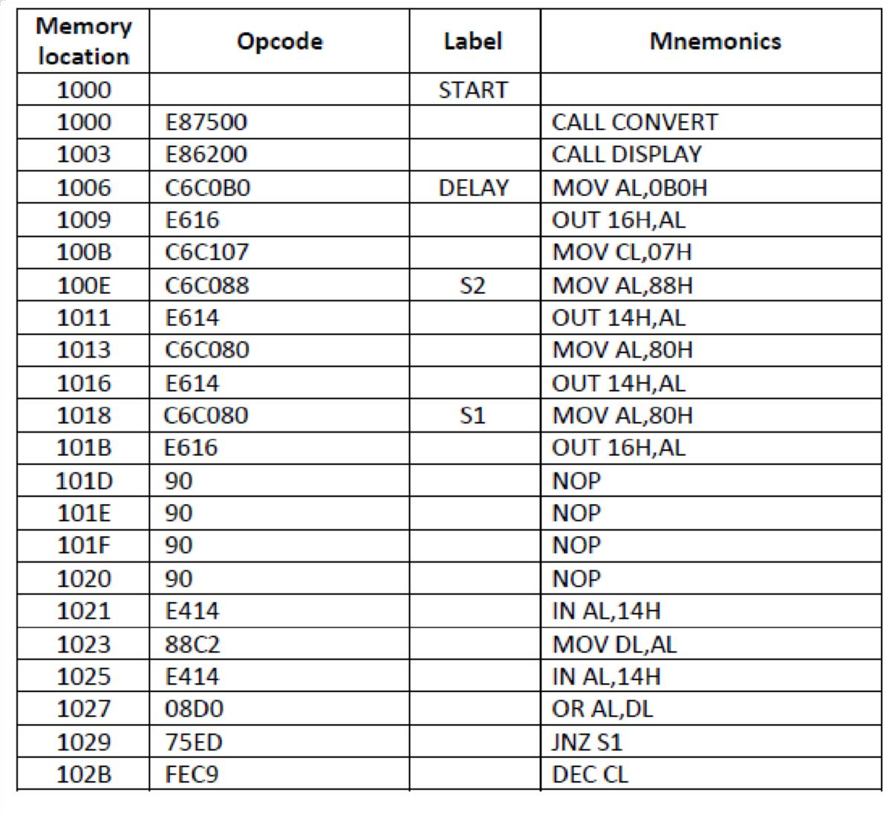

102D | 75DF |  | JNZ S2
102F | C7C60015 |  | MOV SI,1500H
1033 | 8A04 |  | MOV AL,[SI]
1035 | FEC0 |  | INC AL
1037 | 8804 |  | MOV [SI],AL
1039 | 80F83C” |  | CMP AL,3CH
103C | 75C2 |  | JNZ START
103E | C6C000 |  | MOV AL,00H
1041 | 8804 |  | MOV [SI],AL
1043 | 40 |  | INC SI
1044 | 8A04 |  | MOV AL,[SI]
1046 | FEC0 |  | INC AL
1048 | 8804 |  | MOV [SI],AL
104A | 80F83C. |  | CMP AL,3CH
104D | 75B1 |  | JNZ START
1%F | C6CX00 |  | MOV AL,0
1052 | 8804 |  | MOV [SI],AL
1054 | 4s |  | INC SI
1055 | 8A04 |  | MOV AL,[SIj
1057 | FEC0 |  | INC AL
1059 | 8804 |  | MOV [SI],AL
105B | 8OF818 |  | CMP AL,18H
105E | 75A0 |  | JNZ START
1000 | C6C000 |  | MOV AL,0
10d3 | 8804 |  | MOV [SI],AL
1065 | E998FF |  | JMP START
1068 | €:6C406 | DISPLAY | MOV AH,06H
106B | C7C20016 |  | MOV DX,1600H
106F | C6C501 |  | MOV CH,01H
1072 | C.6C100 |  | MOV CL,0H
1073 | CD05 |  | INT 5
1077 | C3 |  | RET
1078 | C7C60015 | CONVERT | MOV SI,1500H
107C | C 7C308I6 |  | MOV BX,1608H
1080 | C6C024 |  | MOV AL,24H
1083 | 8807 |  | MOV [BX],AL
 | SE | CONDS
1085 | 8A04 |  | MOV AL,[SIj
1087 | C6t400 |  | MOV AH,0
l08A | C6060A |  | MOV DH,0AH
108D | F§Fs |  | DIV DH
108F | 80C430 |  | ADD AH,30H
1092 | 4B |  | DEC BX
1093 | 8827 |  | MOV [BX],AH
1095 | 4B |  | DEC BX
1096 | 80C030 |  | ADD AL,30H

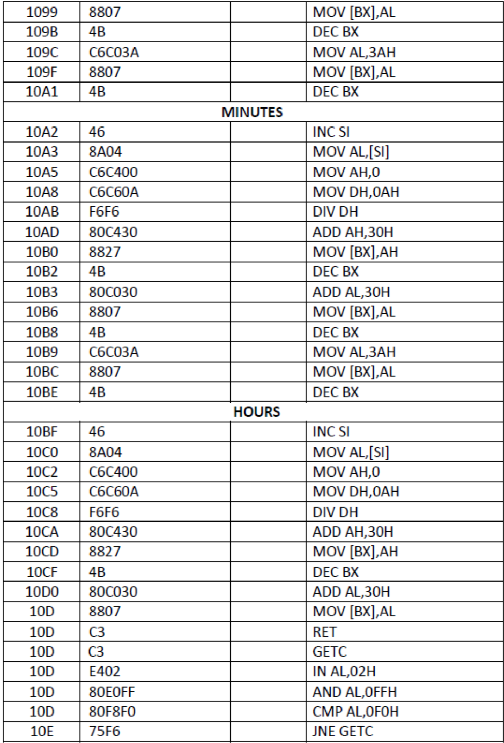

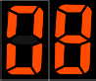

OUTPUT:
hours: minutes: seconds - : :

RESULT
Thus, the digital clock program has been written and executed using 8086 microprocessor kit and the output of digital clock was displayed as [hours: minutes: seconds] successfully.

EXP. 10 INTERFACING PRGRAMMABLE KEYBOARD AND
DISPLAY CONTROLLER- 8279
AIM:
To display the rolling message “ HAI “ in the display.

APPARATUS REQUIRED:
8086 Microprocessor kit, Power supply, Interfacing board.

ALGORITHM:
Display of rolling message “ HAI “
      - Initialize the counter
      - Set 8279 for 8-digit character display, right entry
      - Set 8279 for clearing the display
      - Write the command to display
      - Load the character into accumulator and display it
      - Introduce the delay
      - Repeat from step 1.

PROGRAM TABLE:

ADDRESS | LABEL | OPCODE | MNEMONICS | COMMENTS
1000 | START | C7 C6 00 12 | MOV SI,1200H | Initialize array
1004 |  | C7 C1 0F 00 | MOV  CX,000FH | Initialize array size
1008 |  | C6 C0 10 | MOV AL,10 | Store the control word for display  mode
100B |  | E6 C2 | OUT C2,AL | Send through output port
100D |  | C6 C0 CC | MOV AL,0CC | Store the control word to clear  display
1010 |  | E6 C2 | OUT C2,AL | Send through output port
1012 |  | C6 C0 90 | MOV AL,90 | Store the control word to write  display
1015 |  | E6 C2 | OUT C2,AL | Send through output port
1017 | L1 | 8A 04 | MOV AL,[SI] | Get the first data
1019 |  | E6 C0 | OUT C0,AL | Send through output port
101B |  | E8 06 00 | CALL DELAY | Give delay
101E |  | 46 | INC SI | Go & get next data
101F |  | E2 46 | LOOP L1 | Loop until all the data’s have been  taken

1021 |  | E9 DC FF | JMP START | Go to starting location
1024 | DELAY | C7 C2 FF A0 | MOV  DX,0A0FFH | Store 16bit count value
1028 | L2 | 4A | DEC DX | Decrement count value
1029 |  | 75 FD | JNZ L2 | Loop until count values becomes  zero
102B |  | C3 | RET | Return to main program

OUTPUT:

Input address | Data | Output
1200 | FF | 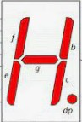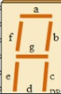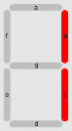
1201 | 98
1202 | 88
1203 | 9F
1204 | FF

RESULT:
Thus, the output for the interfacing programmable keyboard & display controller 8279 was executed successfully.

EXP. 13 A/D AND D/A INTERFACE AND WAVEFORM GENERATION INTERFACING ANALOG – TO – DIGITAL CONVERTER
AIM:
To write an assembly language program to convert an analog signal into a digital signal using an ADC interfacing.

APPARATUS REQUIRED:

S. No. | Item | Specification | Quantity
1 | Microprocessor kit | 8086 | 1
2 | Power Supply | +5V DC, +12 V DC | 1
3 | ADC Interface board | - | 1

ALGORITHM:
  - Select the channel and latch the address.
  - Send the start conversion pulse.
  - Read EOC signal.
  - If EOC = 1 continue else go to step (iii)
  - Read the digital output.
  - Store it in a memory location.

PROGRAM

ADDRESS | OPCODE | PROGRAM | COMMENTS
1000 | C6 C0 00 | MOV AL,00 | Load accumulator with value for  ALE high
1003 | E6 C8 | OUT 0C8H,AL | Send through output port
1005 | C6 C0 08 | MOV AL,08 | Load accumulator with value for  ALE low
1008 | E6 C8 | OUT 0C8H,AL | Send through output port
100A | C6 C0 01 | MOV AL,01 | Store the value to make SOC high in  the accumulator
100D | E6 D0 | OUT 0D0H,AL | Send through output port
100F | C6 C0 00 | MOV AL,00 | Introduce delay
1012 | C6 C0 00 | MOV AL,00 | Introduce delay
1015 | C6 C0 00 | MOV AL,00 | Introduce delay
1018 | C6 C0 00 | MOV AL,00 | Store the value to make SOC low the  accumulator
101B | E6 D0 | OUT 0D0H,AL | Send through output port

101D | E4 D8 | L1 : IN AL, 0D8H | Read the EOC signal from port & check for end of conversion
101F | 80 E0 01 | AND AL,01 | Read the EOC signal from port & check for end of conversion
1022 | 80 F8 01 | CMP AL,01 | Read the EOC signal from port & check for end of conversion
1025 | 75 F6 | JNZ L1 | If the conversion is not yet  completed, read EOC signal from port again
1027 | E4 C0 | IN AL,0C0H | Read data from port
1029 | C7 C3 00 11 | MOV BX,1100 | Initialize the memory location to  store data
102D | 88 07 | MOV[BX],AL | Store the data
102F | F4 | HLT | Stop

OUTPUT:

Analog Data | Output address | Output
 | 1100 | 0F

RESULT:
Thus, the ADC was interfaced with 8086 and the given analog inputs were converted into its digital equivalent.

INTERFACING DIGITAL – TO – ANALOG CONVERTER
AIM:
- To write an assembly language program for digital to analog conversion
- To convert digital inputs into analog outputs & to generate different waveforms

APPARATUS REQUIRED:

S. No. | Item | Specification | Quantity
1 | Microprocessor kit | 8086 | 1
2 | Power Supply | +5V DC, +12V DC | 1
3 | DAC Interface board | - | 1

ALGORITHM:
  - Measurement of analog voltage:
  - Send the digital value of DAC.
  - Read the corresponding analog value of its output.

Waveform generation:
Square Waveform:
- Send low value (00) to the DAC.
- Introduce suitable delay.
- Send high value to DAC.
- Introduce delay.
- Repeat the above procedure. Saw-tooth waveform:
- Load low value (00) to accumulator.
- Send this value to DAC.
- Increment the accumulator.
- Repeat step (ii) and (iii) until accumulator value reaches FF.
- Repeat the above procedure from step 1. Triangular waveform:
- Load the low value (00) in accumulator.
- Send this accumulator content to DAC.
- Increment the accumulator.
- Repeat step 2 and 3 until the accumulator reaches FF, decrement the accumulator and send the accumulator contents to DAC.
- Decrementing and sending the accumulator contents to DAC.
- The above procedure is repeated from step (i)

PROGRAM:
MEASUREMENT OF ANALOG VOLTAGE:

PROGRAM | COMMENTS
MOV AL,7FH | Load digital value 00 in accumulator
OUT C0,AL | Send through output port
HLT | Stop

PROGRAM TABLE:
Square Wave

ADDRESS | OPCODE | PROGRAM | COMMENTS
1000 | C6 C0 00 | L2 : MOV AL,00H | Load 00 in accumulator
1002 | E6 C0 | OUT C0,AL | Send through output port
1004 | E8 12 10 | CALL L1 | Give a delay
1007 | C6 C0 FF | MOV AL,FFH | Load FF in accumulator
100A | E6 C0 | OUT C0,AL | Send through output port
100C | E8 12 00 | CALL L1 | Give a delay
1010 | 75 F9 | JMP L2 | Go to starting location
1012 | C6 C0 05 | L1 : MOV CX,05FFH | Load count value in CX  register
1015 | FE C0 | L3 : LOOP L3 | Decrement until it reaches  zero
1017 | C3 | RET | Return to main program

Saw tooth Wave

ADDRESS | OPCODE | PROGRAM | COMMENTS
1000 | C6 C0 00 | L2 : MOV AL,00H | Load 00 in accumulator
1003 | E6 C0 | L1 : OUT C0,AL | Send through output port
1005 | FE C9 | INC AL | Increment contents of  accumulator
1007 | 75 F9 | JNZ L1 | Send through output port until  it reaches FF
1009 | 75 F9 | JMP L2 | Go to starting location

Triangular Wave

ADDRESS | OPCODE | PROGRAM | COMMENTS
1000 | C6 C0 00 | L3 : MOV AL,00H | Load 00 in accumulator
1003 | E6 C0 | L1 : OUT C0,AL | Send through output port
1005 | FE C9 | INC AL | Increment contents of  accumulator
1007 | 75 F9 | JNZ L1 | Send through output port until it  reaches FF
1009 | C6 C0 FF | MOV AL,0FFH | Load FF in accumulator
100C | E6 E0 | L2 : OUT C0,AL | Send through output port
100E | FE C9 | DEC AL | Decrement contents of  accumulator
1010 | 8A 04 | JNZ L2 | Send through output port until it  reaches 00
1013 | 75 F9 | JMP L3 | Go to starting location

Result:
Thus, the DAC was interfaced with 8086 and different waveforms have been generated.

EXP. 14 BASIC ARITHMETIC AND LOGICAL OPERATIONS
ARITHMETIC OPERATIONS
AIM:
To write a program to perform arithmetic operations of two 8-bit numbers using 8051 microcontroller.

APPARATUS REQUIRED:

S. No. | Item | Specification | Quantity
01 | Microcontroller Kit | 8051 | 1
02 | Power Supply | +5 Vdc | 1

ALGORITHM:
  - Clear Program Status Word.
  - Select Register bank by giving proper values to RS1 & RS0 of PSW.
  - Load accumulator A with any desired 8-bit data.
  - Load the register R 0 with the second 8- bit data.
  - Add these two 8-bit numbers.
  - Store the result.
  - Stop the program.

PROGRAM:
- 8 Bit Addition (Immediate Addressing)

ADDRESS | LABEL | MNEMONIC | OPERAND | HEX  CODE | COMMENTS
4100 |  | CLR | C | C3 | Clear CY Flag
4101 |  | MOV | A, # data 1 | 74,data1 | Get the data1 in  Accumulator
4103 |  | ADDC | A, # data 2 | 24,data2 | Add the data1 with data2
4105 |  | MOV | DPTR, # 4500H | 90,45,00 | Initialize the memory  location
4108 |  | MOVX | @ DPTR, A | F0 | Store the result in memory  location
4109 | L1 | SJMP | L1 | 80,FE | Stop the program

- 8 Bit Subtraction (Immediate Addressing)

ADDRESS | LABEL | MNEMONIC | OPERAND | HEX  CODE | COMMENTS
4100 |  | CLR | C | C3 | Clear CY flag
4101 |  | MOV | A, # data1 | 74, data1 | Store data1 in  accumulator

4103 |  | SUBB | A, # data2 | 94,data2 | Subtract data2 from  data1
4105 |  | MOV | DPTR, # 4500 | 90,45,00 | Initialize memory  location
4108 |  | MOVX | @ DPTR, A | F0 | Store the difference in  memory location
4109 | L1 | SJMP | L1 | 80,FE | Stop

- 8 Bit Multiplication

ADDRESS | LABEL | MNEMONIC | OPERAND | HEX  CODE | COMMENTS
4100 |  | MOV | A ,#data1 | 74, data1 | Store data1 in  accumulator
4102 |  | MOV | B, #data2 | 75,data2 | Store data2 in B reg
4104 |  | MUL | AB | F5,F0 | Multiply both
4106 |  | MOV | DPTR, # 4500H | 90,45,00 | Initialize memory  location
4109 |  | MOVX | @ DPTR, A | F0 | Store lower order  result
401A |  | INC | DPTR | A3 | Go to next memory  location
410B |  | MOV | A,B | E5,F0 | Store higher order result
410D |  | MOVX | @ DPTR, A | F0 | Store higher order result
410E | STOP | SJMP | STOP | 80,FE | Stop

- 8 Bit Division

ADDRESS | LABEL | MNEMONIC | OPERAND | HEX CODE | COMMENTS
4100 |  | MOV | A, # data1 | 74,data1 | Store data1 in  accumulator
4102 |  | MOV | B, # data2 | 75,data2 | Store data2 in B reg
4104 |  | DIV | A,B | 84 | Divide
4015 |  | MOV | DPTR, # 4500H | 90,45,00 | Initialize memory location
4018 |  | MOVX | @ DPTR, A | F0 | Store remainder
4109 |  | INC | DPTR | A3 | Go to next memory  location
410A |  | MOV | A,B | E5,F0 | Store quotient
410C |  | MOV | @ DPTR, A | F0 | Store quotient

410D | STOP | SJMP | STOP | 80,FE | Stop

OUTPUT:
8051 - 8 BIT ADDITION

Input address | Data | Output address | Result
4102 | 04 | 4500 | 05
4104 | 01

8051 - 8 BIT SUBTRACTION

Input address | Data | Output address | Result
4102 | 04 | 4500 | 03
4104 | 01

8051 - 8 BIT MULTIPLICATION

Input address | Data | Output address | Result
4101 | 02 | 4500 | 06
4103 | 03 | 4501 | 00

8051 - 8 BIT DIVISION

Input address | Data | Output address | Result
4101 | 09 | 4500 | 03
4103 | 03 | 4501 | 00

RESULT:
Thus, the 8051 ALP for arithmetic operation is executed.

AIM:
LOGICAL AND BIT MANIPULATION

To write an ALP to perform logical and bit manipulation operations using 8051

microcontroller.

ALGORITHM:
- Initialize content of accumulator as FFH
- Set carry flag (cy = 1).
- AND bit 7 of accumulator with cy and store PSW format.
- OR bit 6 of PSW and store the PSW format.
- Set bit 5 of SCON.
- Clear bit 1 of SCON.
- Move SCON.1 to carry register.
- Stop the execution of program.

PROGRAM: OR:
ADDRESS | LABEL | MNEMONICS | OPERAND | COMMENT
4100 | START: | MOV | A, #DATA1 | Copy to A Register first number
4102 |  | ORL | A, #DATA2 | OR the A register with an  immediate data 45h
4104 |  | MOV | DPTR, #4500 | Store in Data Pointer the memory  address
4107 |  | MOVX | @DPTR, A | Store the result in Memory
4109 | HERE: | SJMP | HERE | Halt here

AND:

ADDRESS | LABEL | MNEMONICS | OPERAND | COMMENT
4100 | START: | MOV | A, #DATA1 | Copy 1st Number to A register
4102 |  | ANL | A, #DATA2 | AND A register with 2nd number
4104 |  | MOV | DPTR, #4500 | Copy the memory address to Data  Pointer
4107 |  | MOVX | @DPTR, A | Store the result in Memory
4108 | HERE: | SJMP | HERE | Halt here

OUTPUT:
OR

Input address | Data | Output address | Result
4101 | 01 | 4500 | 04
4103 | 03

AND

Input address | Data | Output address | Result
4101 | 01 | 4500 | 03
4103 | 03

RESULT
Thus, the Logical and bit manipulation operation is done in 8051 microcontroller.

EXP. 15 SQUARE AND CUBE PROGRAM, FIND 2’S COMPLEMENT OF A NUMBER
AIM:
To convert Square and Cube program, find 2’s complement of a number using 8051
microcontroller.

APPARATUS REQUIRED:
- 8051 Microcontroller kit
- Keyboard
- Power supply

ALGORITHM:
- Save contents of all register which are used in routine.
- Get the data.
- Perform 2’s complement using 8051 microcontroller.
- Restore contents of registers.

PROGRAM TO FIND SQUARE:

ADDRESS | OPCODE | MNEMONICS | COMMENTS
7500 | 90 80 00 | MOV DPTR,# 8000 | Initialize the memory pointer
7503 | E0 | MOVX A,@DPTR | Get the number N
7504 | F5 F0 | MOV B,A | Store it in B
7506 | A4 | MUL AB | Square : N×N
7507 | A3 | INC DPTR | Increment memory pointer
7508 | F0 | MOVX @DPTR,A | Store lower byte of square
7509 | A3 | INC DPTR | Increment memory pointer
750A | E5 F0 | MOV A,B | Get higher byte of square
750C | F0 | MOVX @DPTR,A | Store higher byte of square
750D | 80 FE | SJMP 750D | Stop the program

PROGRAM TO FIND CUBE:

ADDRESS | OPCODE | MNEMONICS | COMMENTS
7500 | 90 80 00 | MOV DPTR,#8000H | Initialize the memory pointer
7503 | E0 | MOVX A,@DPTR | Get the number N
7504 | F8 | MOV R0,A | Store it in R0
7505 | F5 F0 | MOV B,A | Store it in B
7507 | A4 | MUL AB | Square : N×N
7508 | C0 F0 | PUSH B | Save the high byte of square
750A | F5 F0 | MOV B,A | Save the lower byte of square in B
750C | E8 | MOV A,R0 | Get the number N
750D | A4 | MUL AB | N × lower byte of square of N
750E | A3 | INC DPTR | Increment memory pointer
750F | F0 | MOVX @DPTR,A | Save partial result 1 (lower byte)
7510 | E5 F0 | MOV A,B | Get lower byte
7512 | F9 | MOV R1,A | Save higher byte of N × lower byte of  square of N (partial result 2)
7513 | D0 F0 | POP B | Get the higher byte of square
7515 | E8 | MOV A,R0 | Get the number N
7516 | A4 | MUL AB | N × higher byte of square
7517 | 29 | ADD A,R1 | Add to partial result 2
7518 | A3 | INC DPTR | Increment memory pointer
7519 | F0 | MOVX @DPTR,A | Save middle byte
751A | E5 F0 | MOV A,B | Get higher byte
751C | 34 00 | ADDC A,#00 | Add carry of previous addition if any
751E | A3 | INC DPTR | Increment memory pointer
751F | F0 | MOVX @DPTR,A | Save higher byte
7520 | 80 FE | SJMP | Stop the program

PROGRAM TO FIND 2’s COMPLEMENT OF A NUMBER:

ADDRESS | OPCODE | MNEMONICS | COMMENTS
7500 | 74 23 | MOVA, #23 | Move 23 to A register
7502 | F4 | CPL A | Complement of A register
7503 | 24 01 | ADD A,#01 | Add 1 to it to get 2’s complement
7505 | 90 45 00 | MOV DPTR,#4500 | Initialize memory location
7508 | F0 | MOVX @DPTR,A | Store the value in memory location
7509 | 80 FE | SJMP | Stop the program

OUTPUT:
PROGRAM TO FIND SQUARE

Input address | Data | Output address | Result
8000 | 02 | 8000 | 02
 |  | 8001 | 04

PROGRAM TO FIND CUBE

Input address | Data | Output address | Result
8000 | 02 | 8000 | 02
 |  | 8001 | 08

PROGRAM TO FIND 2’s COMPLEMENT OF A NUMBER

Input address | Data | Output address | Result
7501 | 02 | 4500 | FD

RESULT:
Thus, the Square and Cube program, finding 2’s complement of a number is done in 8051 microcontroller and is executed successfully.

EXP. 16 UNPACKED BCD TO ASCII AIM:
To convert BCD number into ASCII by using 8051 microcontroller

APPARATUS REQUIRED:
- 8051 Microcontroller kit
- Keyboard
- Power supply

ALGORITHM:
- Save contents of all registers which are used in routine.
- Get the data in AL register and make AH equal to 00.
- Use AAM instruction to convert number in its decimal equivalent in the unpacked format
- Add 30H in each digit to get its ASCII equivalent.
- Display digit one by one using function 2 if INT 21H.
- Restore contents of registers.

PROGRAM:

ADDRESS | OPCODE | MNEMONICS | COMMENTS
4000 | 75 14 | MOV A,# 14 | Load the first data in A register
4002 | E5 F0 | MOV B, A | Move reg A to reg B
4004 | F3 0F FC | ANL A, #0FH | Mask the bit
4006 | 24 30 | ADD A, #30H | Add 30H with reg A
4008 | 90 45 00 | MOV DPTR,#4500 | Initialize the data pointer for storing the result
400B | F0 | MOVX@DPTR,A | Result move to external memory
400C | E5 F0 | MOV A, B | Transfer B register to A register
400E | F3 F0 | ANL A, #F0H | Mask the bit
4010 | E4 | SWAP A | Swap lower and upper nibble
4011 | 24 30 | ADD A, #30H | Add 30H to reg A
4013 | A3 | INC DPTR | Increment data pointer
4014 | F0 | MOVX@DPTR,A | Move reg A value to data pointer
4016 | 80 FE | SJMP | Stop the program
RESULT:
The given BCD number is converted into ASCII using 8051 microcontroller kit.

