
DEPARTMENT OF ELECTRONICS AND COMMUNICATION ENGINEERING
REGULATION -2023
SEMESTER-V

MASTER MANUAL

U23ECP52/ VLSI LABORATORY

PREPARED BY VERIFIED BY
Mrs.S.Susidra, AP/ECE

DHANALAKSHMI SRINIVASAN ENGINEERING COLLEGE
Department of Electronics and Communication Engineering
U23ECP52/ VLSI LABORATORY
Class –III A ,B &C Semester –Vth

List of Experiments
- Design of basic combinational and sequential (Flip-flops) circuits using HDL. Simulate it using Xilinx/Altera Software and implement by Xilinx/Altera FPGA
- Design an Adder; Multiplier (Min 8 Bit) using HDL. Simulate it using Xilinx/Altera Software and implement by Xilinx/Altera FPGA
- Design and implement Universal Shift Register using HDL. Simulate it using Xilinx/Altera Software
- Design Memories using HDL. Simulate it using Xilinx/Altera Software and implement by Xilinx/Altera FPGA
- Design Finite State Machine (Moore/Mealy) using HDL. Simulate it using Xilinx/Altera Software and implement by Xilinx/Altera FPGA
- Design 3-bit synchronous up/down counter using HDL. Simulate it using Xilinx/Altera Software and implement by Xilinx/Altera FPGA
- Design 4-bit Asynchronous up/down counter using HDL. Simulate it using Xilinx/Altera Software and implement by Xilinx/Altera FPGA
- Design and simulate a CMOS Basic Gates & Flip-Flops. Generate Manual/Automatic Layout.
- Design and simulate a 4-bit synchronous counter using a Flip-flop. Generate Manual/Automatic Layout
- Design and Simulate a CMOS Inverting Amplifier.
- Design and Simulate basic Common Source, Common Gate and Common Drain Amplifiers.
- Design and simulate simple 5 transistor differential amplifier.

Exp. No.: 1 | DESIGN OF BASIC COMBINATIONAL CIRCUITS USING HDL. SIMULATE IT USING XILINX/ALTERA SOFTWARE AND IMPLEMENT BY XILINX/ALTERA FPGA

AIM:
To design basic combinational and sequential circuits using HDL. Simulate it using Xilinx/Altera software and implement by Xilinx/Altera FPGA

APPARATUS REQUIRED:
- Pc With Windows Xp.
- Xilinx Software
- Fpga-Spartan-3 Kit
- Parallel to JTAG Cable

PROCEDURE:

  - Start the Xilinx ISE by using Start>Program files> Xilinx ISE>project navigator
  - Click File>New Project
  - Enter the Project Name and select the location then click next
  - Select the Device and other category and click next twice and finish.
  - Click on the symbol of FPGAdevice and then right click>click on new source.
  - Select the Verilog Module and give the filename>click next and define ports>click next and finish.
  - Type the Verilog Code in Verilog Editor.
  - Run the Check syntax>Process window >synthesize>double click check syntax. If any errors found, then remove the errors with proper syntax &coding.
  - Click on the symbol of FPGA device and then right click>click on new source.
  - Select the Test Bench Waveform and give the filename>select entity click next and finish.
  - Select the desired parameters for simulating your design. In this case combinational circuit and simulation time click finish.
  - Assign all input signal using just click on graph and save file.
  - From the source process window. Click Behavioral simulation from drop-down menu
  - Select the test bench file (. tbw) and click process button>double click the Simulation Behavioral Model
  - Verify your design in wave window by seeing behavior of output signal with respect to input signal.
  - To assign package pins using corresponding CPLD manual via using constraint.
  - Assign package pins.
  - The pace file opened and give the pin details.
  - Go Implement design and generate the programming file and configure the device (impact).
  - In configure device choose JTAG options and add the Xilinx device in boundary scan and download the program and execute successfully.

PROGRAM LOGIC

Half adder is a combinational circuit which computer binary addition of two binary inputs. It is one of the basic combinational circuit in which we have combination of two gates (ex-or gate, and gate). A half adder is a digital logic circuit that performs binary addition of two single-bit binary numbers. It has two inputs, A and B, and two outputs, SUM and CARRY.

The full adder is a digital component that performs three numbers an implemented using the logic gates. It is the main component inside an ALU of a processor and is used to increment addresses, table indices, buffer pointers, and other places where addition is required. A one-bit full adder adds three one- bit binary numbers, two input bits, one carry bit, and outputs a sum and a carry bit.
Half subtractor is a combination circuit with two inputs and two outputs that are difference and borrow. It produces the difference between the two binary bits at the input and also producesan output (Borrow) to indicate if a 1 has been borrowed. In the subtraction (A-B), A is called a Minuend bit and B is called a Subtrahend bit.

Full subtractor is a combinational circuit that performs subtraction of two bits, one is minuend and other is subtrahend, taking into account borrow of the previous adjacent lower minuend bit. This circuit has three inputs and two outputs. The three inputs A, B and Bin, denote the minuend, subtrahend, and previous borrow, respectively. The two outputs, D and Bout represent the difference and output borrow, respectively. Although subtraction is usually achieved by adding the complement of subtrahend to the minuend, it is of academic interest to work out the Truth Table and logic realisation of a full subtractor; x is the minuend; y is the subtrahend; z is the input borrow; D is the difference; and B denotes the output borrow. The corresponding maps for logic functions for outputs of the full subtractor namely difference and borrow.

In D flip flop, the single input "D" is referred to as the "Data" input. When the data input is set to 1, the flip flop would be set, and when it is set to 0, the flip flop would change and become reset. However, this would be pointless since the output of the flip flop would always change on every pulse applied to this data input.

The "CLOCK" or "ENABLE" input is used to avoid this for isolating the data input from the flip flop's latching circuitry. When the clock input is set to true, the D input condition is only copied to the output Q. This forms the basis of another sequential device referred to as D Flip Flop.

When the clock input is set to 1, the "set" and "reset" inputs of the flip-flop are both set to 1. So it will not change the state and store the data present on its output before the clock transition occurred. In simple words, the output is "latched" at either 0 or 1.
The "T Flip Flop" is designed by passing the AND gate's output as input to the NOR gate of the "SR Flip Flop". The inputs of the "AND" gates, the present output state Q, and its complement Q' are sent back to each AND gate. The toggle input is passed to the AND gates as input. These gates are connected to the Clock (CLK) signal. In the "T Flip Flop", a pulse train of narrow triggers are passed as the toggle input, which changes the flip flop's output state.

SR Flip flop: Flip flops are the basic building blocks of sequential circuits. They are memory elements made by connecting logic gates. An SR Flip Flop is short for Set-Reset Flip Flop. It has two inputs S (Set) and R (Reset) and two outputs Q (normal output) and Q'(inverted output). It can shift between two states (0 and 1) The SR flip flop has two inputs SET ‘S’ and RESET ‘R’. As the name suggests, when S = 1, output Q becomes 1, and when R = 1, output Q becomes 0. The output Q’ is the complement of Q. It can be seen that when both inputs S = “1” and R = “1” the outputs Q and Q can be at either logic level “1” or “0”, depending upon the state of the inputs S or R BEFORE this input condition existed. However, the input state of S = “0” and R = “0” is an undesirable or invalid condition and must be avoided. The condition of S = R = “0” causes both outputs Q and Q tobe HIGH together at logic level “1” when we would normally want Q to be the inverse of Q. The result is that the flip-flop loses control of Q and Q, and if the two inputs arenow switched “HIGH” again after this condition to logic “1”, the flip-flop becomes unstable and switches to an unknown data state based upon the unbalance.

HALF ADDER:
LOGIC DIAGRAM:
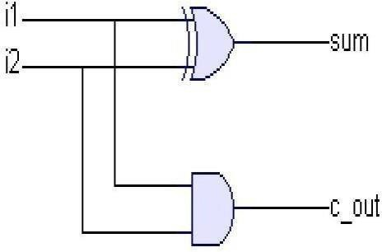
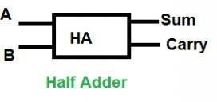
TRUTH TABLE:

Input 1(i1) | Input 2 (i2) | Sum | C_out
0 | 0 | 0 | 0
0 | 1 | 1 | 0
1 | 0 | 1 | 0
1 | 1 | 0 | 1

PROGRAM:
Half Adder:

module HalfAddr (sum, c_out, i1, i2); output sum, c_out;
input i1; input i2; xor (sum,i1,i2); and(c_out,i1,i2); endmodule
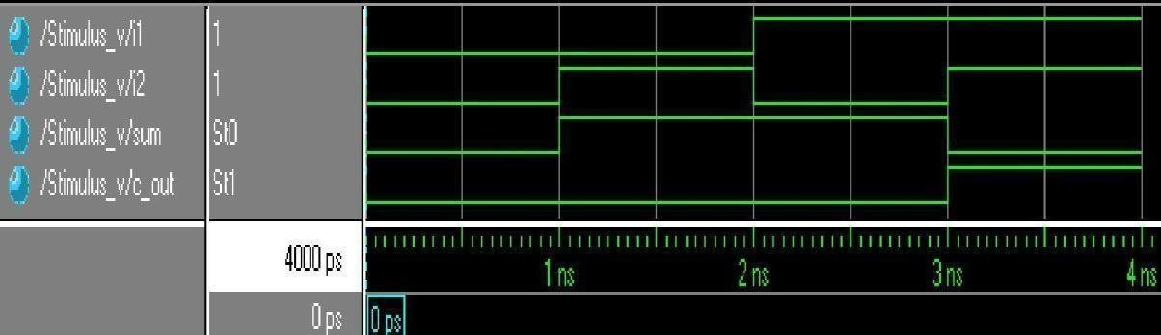
SIMULATED WAVEFORM:

FULL ADDER
LOGIC DIAGRAM
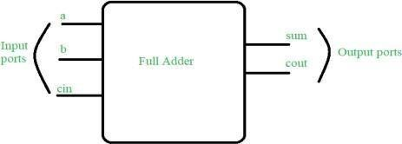
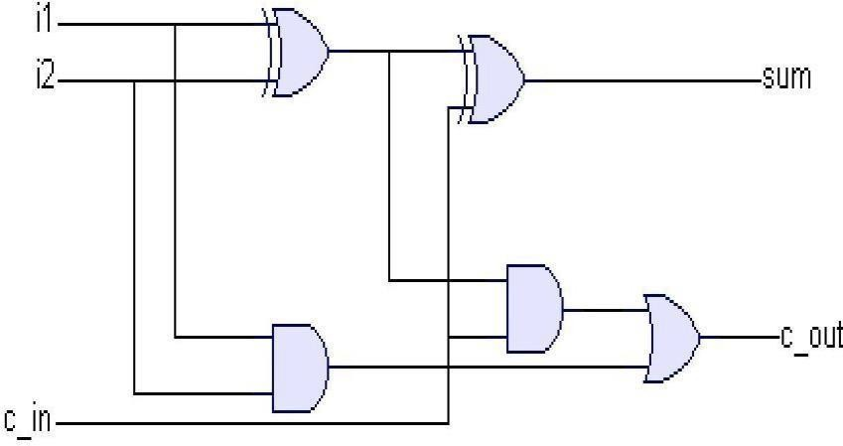

TRUTH TABLE

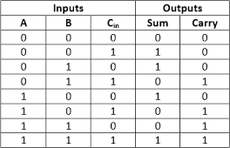

PROGRAM:

Full Adder:

module FullAddr (i1, i2, c_in, c_out, sum); input i1,i2,c_in;
output c_out, sum; wire s1,c1,c2;
xor n1 (s1,i1,i2);and n2(c1,i1,i2);
xor n3(sum,s1,c_in); and n4(c2,s1,c_in); or n5(c_out,c1,c2); endmodule
SIMULATED WAVEFORM:
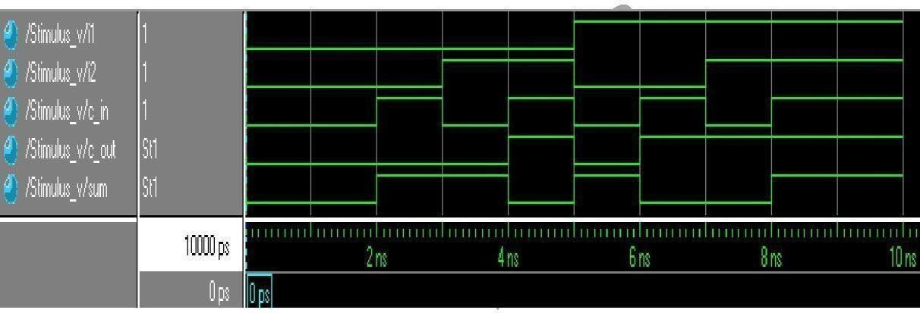

HALF SUBTRACTOR:
LOGIC DIAGRAM:
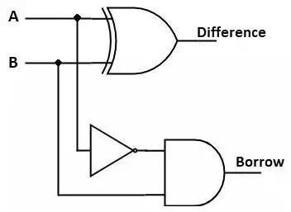
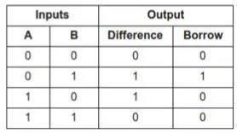
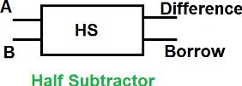
TRUTH TABLE:

Half Subtractor:
module halfsubtractor(diff, borrow, a, b); input a;
input b; output diff;
output borrow; wire d;
xor x1(diff,a,b);
not n1(d,a);
and a1(borrow,b,d); endmodule

SIMULATED WAVEFORM:
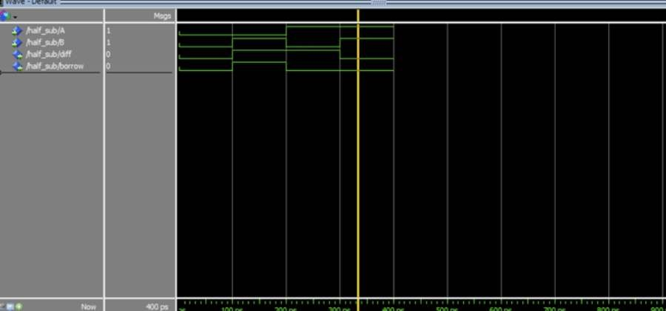

FULL SUBTRACTOR:

LOGIC DIAGRAM:

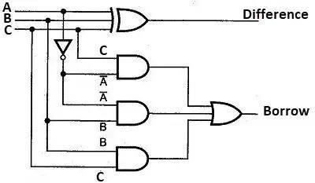
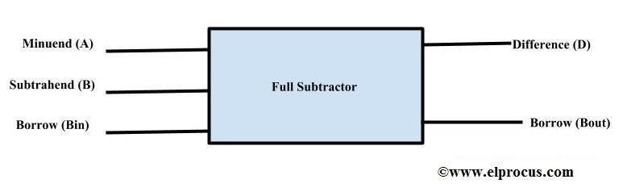

TRUTH TABLE:
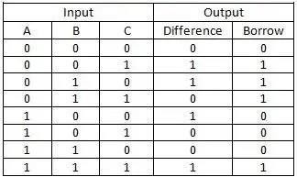

Full Subtractor:
module fullsubtractor(diff, borrow, a, b, c); input a;
input b; input c; output diff; output borrow; wire g,h,d,e,f;
xor x1(diff,a,b,c);
and a1(d,g,b);
and a2(e,b,c);
and a3(f,h,c);
not n1(g,a);
not n2(h,a);
or r1(borrow,d,e,f); endmodule

SIMULATED WAVEFORM:

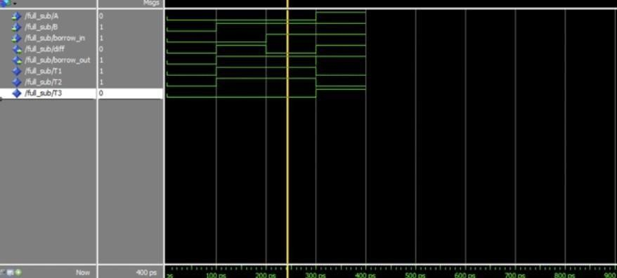

D FLIPFLOP

LOGIC DIAGRAM:
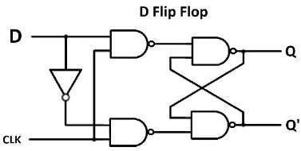
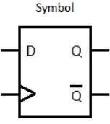

TRUTH TABLE
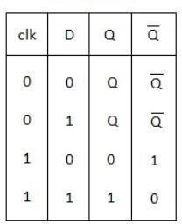
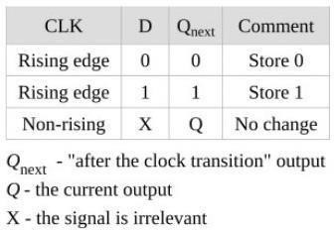

D FLIP-FLOP

module dff (Q,D,clk,rst);
input D,clk,rst;
output reg Q;
always @(posedge clk or posedge rst) begin
if (rst)
Q=1'b0;
else Q=D;
end endmodule

SIMULATED WAVEFORM:
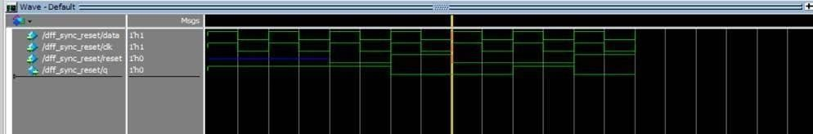

T FLIPFLOP

LOGIC DIAGRAM:

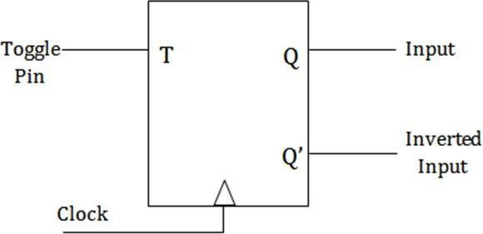
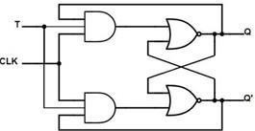

TRUTH TABLE

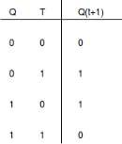
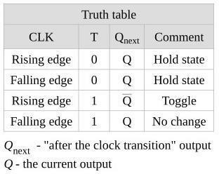

T FLIP-FLOP
module dff(Q, T,clk,rst); input T,clk,rst;
output reg Q;
always @(posedge clk or posedge rst) begin
if (rst) Q=1'b0;
else begin
if(T)
Q=~Q;
else
Q=Q;
end end
endmodule

SIMULATED WAVEFORM:
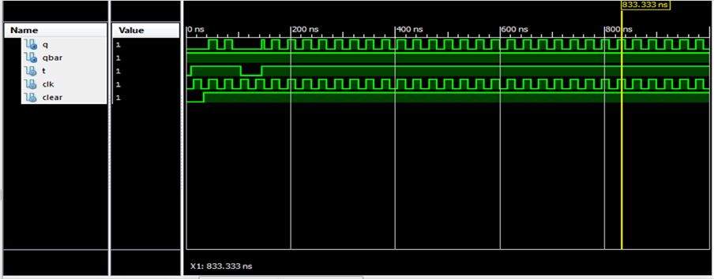

SR FLIPFLOP

LOGIC DIAGRAM:
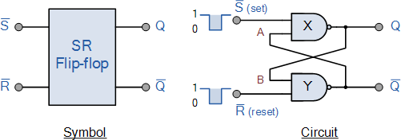

TRUTH TABLE

State | S | R | Q | Q’ | Description
Set | 1 | 0 | 0 | 1 | SetQ»1
Set | 1 | 1 | 0 | 1 | No change
Reset | 0 | 1 | 1 | 0 | Reset Q»0
Reset | 1 | 1 | 1 | 0 | No change
Invalid | 0 | 0 | 1 | 1 | Invalid Condition

SR FLIP-FLOP
Module srff_behave (s, r, clk, q, qbar); inputs, r, clk;
Output reg q, qbar; always@(posedge clk) begin
if (s == 1) begin
q = 1;
qbar = 0; end
else if (r == 1) begin
q = 0;
qbar =1;

end
else if(s == 0 & r == 0) begin
q <= q; qbar<= qbar end
end endmodule
SIMULATED WAVEFORM:
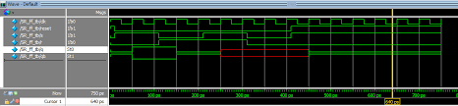

RESULT:
Thus, the simulation of basic combinational and sequential circuits using Verilog HDL was performed and output was verified using XILINX FPGA
Exp. No.: 2a | DESIGN AN ADDER (MIN 8 BIT) USING HDL. SIMULATE IT USING XILINX/ALTERA SOFTWARE AND IMPLEMENT BY XILINX/ALTERA FPGA

AIM
To design an adder (min 8 bit) using HDL. Simulate it using Xilinx/Altera software and implement by Xilinx/Altera FPGA

APPARATUS REQUIRED:
- PC with Windows XP.
- XILINX 9.2i
- FPGA-SPARTAN-3 KIT
- PARALLEL TO JTAG CABLE

PROCEDURE:

- Start the Xilinx ISE by using Start>Program files> Xilinx ISE>project navigator
- Click File>New Project
- Enter the Project Name and select the location then click next
- Select the Device and other category and click next twice and finish.
- Click on the symbol of FPGAdevice and then right click>click on new source.
- Select the Verilog Module and give the filename>click next and define ports>click next and finish.
- Type the Verilog Code in Verilog Editor.
- Run the Check syntax>Process window >synthesize>double click check syntax. If any errors found,
- then remove the errors with proper syntax &coding.
- Click on the symbol of FPGA device and then right click>click on new source.
- Select the Test Bench Waveform and give the filename>select entity click next and finish.
- Select the desired parameters for simulating your design. In this case combinational circuit and simulation time click finish.
- Assign all input signal using just click on graph and save file.
- From the source process window. Click Behavioral simulation from drop-down menu
- Select the test bench file (. tbw) and click process button>double click the Simulation Behavioral
Model
- Verify your design in wave window by seeing behavior of output signal with respect to input signal.
- To assign package pins using corresponding CPLD manual via using constraint.
- Assign package pins.
- The pace file opened and give the pin details.
- Go Implement design and generate the programming file and configure the device (impact).
- In configure device choose JTAG options and add the Xilinx device in boundary scan and download the program and execute successfully.

PROGRAM:
module ad(a,b,sum); input [7:0]a,b; output [7:0]sum; assign sum=a+b; endmodule
Truth Table:

A B RES

-- - - - - - -

1111111 0000000 1111111

RTL SCHEMATIC:

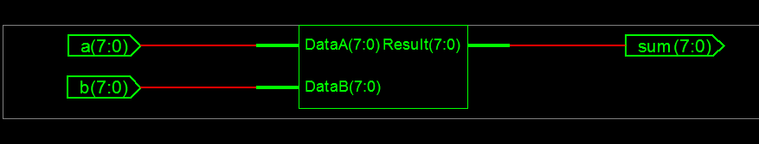

TECHNOLOGIC SCHEMATIC
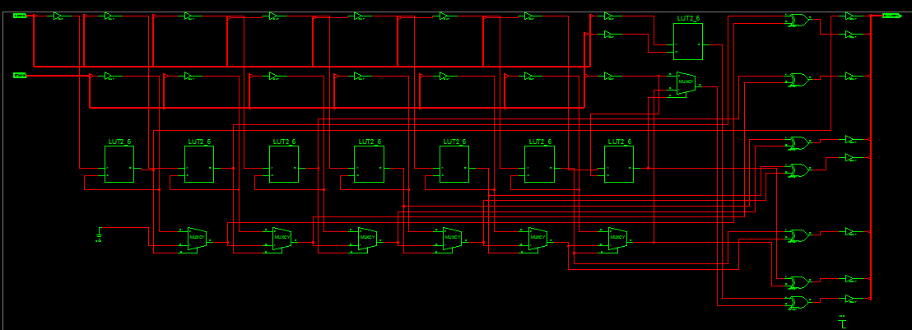

OUTPUT WAVEFORM:
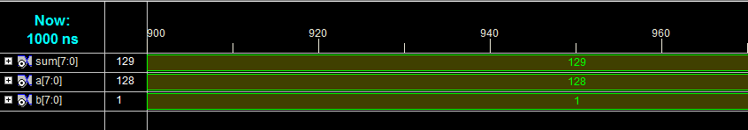

RIPPLE CARRY ADDER:
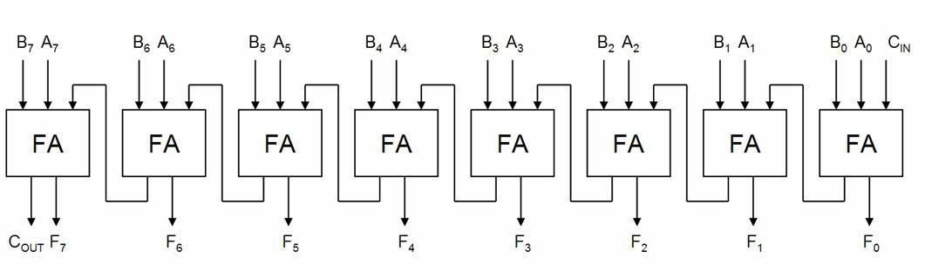
PROGRAM:
Main program:
module sw(a, b, c, sum, carry); input [7:0]a;
input [7:0]b; input c;
output [7:0]sum; output carry; wire [6:0]c;
gk fa0(a[0],b[0],c,sum[0],c1);
gk fa1(a[1],b[1],c1,sum[1],c2);
gk fa2(a[2],b[2],c2,sum[2],c3);
gk fa3(a[3],b[3],c3,sum[3],c4);
gk fa4(a[4],b[4],c4,sum[4],c5);
gk fa5(a[5],b[5],c5,sum[5],c6);
gk fa6(a[6],b[6],c6,sum[6],c7);
gk fa7(a[7],b[7],c7,sum[7],carry); endmodule

Sub-Program

module fulladd (sum, carry, a, b, c); input a, b, c;
output sum, carry; wire w1, w2, w3; xor (sum,a,b,c);
and (w1,a,b);
and(w2,b,c,);
and(w3,c,a);
or(carry,w1,w2,w3); endmodule

RTL SCHEMATIC:
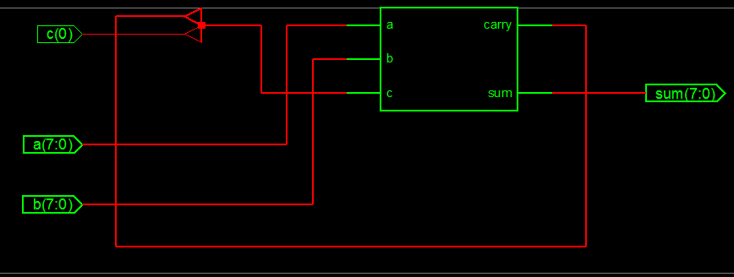

TECHNOLOGICAL SCHEMATIC:
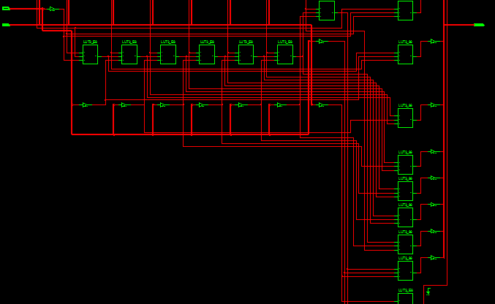

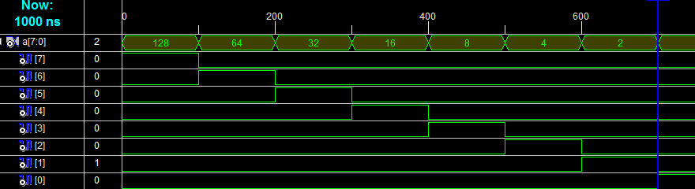
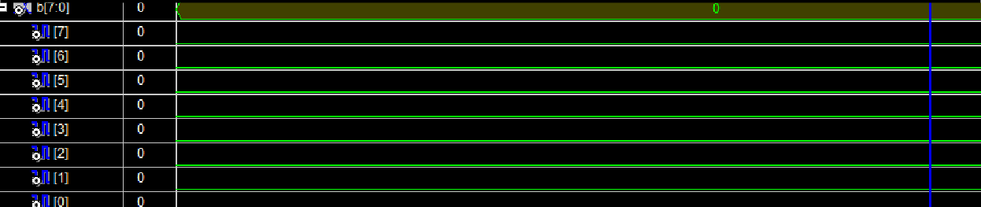
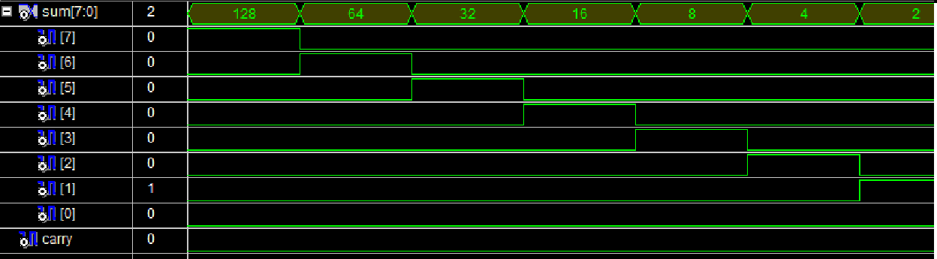
OUTPUT WAVEFORM:

RESULT:

Thus an adder (min 8 bit) using HDL was simulated using Xilinx/Altera software and implement
by Xilinx/Altera FPGA

Exp. No.: 2b | DESIGN AN MULTIPLIER (MIN 8 BIT) USING HDL. SIMULATE IT USING XILINX/ALTERA SOFTWARE AND IMPLEMENT BY XILINX/ALTERA FPGA

AIM
To design a multiplier (min 8 bit) using HDL. Simulate it using Xilinx/Altera software and implement by Xilinx/Altera FPGA

APPARATUS REQUIRED:

PC with Windows, Xilinx ISE, Spartan 3E FPGA Board

PROCEDURE:

- Start the Xilinx ISE by using Start>Program files> Xilinx ISE>project navigator
- Click File>New Project
- Enter the Project Name and select the location then click next
- Select the Device and other category and click next twice and finish.
- Click on the symbol of FPGAdevice and then right click>click on new source.
- Select the Verilog Module and give the filename>click next and define ports>click next and finish.
- Type the Verilog Code in Verilog Editor.
- Run the Check syntax>Process window >synthesize>double click check syntax. If any errors found, then remove the errors with proper syntax &coding.
- Click on the symbol of FPGA device and then right click>click on new source.
- Select the Test Bench Waveform and give the filename>select entity click next and finish.
- Select the desired parameters for simulating your design. In this case combinational circuit and simulation time click finish.
- Assign all input signal using just click on graph and save file.
- From the source process window. Click Behavioral simulation from drop-down menu
- Select the test bench file (. tbw) and click process button>double click the Simulation Behavioral Model
- Verify your design in wave window by seeing behavior of output signal with respect to input signal.
- To assign package pins using corresponding CPLD manual via using constraint.
- Assign package pins.
- The pace file opened and give the pin details.
- Go Implement design and generate the programming file and configure the device (impact).
- In configure device choose JTAG options and add the Xilinx device in boundary scan and download the program and execute successfully.

PROGRAM LOGIC:
8-bit multiplier: A binary multiplier is a combinational logic circuit or digital device used for multiplying two binary numbers. The two numbers are more specifically known as multiplicand and multiplier and the result is known as a product. The multiplicand & multiplier can be of various bit size. 16-bit multiplication is the multiplication of two 16-bit value from another. … For example, multiplying an 8-bit value by a 16-bit value results in a 24-bit value (8 + 16). A 16-bit value multiplied by another 16-bit value results in a 32-bit value (16 + 16), etc.
An array multiplier is a digital combinational circuit used for multiplying two binary numbers by employing an array of half adders and full adders. This is a fast way of multiplying two numbers. The Array architecture is a popular technique to implement the multipliers due to its compact structure

BLOCK DIAGRAM::

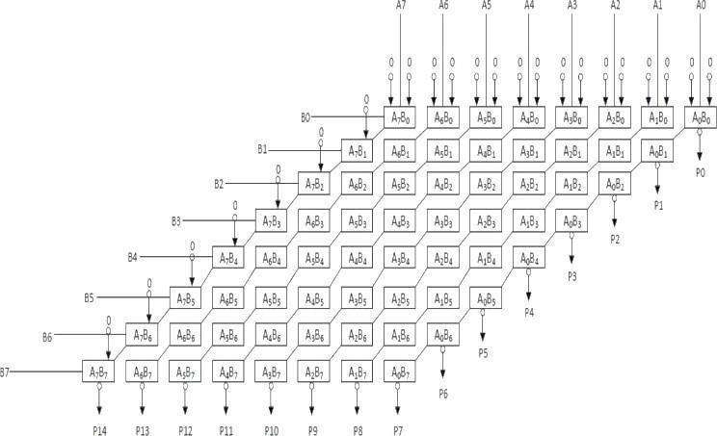

PROGRAM:

8 BIT MULTIPLIER
module multiplier(p, x, y);input [3:0] x;
input [3:0] y;
output [7:0] p; wire zero=1'b0;
wire
a11,a12,a13,a14,a21,a22,a23,a24,a31,a32,a33,a34,a41,a42,a43,a44;
wire c11,c12,c13,c14,c21,c22,c23,c24,c31,c32,c33,c34,c41,c42,c43,c44;
wire
s12,s13,s14,s22,s23,s24,s32,s33,s34;
and g11(a11,y[0],x[0]);
and g12(a12,y[0],x[1]);
and g13(a13,y[0],x[2]);
and g14(a14,y[0],x[3]);
and g21(a21,y[1],x[0]);
and g22(a22,y[1],x[1]);
and g23(a23,y[1],x[2]);
and g24(a24,y[1],x[3]);
and g31(a31,y[2],x[0]);
and g32(a32,y[2],x[1]);
and g33(a33,y[2],x[2]);
and g34(a34,y[2],x[3]);
and g41(a41,y[3],x[0]);
and g42(a42,y[3],x[1]);
and g43(a43,y[3],x[2]);
and g44(a44,y[3],x[3]);
full_adder1 fa11(p[0],c11,a11,zero,zero); full_adder1 fa12(s12,c12,a12,zero,c11); full_adder1 fa13(s13,c13,a13,zero,c12); full_adder1 fa14(s14,c14,a14,zero,c13); full_adder1 fa21(p[1],c21,a21,zero,s12); full_adder1 fa22(s22,c22,a22,s13,c21); full_adder1 fa23(s23,c23,a23,s14,c22); full_adder1 fa24(s24,c24,a24,c14,c23); full_adder1 fa31(p[2],c31,a31,s22,zero); full_adder1 fa32(s32,c32,a32,c31,s23); full_adder1 fa33(s33,c33,a33,c32,s24); full_adder1 fa34(s34,c34,a34,c33,c24); full_adder1 fa41(p[3],c41,a41,zero,s32); full_adder1 fa42(p[4],c42,a42,s33,c41);
full_adder1 fa43(p[5],c43,a43,c42,s34); full_adder1 fa44(p[6],p[7],a44,c34,c43); end module

DATA FLOW MODELING
module multiplier (p, a, b); input [3:0] a;
input [3:0] b;
output [7:0] p;
assign p=a*b;
end module

SIMULATED WAVEFORM:

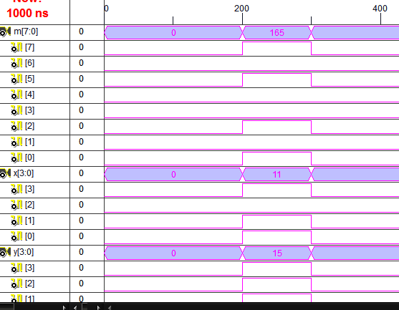

RESULT:
Thus a multiplier (min 8 bit) using HDL was simulated using Xilinx/Altera software and implement by Xilinx/Altera FPGA.

Exp. No.: 3 | DESIGN AND IMPLEMENT UNIVERSAL SHIFT REGISTER USING HDL. SIMULATE IT USING XILINX/ALTERA SOFTWARE

AIM:

To implement Universal Shift Register using Verilog HDL.

APPARATUS REQUIRED:
- PC with Windows XP.
- XILINX 9.2i
- FPGA-SPARTAN-3 KIT
- PARALLEL TO JTAG CABLE

PROCEDURE:

- Start the Xilinx ISE by using Start>Program files> Xilinx ISE>project navigator
- Click File>New Project
- Enter the Project Name and select the location then click next
- Select the Device and other category and click next twice and finish.
- Click on the symbol of FPGAdevice and then right click>click on new source.
- Select the Verilog Module and give the filename>click next and define ports>click next and finish.
- Type the Verilog Code in Verilog Editor.
- Run the Check syntax>Process window >synthesize>double click check syntax. If any errors found, then remove the errors with proper syntax &coding.
- Click on the symbol of FPGA device and then right click>click on new source.
- Select the Test Bench Waveform and give the filename>select entity click next and finish.
- Select the desired parameters for simulating your design. In this case combinational circuit and simulation time click finish.
- Assign all input signal using just click on graph and save file.
- From the source process window. Click Behavioral simulation from drop-down menu
- Select the test bench file (. tbw) and click process button>double click the Simulation Behavioral Model
- Verify your design in wave window by seeing behavior of output signal with respect to input signal.
- To assign package pins using corresponding CPLD manual via using constraint.
- Assign package pins.
- The pace file opened and give the pin details.
- Go Implement design and generate the programming file and configure the device (impact).

- In configure device choose JTAG options and add the Xilinx device in boundary scan and download the program and execute successfully.

THEORY:
Universal Shift Register
A Universal Shift Register is a register which can shift its data in both direction i.e. left and right directions. In other Words, a universal shift register is a bidirectional shift register. A universal shift register is combination of design of bidirectional shift register and a unidirectional shift register with the parallel load provisions. A universal shift register can perform parallel to serial operation (first loading parallel input and then shifting. A universal shift register can also perform serial to parallel operation (first shifting and then retrieving parallel output. The desired operation is then specified by a 2-bit control signal

Register Operation Control Signals
S0 | S1 | Register Operation
0 | 0 | No changes
0 | 1 | Shift Right
1 | 0 | Shift Left
1 | 1 | Parallel Load

Verilog Code for Universal Shift Register ( 4-bit)
‘timescale 1ns / 1ps
module universal_shift_register (clr,clk,sel,parin,out); input clr,clk;
input [1:0]sel; input [3:0]parin; output reg[3:0]out;
always @(posedge clk) begin
if(clr) out=4'b0000; else
begin case(sel)
2'b00: out=out;
2'b01: out={parin[0],parin[3:1]};
2'b10: out={parin[2:0],parin[3]}; 2'b11: out=parin;
endcase end
end endmodule

Test Bench
The test bench check that each combination of input lines that connects the appropriate input to the output. The test bench code in Verilog for 8 Bit Universal Shift Register is given below :
timescale 1ns / 1ps module unsrtb;
reg [3:0]parin;

reg clr;
reg clk;
reg [0:1]sel;
wire [3:0]out;
universal_shift_register uut(.parin(parin),.clr(clr),.clk(clk),.sel(sel),.out(out)); initial begin
clk=0; repeat(100) #20 clk=~clk; end
initial begin parin=4'b1011; sel=2'b01; clr=1'b0;
#40;
parin=4'b1011; sel=2'b10; clr=1'b0;
#40;
parin=4'b1011; sel=2'b11; clr=1'b0;
#40;
end endmodule

RTL SCHEMATIC OUTPUT
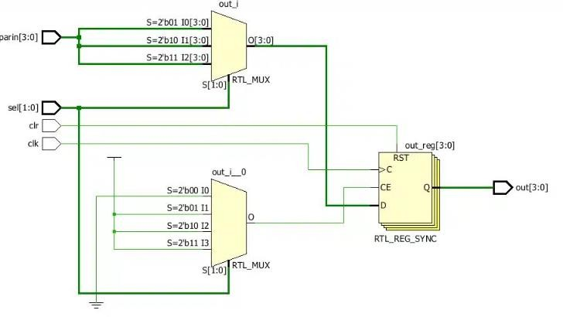

OUTPUT:

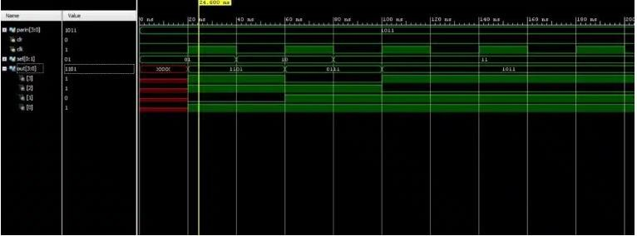

RESULT:
Thus Universal Shift Register using HDL was simulated using Xilinx/Altera software.

Exp. No.: 4 | DESIGN MEMORIES USING HDL. SIMULATE IT USING XILINX/ALTERA SOFTWARE AND IMPLEMENT BY XILINX/ALTERA FPGA

AIM:
To design Memories using HDL. Simulate it using Xilinx/Altera software and implement by Xilinx/Altera FPGA

APPARATUS REQUIRED:
- PC with Windows XP.
- XILINX 9.2i
- FPGA-SPARTAN-3 KIT
- PARALLEL TO JTAG CABLE

PROCEDURE:
- Start the Xilinx ISE by using Start>Program files> Xilinx ISE>project navigator
- Click File>New Project
- Enter the Project Name and select the location then click next
- Select the Device and other category and click next twice and finish.
- Click on the symbol of FPGAdevice and then right click>click on new source.
- Select the Verilog Module and give the filename>click next and define ports>click next and finish.
- Type the Verilog Code in Verilog Editor.
- Run the Check syntax>Process window >synthesize>double click check syntax. If any errors found,
- then remove the errors with proper syntax &coding.
- Click on the symbol of FPGA device and then right click>click on new source.
- Select the Test Bench Waveform and give the filename>select entity click next and finish.
- Select the desired parameters for simulating your design. In this case combinational circuit and simulation time click finish.
- Assign all input signal using just click on graph and save file.
- From the source process window. Click Behavioral simulation from drop-down menu
- Select the test bench file (. tbw) and click process button>double click the Simulation Behavioral
- Model
- Verify your design in wave window by seeing behavior of output signal with respect to input signal.
- To assign package pins using corresponding CPLD manual via using constraint.
- Assign package pins.
- The pace file opened and give the pin details.
- Go Implement design and generate the programming file and configure the device (impact).
- In configure device choose JTAG options and add the Xilinx device in boundary scan and download
- the program and execute successfully.

MEMORY MODULE
A memory module is another name for a RAM chip. It is often used as a general term used to describe SIMM, DIMM, and SO-DIMM memory. While there are several different types of memory modules available, they all serve the same purpose, which is to store temporary data while the computer is running.

MEMORY READ AND WRITE:
The following steps have to be followed in a typical read operation:
- Place the address of the location to be read on the address line.
- Activate the memory read control signal.
- Wait for the memory to retrieve the data from the address memory location.
- Read the data from the data line.
- Drop the memory read control signal to terminate the read operation. The following steps have to be follow in a typical write

PROGRAM:
module memory_16x4_bi(data, clk, out_en, address, rd_en, wr_en ); input [0:3] data;
input clk; input out_en;
input rd_en, wr_en; input [0:3] address;
reg [0:3] memory [0:15];
reg [0:3] data_out;
assign data = out_en ? data_out : 4'bZ; always@(posedge clk)
begin
if(rd_en)
data_out = memory[address]; else if (wr_en) memory[address] = data;
else data_out = 4'bx;
end endmodule

RAM CODING:
Module memo(input[7:0]data, input[5:0]addr, input rst,clk,output[7:0]q);
Reg[7:0]ram[63:0];
Reg[5:0]addr_reg; always@(posedge clk) begin
if(rst) ram[addr]<=data; addr_reg<=addr;
end assign=ram[addr];
endmodule

OUTPUT WAVEFORM:
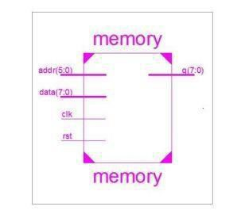

SIMULATED WAVEFORM:

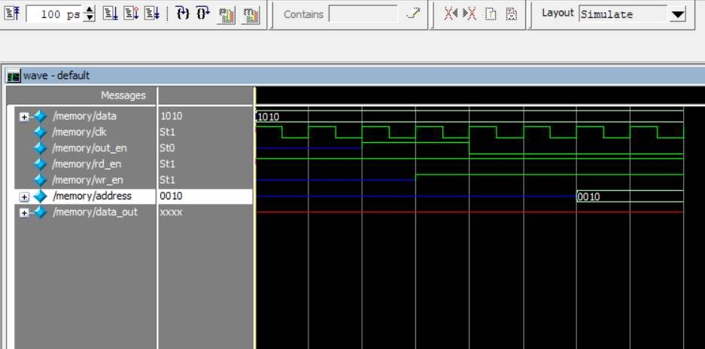

RESULT:
Thus Memory Modules using HDL was simulated using Xilinx/Altera software and implement by Xilinx/Altera FPGA

Exp. No.:5 | DESIGN FINITE STATE MACHINE (MOORE/MEALY) USING HDL. SIMULATE IT USING XILINX/ALTERA SOFTWARE AND IMPLEMENT BY XILINX/ALTERA FPGA

AIM:
To design Finite State Machine using HDL. Simulate it using Xilinx/Altera software and implement by Xilinx/Altera FPGA

APPARATUS REQUIRED:
- PC with Windows XP.
- XILINX 9.2i
- FPGA-SPARTAN-3 KIT
- PARALLEL TO JTAG CABLE

PROCEDURE:

- Start the Xilinx ISE by using Start>Program files> Xilinx ISE>project navigator
- Click File>New Project
- Enter the Project Name and select the location then click next
- Select the Device and other category and click next twice and finish.
- Click on the symbol of FPGAdevice and then right click>click on new source.
- Select the Verilog Module and give the filename>click next and define ports>click next and finish.
- Type the Verilog Code in Verilog Editor.
- Run the Check syntax>Process window >synthesize>double click check syntax. If any errors found, then remove the errors with proper syntax &coding.
- Click on the symbol of FPGA device and then right click>click on new source.
- Select the Test Bench Waveform and give the filename>select entity click next and finish.
- Select the desired parameters for simulating your design. In this case combinational circuit and simulation time click finish.
- Assign all input signal using just click on graph and save file.
- From the source process window. Click Behavioral simulation from drop-down menu
- Select the test bench file (. tbw) and click process button>double click the Simulation Behavioral Model
- Verify your design in wave window by seeing behavior of output signal with respect to input signal.
- To assign package pins using corresponding CPLD manual via using constraint.
- Assign package pins.

- The pace file opened and give the pin details.
- Go Implement design and generate the programming file and configure the device (impact).
- In configure device choose JTAG options and add the Xilinx device in boundary scan and download the program and execute successfully.
PROGRAM LOGIC

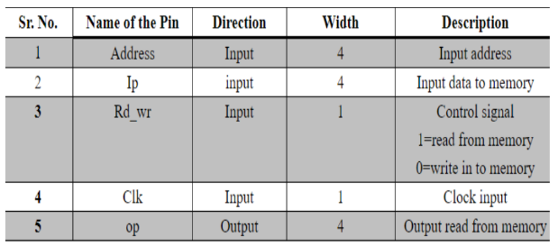

STATE DIAGRAM:
MOORE STATE MACHINE STATE DIAGRAM
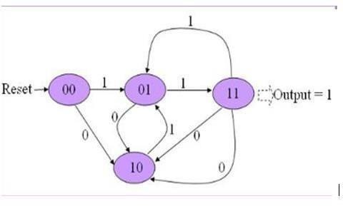

MEALY STATE MACHINE STATE DIAGRAM

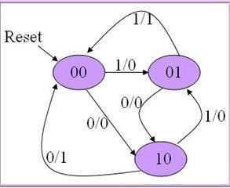

PROGRAM

MOORE MACHINE:
module fsm_moore (clk, rst, inp, outp);
input clk, rst, inp;
output outp; reg [1:0] state; reg outp;

always @( posedge clk, posedge rst ) begin
if( rst )
state <= 2'b00; else
begin
case( state ) 2'b00:

begin
if( inp ) state <= 2'b01; else state <= 2'b10; end
2'b01:
begin
if( inp ) state <= 2'b11; else state <= 2'b10; end
2'b10:
begin
if( inp ) state <= 2'b01;
else state <= 2'b11; end
2'b11:
begin
if( inp ) state <= 2'b01; else state <= 2'b10; end
endcase end
end
always @(posedge clk, posedge rst) begin
if( rst ) outp <= 0;
else if( state == 2'b11 ) outp <=1;
else outp <= 0;
end
end module

PROGRAM

MEALY MACHINE:
module fsm_melay( clk, rst, inp, outp); input clk, rst, inp;
output outp; reg [1:0] state; reg outp;
always @( posedge clk, posedge rst ) begin if( rst ) begin
state <= 2'b00; outp <= 0;
end
else begin case( state ) 2'b00: begin
if( inp ) begin state <= 2'b01; outp <= 0;
end
else begin
state <= 2'b10; outp <= 0;
end end
2'b01: begin
if( inp ) begin state <= 2'b00; outp <= 1;

end
else begin
state <= 2'b10; outp <= 0;
end

end
2'b10: begin
if( inp ) begin state <= 2'b01;
outp <= 0; end
else begin
state <= 2'b00; outp <= 1;

end

end

default: begin state <= 2'b00; outp <= 0;
end end case end
end end module

SIMULATED WAVEFORM FOR MOORE MACHINE
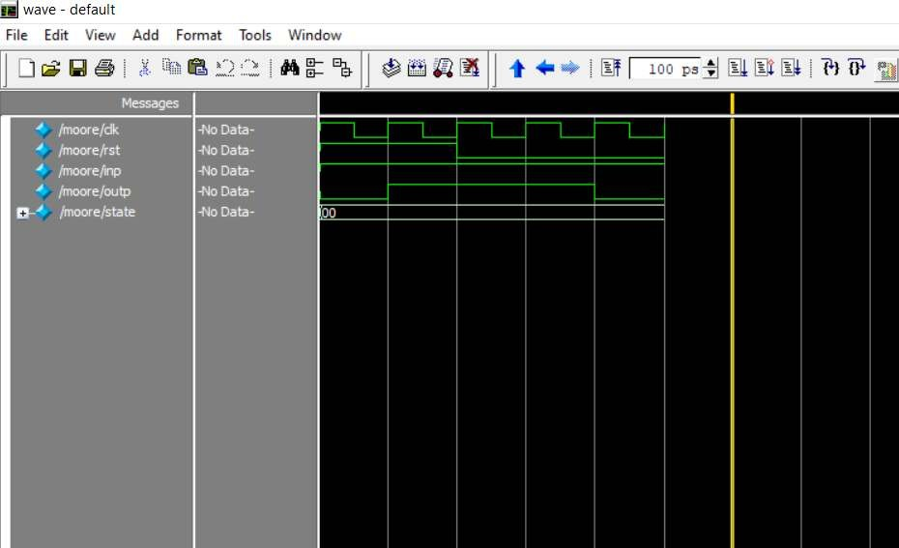

SIMULATED WAVEFORM FOR MEALY MACHINE

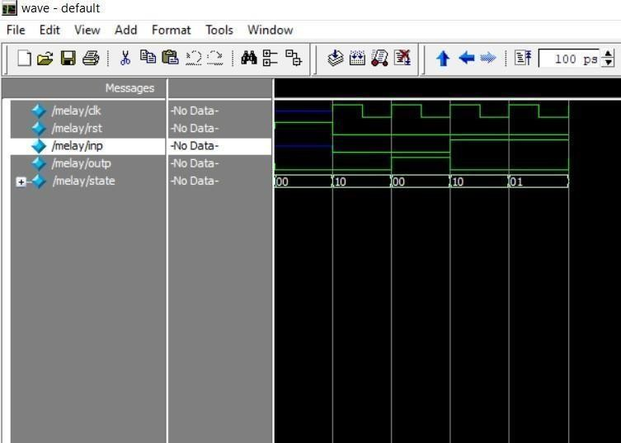

RESULT:
Thus Finite State Machine using HDL was simulated using Xilinx/Altera software and implement by Xilinx/Altera FPGA

Exp. No.:6 | DESIGN 3-BIT SYNCHRONOUS UP/DOWN COUNTER USING HDL. SIMULATE IT USING XILINX/ALTERA SOFTWARE AND IMPLEMENT BY XILINX/ALTERA FPGA

AIM:
To design the 3-bit synchronous up/down counter using HDL. Simulate it using Xilinx Software and implement by Xilinx FPGA.

APPARATUS REQUIRED:
- PC with Windows XP.
- XILINX 9.2i
- FPGA-SPARTAN-3 KIT
- PARALLEL TO JTAG CABLE

PROCEDURE:
- Start the Xilinx ISE by using Start>Program files> Xilinx ISE>project navigator
- Click File>New Project
- Enter the Project Name and select the location then click next
- Select the Device and other category and click next twice and finish.
- Click on the symbol of FPGAdevice and then right click>click on new source.
- Select the Verilog Module and give the filename>click next and define ports>click next and finish.
- Type the Verilog Code in Verilog Editor.
- Run the Check syntax>Process window >synthesize>double click check syntax. If any errors found, then remove the errors with proper syntax &coding.
- Click on the symbol of FPGA device and then right click>click on new source.
- Select the Test Bench Waveform and give the filename>select entity click next and finish.
- Select the desired parameters for simulating your design. In this case combinational circuit and simulation time click finish.
- Assign all input signal using just click on graph and save file.
- From the source process window. Click Behavioral simulation from drop-down menu
- Select the test bench file (. tbw) and click process button>double click the Simulation Behavioral Model
- Verify your design in wave window by seeing behavior of output signal with respect to input signal.
- To assign package pins using corresponding CPLD manual via using constraint.
- Assign package pins.
- The pace file opened and give the pin details.
- Go Implement design and generate the programming file and configure the device (impact).
- In configure device choose JTAG options and add the Xilinx device in boundary scan and download the program and execute successfully.

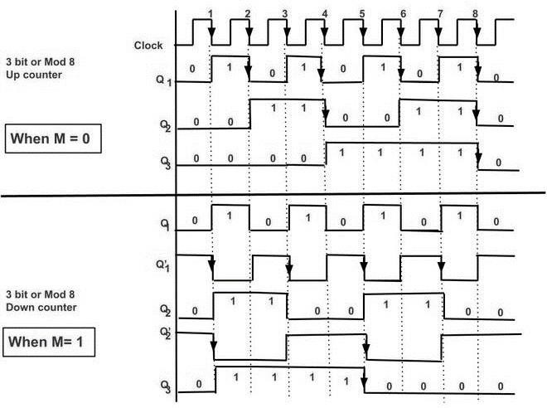
TIMING DIAGRAM:

A counter is a register capable of counting the number of clock pulses arriving at its clock input. Counter represents the number of clock pulses arrived. A specified sequence of states appears as counter output. This is the main difference between a register and a counter. There are two types of counter, synchronous and asynchronous. In synchronous common clock is given to all flip flop and in asynchronous first flip flop is clocked by external pulse and then each successive flip flop is clocked by Q or Q output of previous stage. Soon the clock of the second stage is triggered by the output of the first stage. Because of inherent propagation delay time all flip flops are not activated at same time which results in asynchronous operation. The 3-bit Synchronous binary up counter contains three T flip-flops & one 2-input AND gate. All these flip-flops are negative edge triggered and the outputs of flip-flops change affect synchronously. The T inputs of first, second and third flip-flops are 1, Q0 & Q1Q0 respectively.
The circuit excitation table represents the present states of the counting sequence and the next states after the clock pulse is applied and input T of the flip-flops. By seeing the transition between the present state and the next state, we can find the input values of 3 Flip Flops using the Flip Flops excitation table. The table is designed according to the required counting sequence.

PROGRAM:
module up or down _counter (Clk, reset, Up or Down, //high for UP counter and low for Down counter Count);
//input ports and their sizes input Clk, reset, Up or Down;
//output ports and their size output [3: 0] Count;
//Internal variables reg [3: 0] Count = 0;
always @(posedge(Clk) or posedge(reset)) begin
if (reset == 1)
Count <= 0;
else
if (UpOrDown == 1) //Up mode selected if(Count == 15)
Count <= 0; else
Count <= Count + 1; //Increment Counter else //Down mode selected
if(Count == 0)
Count <= 15; else

Count <= Count - 1; //Decrement counter
end endmodule

TESTBENCH CODE:
//Generate clock with 10 ns clk period. initial Clk = 0;
always #5 Clk = ~Clk;

initial begin
// Apply Inputs reset = 0;
Up or Down = 0;
#300;
Up or Down = 1;
#300;
reset = 1;
Up or Down = 0;
#100;
reset = 0; end
end module

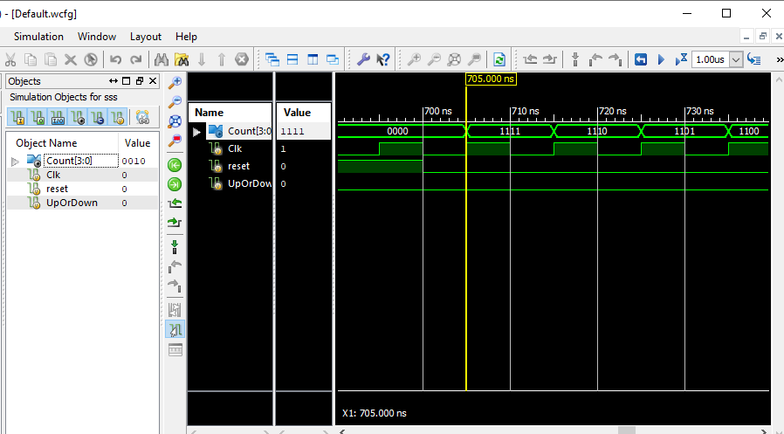
SIMULATED WAVEFORM:

RESULT:
Thus, the simulation of 3-bit synchronous up/down counter using Verilog HDL was performed and the output was verified using XILINX FPGA.

Exp. No.:7 | DESIGN 4-BIT ASYNCHRONOUS UP/DOWN COUNTER USING HDL. SIMULATE IT USING XILINX/ALTERA SOFTWARE AND IMPLEMENT BY XILINX/ALTERA FPGA

AIM:
To design the 4 bit asynchronous up/down counter using HDL. Simulate it using Xilinx Software and implement by Xilinx FPGA.

APPARATUS REQUIRED:
- PC with Windows XP.
- XILINX 9.2i
- FPGA-SPARTAN-3 KIT
- PARALLEL TO JTAG CABLE

PROCEDURE:

- Start the Xilinx ISE by using Start>Program files> Xilinx ISE>project navigator
- Click File>New Project
- Enter the Project Name and select the location then click next
- Select the Device and other category and click next twice and finish.
- Click on the symbol of FPGAdevice and then right click>click on new source.
- Select the Verilog Module and give the filename>click next and define ports>click next and finish.
- Type the Verilog Code in Verilog Editor.
- Run the Check syntax>Process window >synthesize>double click check syntax. If any errors found, then remove the errors with proper syntax &coding.
- Click on the symbol of FPGA device and then right click>click on new source.
- Select the Test Bench Waveform and give the filename>select entity click next and finish.
- Select the desired parameters for simulating your design. In this case combinational circuit and simulation time click finish.
- Assign all input signal using just click on graph and save file.
- From the source process window. Click Behavioral simulation from drop-down menu
- Select the test bench file (. tbw) and click process button>double click the Simulation Behavioral Model
- Verify your design in wave window by seeing behavior of output signal with respect to input signal.
- To assign package pins using corresponding CPLD manual via using constraint.
- Assign package pins.
- The pace file opened and give the pin details.
- Go Implement design and generate the programming file and configure the device (impact).
- In configure device choose JTAG options and add the Xilinx device in boundary scan and download
the program and execute successfully.

CIRCUIT DIAGRAM:
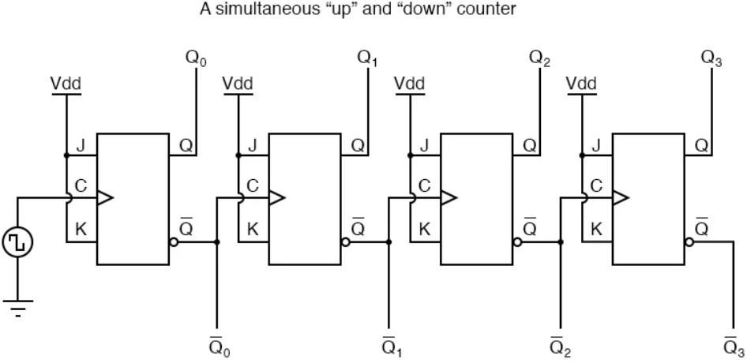

TIMING DIAGRAM:

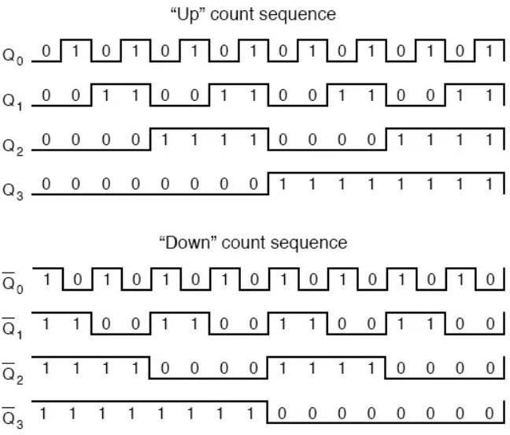

PROGRAM LOGIC:
In asynchronous/ripple counter output of the first flip-flop is provided as the clock to the second flip-flop i.e flip-flop (FF) are not clocked simultaneously. When -ve edge clock pulseis applied and input is given to FF logic 1 then the output state of FF will toggle for every falling edge. The output frequency will be f/2 (If f is clock frequency). It is known as binary or mod -2 counter or bit ripple counter. It has 2 unique output states (0 and 1). When two FFs are connected in series and output of one FF is act as clock for 2nd FF. So, the state of 2ndFF will change only when output and 1st FF is logic 1 and falling edge occur. The output frequency of Q1 is f/4(if f is clock frequency).
It can generate 4 different unique states. This is known as divide by 4 circuits or mod 4 ripple counter. Here output is taken as Q1(MSB) Q0(LSB).
By this, we can conclude that –If there are n FFs then the output frequency will be divided by 2^{n}. Also generate 2n unique states. So, the frequency division basically forms counting state. Here we are seeing that the output of the 1st FF act as clock for 2nd FF. Suppose the FF takes 30ns for generating output (i.e., propagation delay because of gates). Therefore, the output of second FF will be obtained after 60 ns. So, the propagation delay is ripples through the FFs and becomes more when the number of FFs increases.
Therefore, asynchronous counter is too slow for generating big counting.

PROGRAM:
module asynchronous counter mod(clk, clear, q); input clk;
input clear; output [3:0] q;
reg [3:0] q;
always @(negedge clk or posedge clear) q[0]<=~q[0];
always @(negedge q[0] or posedge clear) q[1]<=~q[1];
always @(negedge q[1] or posedge clear) q[2]<=~q[2];
always @(negedge q[2] or posedge clear)
begin if(clear)
q <=4'b0000;
else
q[3]<=~q[3];
end endmodule
TESTBENCH CODE
module asynchronouscountert_b; reg clk;
reg clear; wire [3:0] q;
asynchronous counter mod uut (.clk(clk),.clear(clear),.q(q) ); initial begin
clk = 0;
clear = 0;
#5 clear=1'b1;
#5 clear=1'b0; end
always #5 clk=~clk; endmodule

SIMULATED WAVEFORM:
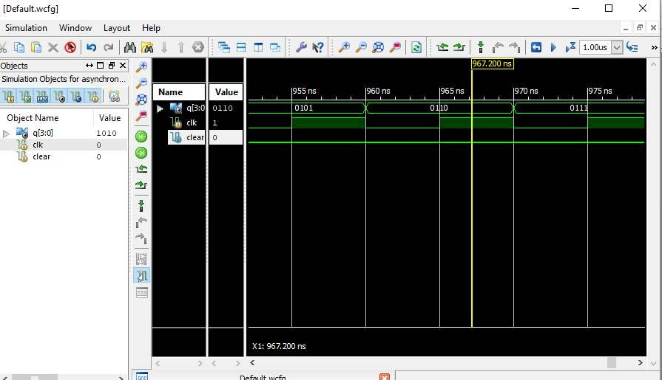

RESULT:
Thus, the simulation of 4-bit asynchronous up/down counter using Verilog HDL was performed and the output was verified using XILINX FPGA

Exp. No.:8 | DESIGN AND SIMULATE A CMOS BASIC GATES & FLIP-FLOPS. GENERATE MANUAL/AUTOMATIC LAYOUT.

AIM:
To design and simulate the CMOS basic gates and flip-flops using DSCH and microwind.

TOOLS REQUIRED:
- Microwind DSCH
- Microwind 2.0

PROCEDURE:
  - Open DSCH 2 and create a new file
  - Using symbol library drag and drop the circuit elements on the workspace
  - Make the circuit connections using “add a line”
  - Use button as input for enable and light as output
  - Save and simulate the design, simulation control can be adjusted for operating speed
  - View the timing diagram for functional verification
  - From the file menu use “make Verilog file” for the schematic and save the file, this is used to generate the layout
  - Observe the DC, transient responses
  - Open Micro wind 2.0 and create a new file.
  - From menu-compile-compile Verilog file and select the Verilog file created for the design
-Generate and back to editor, the layout will be created automatically

CMOS NAND GATE
SCHEMATIC
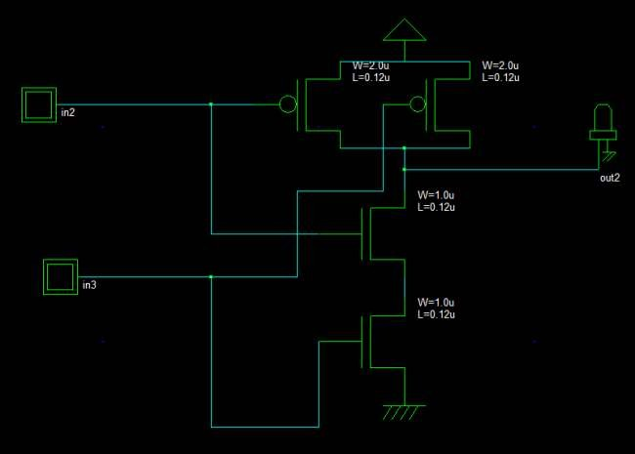

LAYOUT GENERATION

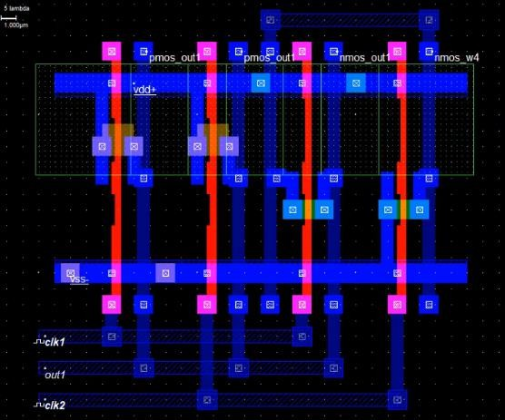

OUTPUT WAVEFORM
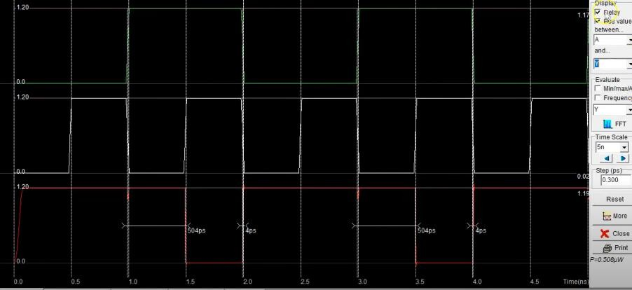

CMOS NOR GATE SCHEMATIC
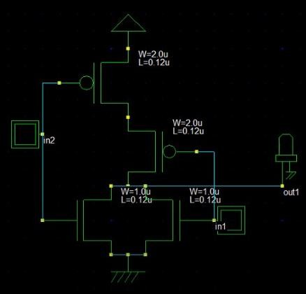

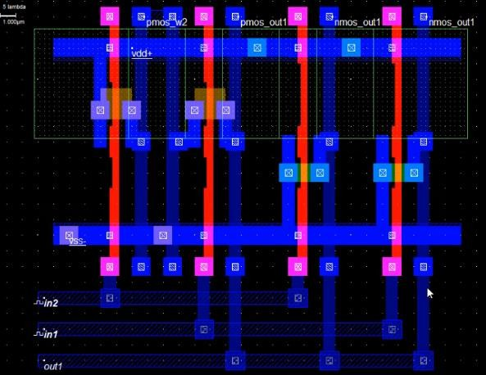
LAYOUT GENERATION

OUTPUT WAVEFORM
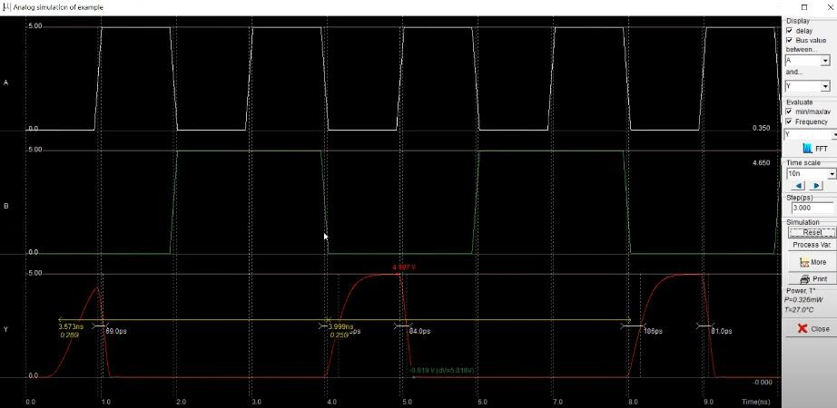

D FLIPFLOP SCHEMATIC

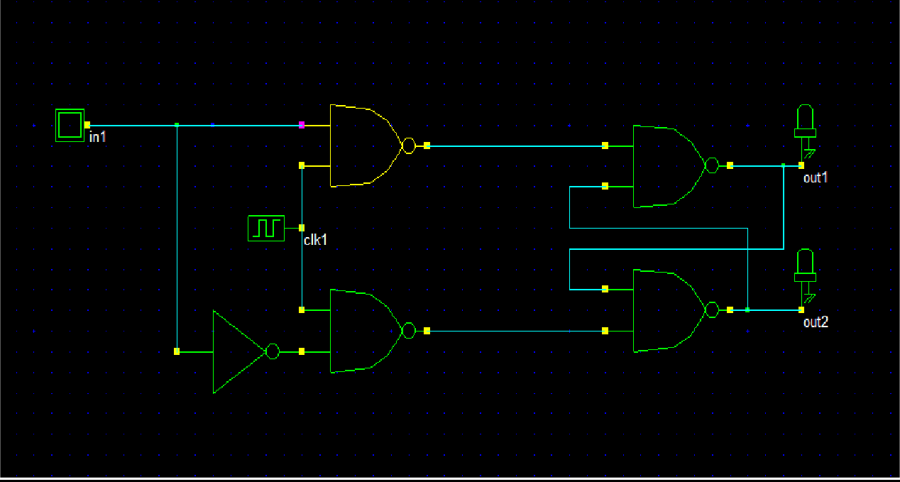

LAYOUT GENERATION
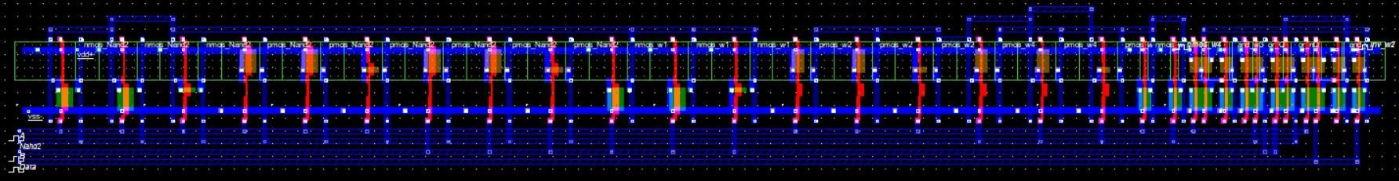

OUTPUT WAVEFORM
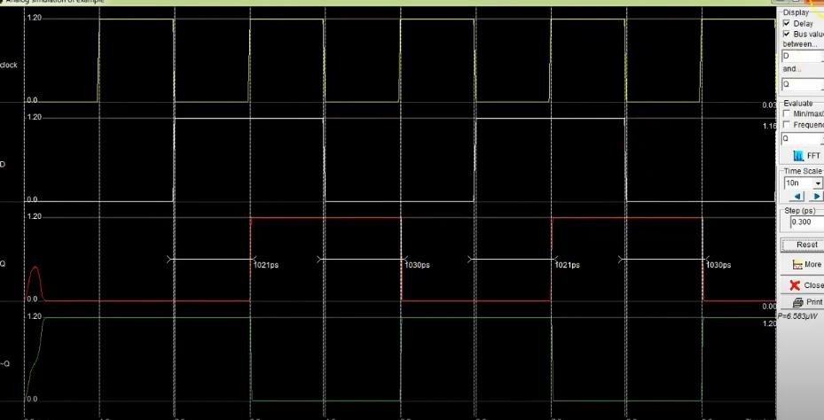

SR FLIPFLOP

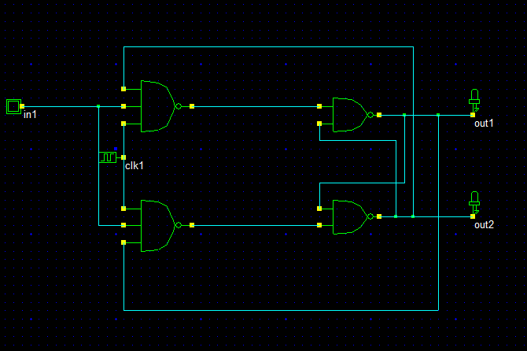
SCHEMATIC

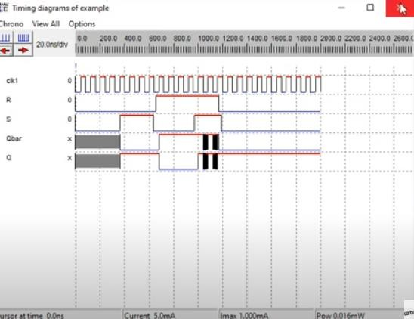
TIMING DIAGRAM

T FLIPFLOP
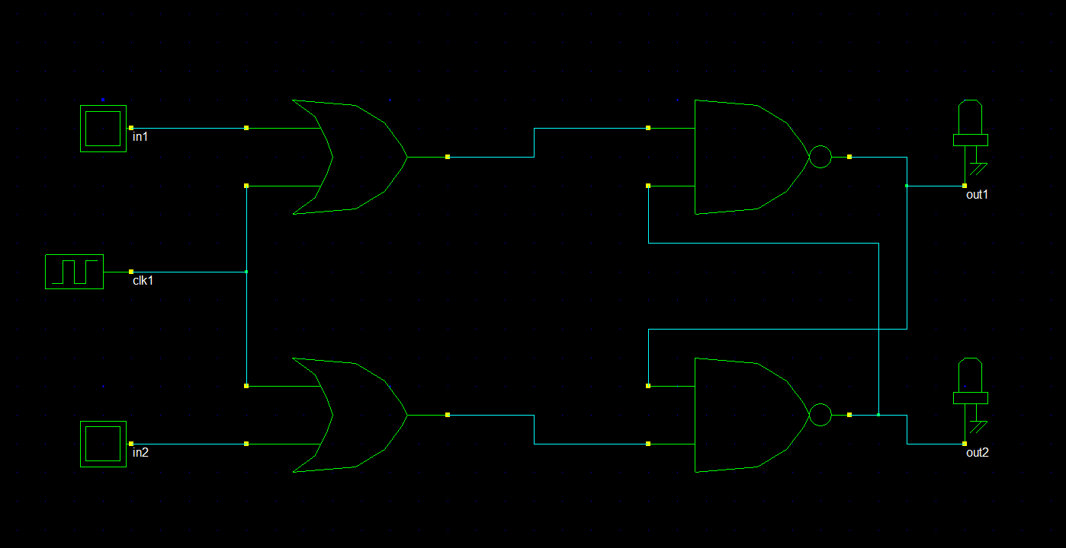

LAYOUT GENERATION
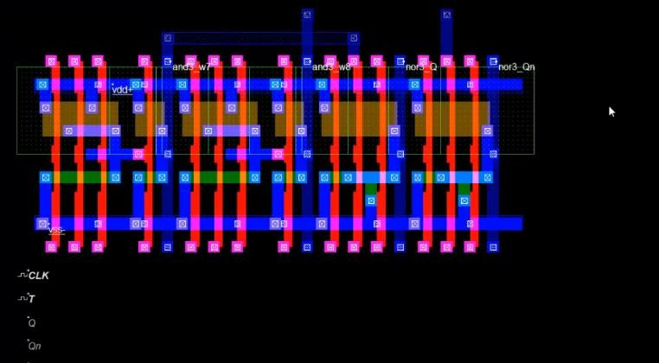

RESULT:
Thus, the CMOS basic gates and flip-flops was designed using micro wind and thereby performed the
automatic layout compaction.

Exp. No.:9 | DESIGN AND SIMULATE A 4-BIT SYNCHRONOUS COUNTER USING A FLIP-FLOP. GENERATE MANUAL/AUTOMATIC LAYOUT

AIM:
To design and simulate the 4-bit synchronous counter using DSCH and microwind.

TOOLS REQUIRED:
- Microwind DSCH
- Microwind 2.0

PROCEDURE:
- Open DSCH 2 and create a new file
- Using symbol library drag and drop the circuit elements on the workspace
- Make the circuit connections using “add a line”
- Use button as input for enable and light as output
- Save and simulate the design, simulation control can be adjusted for operating speed
- View the timing diagram for functional verification
- From the file menu use “make verilog file” for the schematic and save the file, this is used to generate the layout
- Observe the DC, transient responses
- Open Microwind 2.0 and create a new file.
- From menu→compile→compileverilog file and select the Verilog file created for the design
→Generate and back to editor, the layout will be created automatically

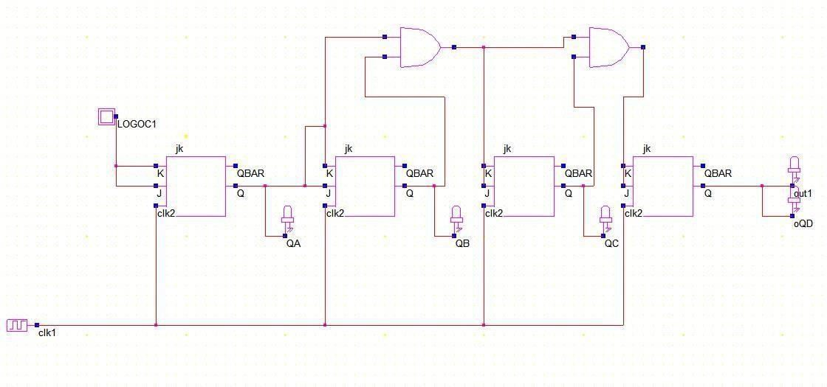
4BIT SYNCHRONOUS COUNTER USING JK FLIPFLOP

4BIT SYNCHRONOUS COUNTER PRE-LAYOUT SIMULATION

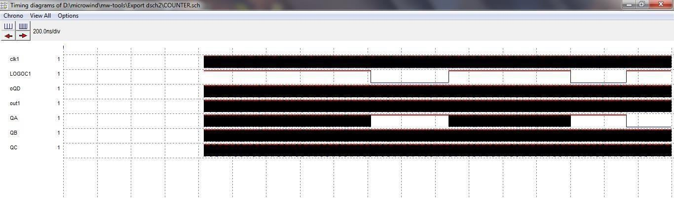

4BIT SYNCHRONOUS COUNTER LAYOUT SIMULATION

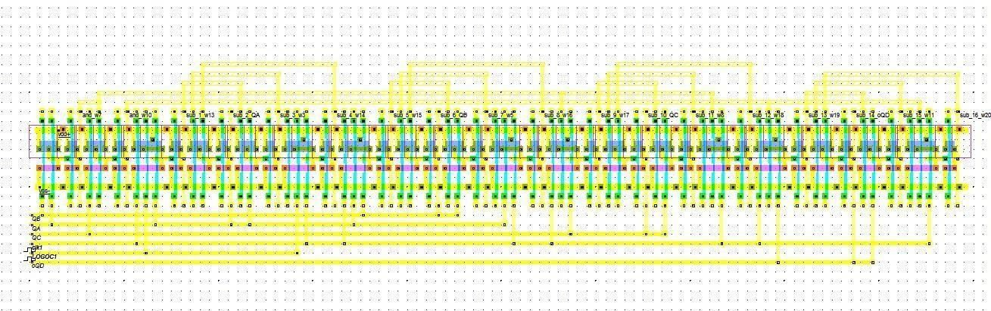

FREQUENCY VS VOLTAGE
GRACE COE

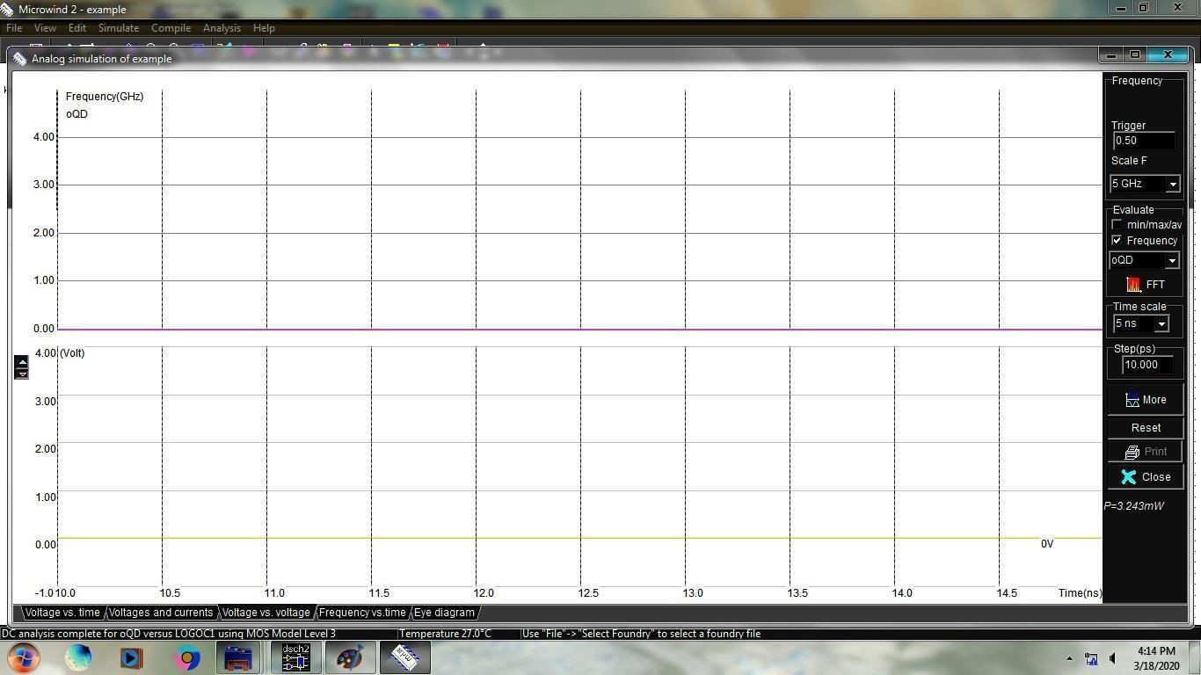

RESULT
Thus the 4-bit synchronous counter using digital flow was simulated and power, area,timing areanalysed,pre and post layout simualtion was done

Exp. No.:10 | DESIGN AND SIMULATE A CMOS INVERTING AMPLIFIER.

AIM:
To design and simulate the CMOS Inverting amplifier using DSCH and microwind.

TOOLS REQUIRED:
- Microwind DSCH
- Microwind 2.0

PROCEDURE:
- Open DSCH 2 and create a new file
- Using symbol library drag and drop the circuit elements on the workspace
- Make the circuit connections using “add a line”
- Use button as input for enable and light as output
- Save and simulate the design, simulation control can be adjusted for operating speed
- View the timing diagram for functional verification
- From the file menu use “make verilog file” for the schematic and save the file, this is used to generate the layout
- Observe the DC, transient responses
- Open Microwind 2.0 and create a new file.
- From menu→compile→compileverilog file and select the Verilog file created for the design
→Generate and back to editor, the layout will be created automatically

THEORY:
The NMOS transistor and the PMOS transistor form a typical complementary MOS (CMOS) device. When a low voltage (0 V) is applied at the input, the top transistor (P-type) is conducting (switch closed) while the bottom transistor behaves like an open circuit. Therefore, the supply voltage (5 V) appears at the output. Conversely, when a high voltage (5 V) is applied at the input, the bottom transistor (N-type) is conducting (switch closed) while the top transistor behaves like an open circuit. Hence, the output voltage is low (0 V). CMOS inverter act as an inverting linear amplifier with a characteristics of Vout =-AVin where A is the stage gain. Near the input threshold voltage the, the CMOS inverter acts as an inverting linear amplifier. It should be noted that the CMOS inverter when used as a logic element is in reality an analog amplifier operated under saturating condition. It can also be viewed as an nMOS common source amplifier driving a pMOS common source amplifier. For amplifiers operating at very low supply voltages, the inverting amplifier stages should be applied. This circuits display an output voltage range that is nearly equal to the supply voltage and can operate on supply voltages.

CMOS INVERTING AMPLIFIER SCHEMATIC
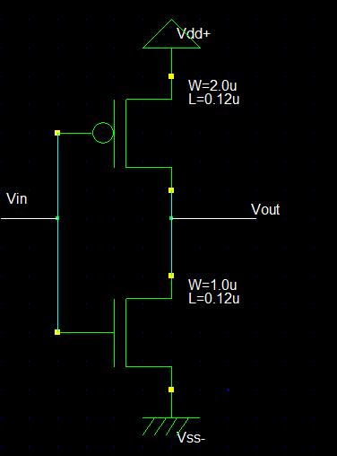

LAYOUT GENERATION
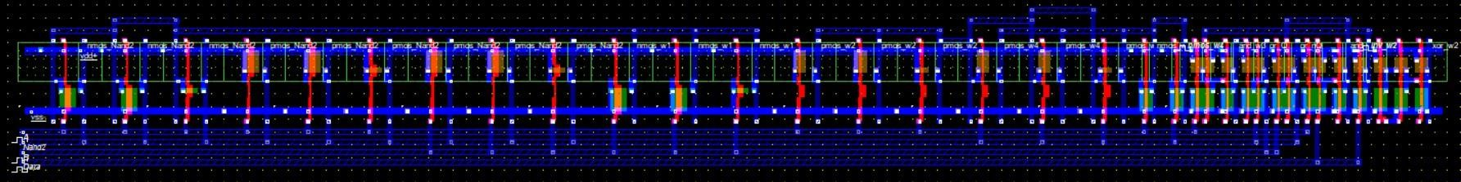

RESULT:
Thus, the CMOS inverting amplifier was designed using micro wind and thereby performed the automatic layout generation.

Exp. No.:11 | DESIGN AND SIMULATE BASIC COMMON SOURCE, COMMON GATE AND COMMON DRAIN AMPLIFIERS.

AIM:
To design and simulate the basic common source, common gate and common drain using DSCH and microwind.

TOOLS REQUIRED:
- Microwind DSCH
- Microwind 2.0

PROCEDURE:
- Open DSCH 2 and create a new file
- Using symbol library drag and drop the circuit elements on the workspace
- Make the circuit connections using “add a line”
- Use button as input for enable and light as output
- Save and simulate the design, simulation control can be adjusted for operating speed
- View the timing diagram for functional verification
- From the file menu use “make verilog file” for the schematic and save the file, this is used to generate the layout
- Observe the DC, transient responses
- Open Microwind 2.0 and create a new file.
- From menu→compile→compile verilog file and select the Verilog file created for the design
→Generate and back to editor, the layout will be created automatically

THEORY:
Common Drain Amplifier (Source Follower):

The common drain amplifier figure shows the source follower circuit in which drain terminal of the device is common. In this circuit the drain terminal is directly connected to VDD. In CS amplifier analysis we have seen that in order to achieve the high voltage gain the load impedance should be as high as possible. Therefore for low impedance load the buffer must be placed after the amplifier to drive the load with negligible loss of the signal level. The source follower thus worked as a buffer stage. The source follower is also called as the common drain amplifier. In this circuit, the signal at the gate is sensed and drives the load at the source which allows the source potential to follow the gate voltage. The drawback of source follower is nonlinearity due to body effect and poor driving capability of the input signal.

Common Source Amplifier:

In this circuit the MOSFET converts variations in the gate-source voltage into a small signal drain current which passes through a resistive load and generates the amplified voltage across the load the voltage gain of

CS amplifier is depends upon the transconductance, the linear resister and load. In order to increase the gain we have to increase the gm. In turn we have to increase the ratio.

Common Gate amplifier:

In common source amplifier and source follower circuits, the input signal are applied to the gate of a MOSFET. It is also possible to apply the input signal to the source terminal by keeping common gate terminal. This type of amplifier is called as common gate amplifier. The CG amplifier in which the input signal is sensed at the source terminal and the output is produced at the drain terminal. The gate terminal is connected to VB i.e. dc potential which will maintain the proper operating conditions.

COMMON SOURCE AMPLIFIER SCHEMATIC

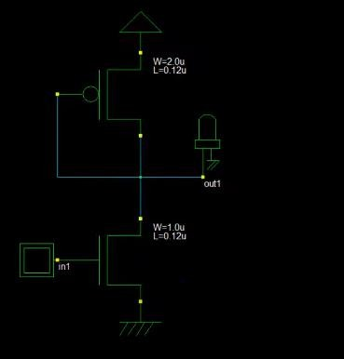

LAYOUT GENERATION

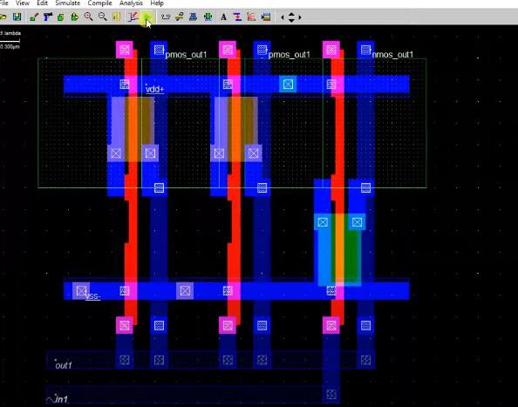

OUTPUT WAVEFORM
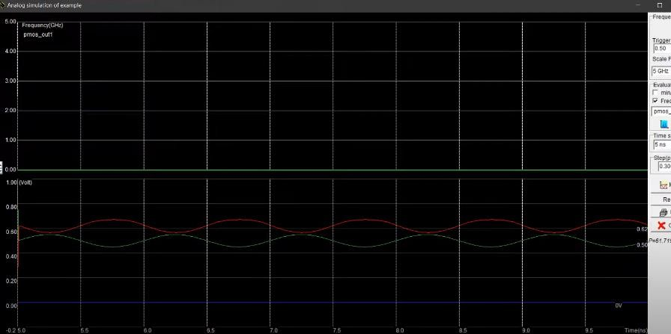

COMMON DRAIN AMPLIFIER

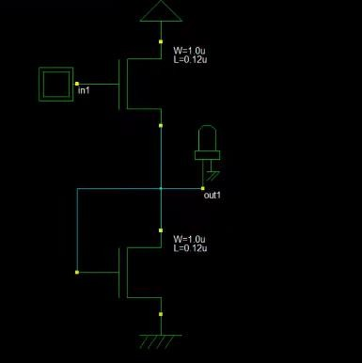

LAYOUT GENERATION

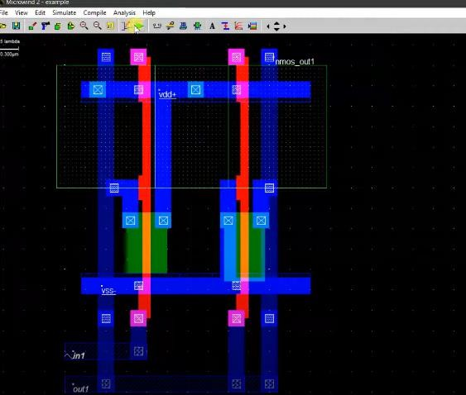

OUTPUT WAVEFORM
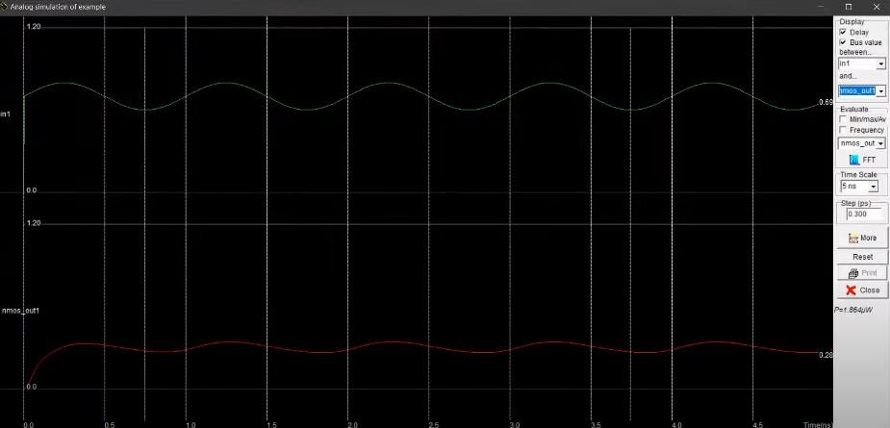

COMMON GATE AMPLIFIER

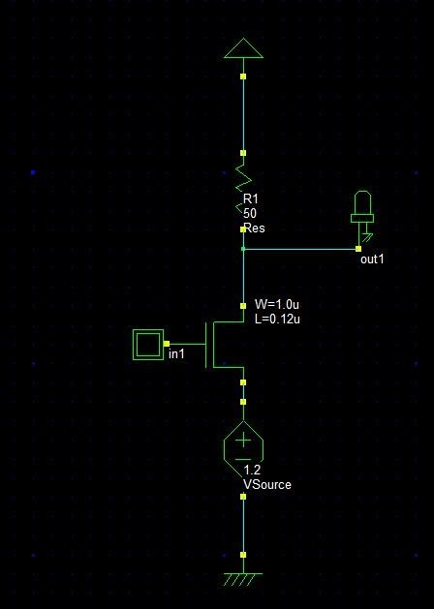

RESULT:
Thus, the common source, common gate and common drain was designed using microwind and thereby performed the automatic layout generation.

Exp. No.:12 | DESIGN AND SIMULATE SIMPLE 5 TRANSISTOR DIFFERENTIAL AMPLIFIER.

AIM:
To design and simulate the basic simple 5 transistor differential amplifier using DSCH and microwind.

TOOLS REQUIRED:
- Microwind DSCH
- Microwind 2.0

PROCEDURE:
- Open DSCH 2 and create a new file
- Using symbol library drag and drop the circuit elements on the workspace
- Make the circuit connections using “add a line”
- Use button as input for enable and light as output
- Save and simulate the design, simulation control can be adjusted for operating speed
- View the timing diagram for functional verification
- From the file menu use “make Verilog file” for the schematic and save the file, this is used to generate the layout
- Observe the DC, transient responses
- Open Micro wind 2.0 and create a new file.
- From menu-compile-compile verilog file and select the Verilog file created for the design
→Generate and back to editor, the layout will be created automatically

THEORY:

The differential amplifier is a form of amplifier that strengthens the difference between two voltages in a circuit. In electronic designs, we use a differential amplifier to produce high voltage gain and high CMRR. Its main characteristics include very low bias current input, very high impedance input, and very Low offset voltage. The essential benefit of differential mode from common mode is its higher immunity to noise. Also, differential amplifiers provide better immunity to environmental noise, improve linearity, and more upper signal swing. It may operate in two modes: common mode and differential mode. The common method produces a zero voltage output result while the differential mode produces a high voltage output result. Given this, the differential amplifier generally has high CMRR. If the two input voltages are of similar value, the amp provides an output voltage value that is almost zero. When the two input voltages are unequal, the amplifier produces a high voltage output. The remarkable of differential operation over common mode operation is its higher immunity to noise.

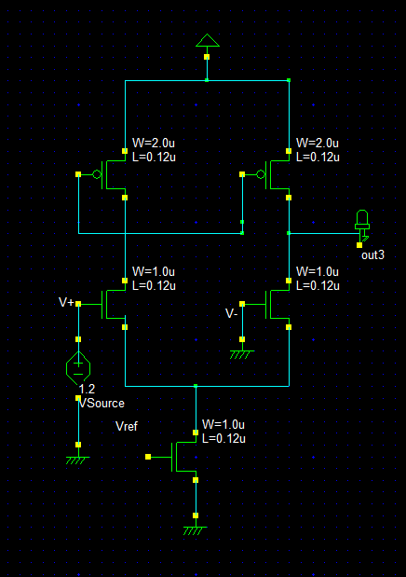
SCHEMATIC

FREQUENCY RESPONSE:

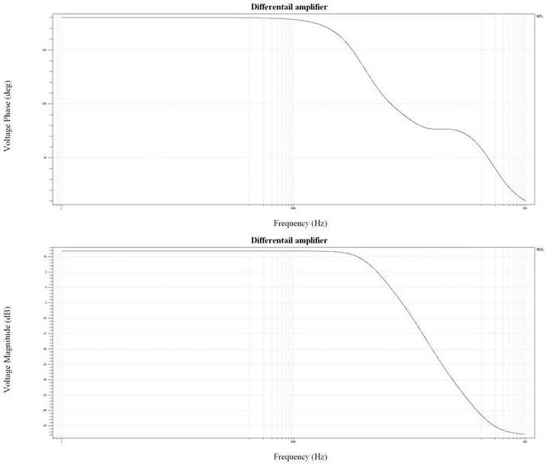

RESULT:
Thus, the basic simple 5 transistor differential amplifier was designed using micro wind

