
DEPARTMENTOFELECTRONICSANDCOMMUNICATION ENGINEERING
U23ECP41–COMMUNICATIONSYSTEMSLABORATORY

MASTER MANUAL

Prepared by Verifiedby

Mrs. M. SARITHA HOD/ECE
Ms. R. ABINAYA
AP/ECE

COURSEOBJECTIVE:
The student should be made to:
- To visualize the effects of sampling and TDM
- To Implement AM&FM modulation and demodulation
- To implement PCM &DM
- To simulate Digital Modulation schemes
- To simulate Error control coding schemes

HARDWAREANDSOFTWAREREQUIREMENT:
LAB Requirements for a Batch of 30 students (3 students per experiment):
- Kits for Signal Sampling ,TDM ,AM, FM, PCM, DM and Line Coding Schemes
- CROs/DSOs–15Nos, Function Generators– 15Nos.
- MATLAB or equivalent software package for simulation experiments
- PCs -15 Nos

COURSEOUTCOME:

- Simulate &validate the various functional modules of a communication system
- Demonstrate their knowledge in baseband signaling schemes through implementation of digital modulation schemes
- Apply various channel coding schemes & demonstrate their capabilities towards the improvement of the noise performance of communication system
- Simulate end-to-end communication Link

LIST OF EXPERIMENTS:

1.Signal Sampling and reconstruction
2.AMModulation and Demodulation
3.FM Modulation and Demodulation
4.PulseCode Modulation and Demodulation
5.DeltaModulationandAdaptivedelta modulation
6.TDMand FDM
7.Line coding schemes
8.Simulation of BFSK Modulation and Demodulation
9.Simulation of BPSK Modulation and Demodulation
- Simulation of FSK, QPSK, and DPSK schemes
- Simulation of error control coding schemes
- Communication link simulation

EXP.NO | NAMEOFTHE EXPERIMENT | NO.OFPERIOD REQUIRED PERBATCH | CUMULATIVE PERIOD REQUIRED  PERBATCH
CYCLE-I
1 | Signal Sampling and reconstruction | 4 | 4
2 | AM Modulation and Demodulation | 4 | 8
3 | FM Modulation and Demodulation | 4 | 12
4 | Pulse Code Modulation and Demodulation | 4 | 16
5 | Delta Modulation and Adaptive delta modulation | 4 | 20
6 | TDM and FDM | 8 | 28
7 | Line coding schemes | 4 | 32
CYCLE –II
8 | Simulation of BFSK Modulation and Demodulation | 4 | 36
9 | Simulation of BPSK Modulation and Demodulation | 4 | 40
10 | Simulation of FSK, QPSK, and DPSK schemes | 12 | 52
11 | Simulation of error control coding schemes | 4 | 56
12 | Communication link Simulation | 4 | 60

TOTAL: 60 PERIODS

S.NO. | DATE | NAME | PAGENO | MARKS | SIGN
1 |  | Signal Sampling and reconstruction
2 |  | AM Modulation and Demodulation
3 |  | FM Modulation and Demodulation
4 |  | Pulse Code Modulation and Demodulation
5 |  | Delta Modulation and Adaptive delta modulation
6 |  | TDM and FDM
7 |  | Line coding schemes
8 |  | Simulation of BFSK Modulation and Demodulation
9 |  | Simulation of BPSK Modulation and Demodulation
10 |  | Simulation of FSK, QPSK, and DPSK schemes
11 |  | Simulation of error control coding schemes
12 |  | Communication link simulation

EXP.NO:1 SIGNALSAMPLINGAND RECONSTRUCTION

AIM:
To demonstrate the signal sampling and reconstruction process and obtain the
Waveform using sampling trainer kit.

APPARATUS REQUIRED:
- Sampling trainer kit
- Patch card
- CRO

THEORY:
An information source may be either in Analog or Digital form. In a digital communication system, the process requires signal in digital form Hence analog to digital conversion takes place before the transmission and after the reception the corresponding digital to analog conversion takes place depending upon the applications. In the analog to digital conversion, the analog signal which has continuous amplitude and time can be converted to digital signal in three steps. They are
- Sampling-Discretization in time.
- Quantization –Discretization in amplitude.
- Encoding-Coding the quantized values.
The sampling process discretizes an analog signal in time domain to get a continuous value of signal at discrete points of time. Easily we can state that sampling process converts an continuous time signal to discrete time signal by measuring the signal at periodic instants time.

PROCEDURE:
  - Connect the required components and primary connections are made.
  - Turn on the kit to the power supply ON.
  - Connect the pin 12 to signal input pin 34 using patch card and short circuit the 0V using another patch card.
  - Now check the input at the pin 35 by connecting the positive end of the CRO probe whereas the negative end is ground.
  - Amplitude and time period of the waveform is noted at different frequency fix the frequencies level like 40 KHZ, 20 KHZ, 80KHZ and obtain respective amplitude and time period in that frequencies .The positive end of the CRO is removed and connect at pin 37 to get sampled output.
  - Similarly remove the probe from 37 and connect it inpin39 to get the sample and hold output.
  - Then take another patch card to connect the pin 37 and pin 40 , Now remove the probe from pin 39, Connect t in pin 42 to get second order Low pass filter.
  - Similarly remove the patch card which connect the pin 37 and pin 40 and fix that patch card between pin 39 and pin 43.Finally fix the probe in pin 46 obtain the 4th order Low pass filter.
  - Note Amplitude and frequency of all waveforms and noted it in tabular column.
  - Finally plot the graph.

TABULATION:

SIGNALS | Amplitude(V) |  | Time period (ms)
SIGNALS | 40 KHZ | 80 KHZ | Time period (ms)
Message output
Sampled output
Sample and hold output
Second order LPF
Fourth order LPF

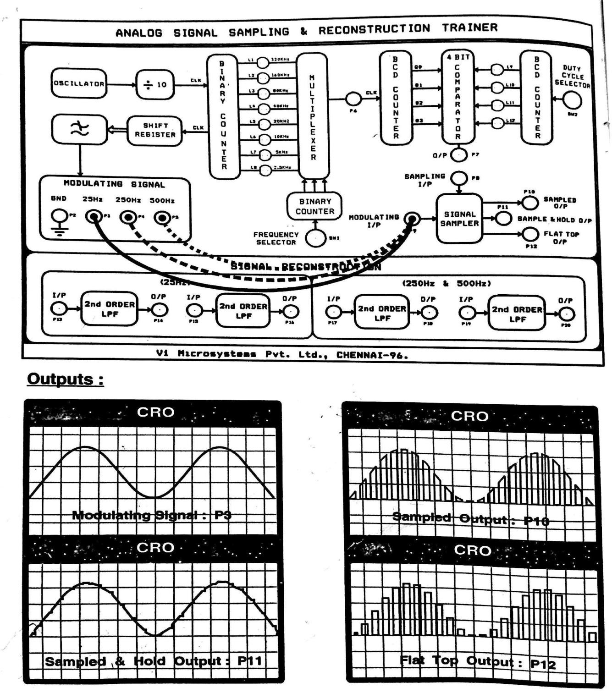

RESULT:
Thus the signal sampling and the reconstructed process was demonstrated and thus obtained the waveform.

EXP.NO:2 AM MODULATION AND DEMODULATION

AIM:
To demonstrate the amplitude modulation and demodulation process and obtain the waveform
Using amplitude modulator and demodulator kit.

APPARATUS REQUIRED:
    - Amplitude modulator and demodulator kit
    - Function generator
    - CRO

THEORY:
Amplitude modulation is the modulation technique used in electronic communication most commonly for transmitting information via a radio carrier wave in amplitude modulation the amplitude of the carrier wave is varied in proportion to the waveform being transmitted that waveform may for instant correspond to the sounds to produce by a loud speaker or the light intensity of television pixels this technique contrast with frequency modulation in which the frequency of the carrier signal is varied and phase modulation in which it’s phase is varied .

PROCEDURE:
- Collect the AM trainer kit, CRO and a function generator.
- Required connections are given as per the circuit diagram.
- From the RF generator block, the carrier wave is[sinewave-high frequency ]given to the RF input of amplitude modulator block
- Message input is generator from AFO and given to the AF input in amplitude modulator block
- The carrier signal varied in accordance with message signal modulation process and the modulated output is obtained at the point across 0.001µf capacitor in circuit
- The modulated output is connected to input of demodulator block and the demodulated output is obtained across22µf capacitor in the block
- The input signal such as message and carrier modulated output demodulated output waveforms are observed using CRO and waveform is plotted in graph

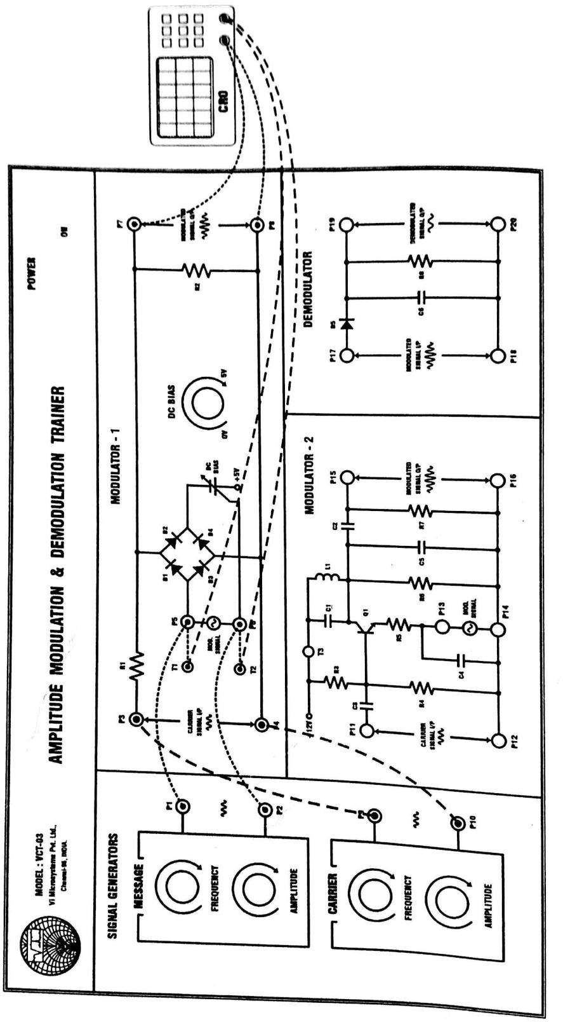

TABULATION:

SIGNAL | AMPLITUDE(V) | TIME PERIOD (ms)
Message signal
Carrier signal
Modulated signal
Demodulated signal

MODELGRAPHS:
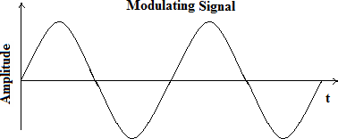

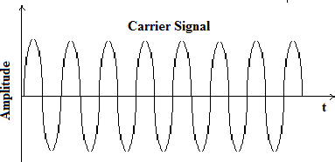

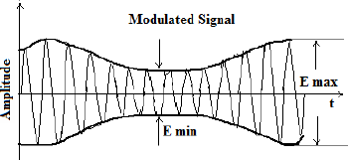

RESULT:
Thus the amplitude modulation and demodulation process was demonstrated and the
Waveform was obtained and graph is plotted.

EXP.NO:3 FREQUENCY MODULATION AND DEMODULATION

AIM:
To demonstrate the frequency modulation and demodulation process and obtain the waveform
Using frequency modulator and demodulator kit

APPARATUS REQUIRED:
- Frequency modulator and demodulator trainer kit
- Function generator
- CRO

THEORY:
Frequency modulation is a form of modulation that represents information ass variation in the instantaneous frequency of carrier wave.FM is commonly used at VHF radio frequencies for high – fidelity broadcast of music and speech .Normal TV sound is also broadcast using FM . A narrowband form used for voice communications in commercial and amateur radio setting. The type of FM used in broadcast is generally called wide-FM. In two way radio narrowband narrow FM used to conserve bandwidth. In addition. It used to send signals into space.

PROCEDURE:
- Collect the FM trainer kit, CRO and a function generator
- Required connections are given as per the circuit diagram
- From the function generator block , the carrier wave is given to sine input and the message signal to the FM input frequency modulator block.
- The carrier signal is varied in accordance with message signal (modulation process)and the modulated output is obtained .
- The modulated output is connected to input demodulator block and demodulated output is obtained.
- The input signal such as message and carrier, modulated output and demodulated output waveform are observed using CRO and waveform is plotted in graph.

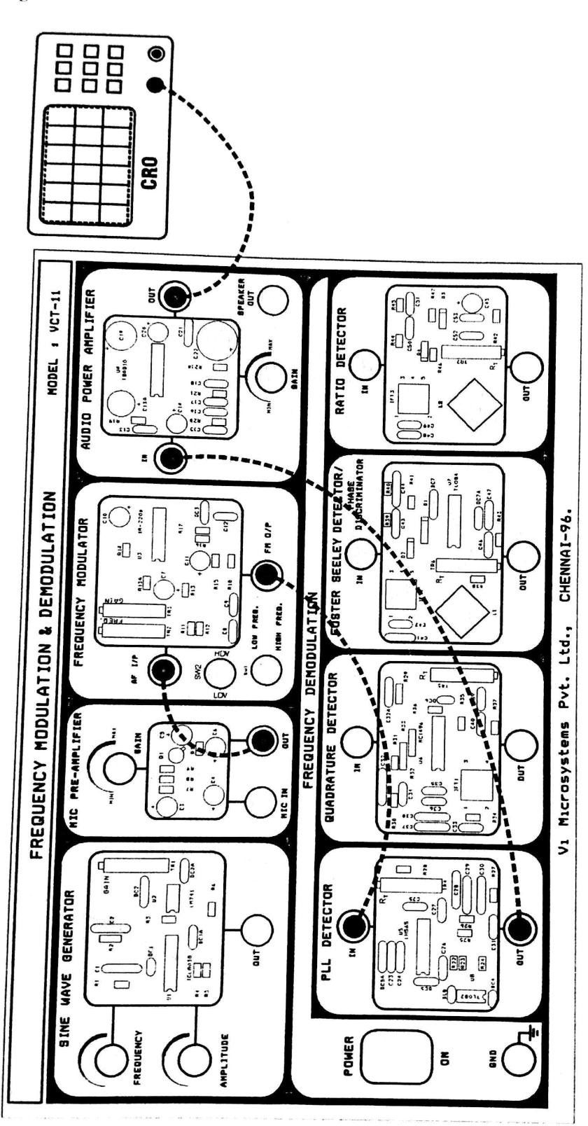

TABULATION:

SIGNAL | Amplitude(V) | Time period(ms)
Message signal
Carrier signal
Modulated signal
Demodulated signal

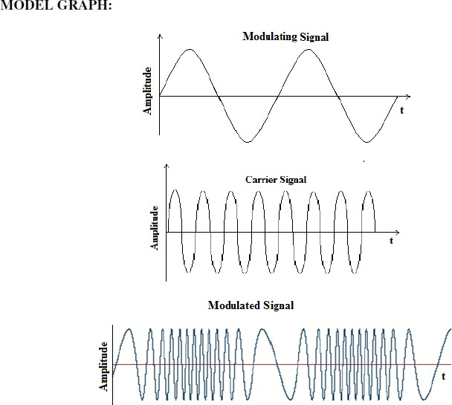

RESULT:
Thus the frequency modulation and demodulation process was demonstrated and the
Waveform was obtained and graph is plotted.

EXP.NO:4 PULSE CODE MODULATION AND DEMODULATION

AIM:
To demonstrate the pulse code modulation and obtained the required waveform using pulse code
Modulation trainer kit.

APPARATUS REQUIRED:
- PCM trainer kit
- CRO
- Patch cords

THEORY:
The coded version of sampled signal to represent digitally for the digital transmission. Generally modulation refers to variations of characteristics (amplitude /phase /frequency) of carrier wave in accordance with the message signal. If the carrier wave is pulse type, then it is said to be pulse modulation Depending on the parameters we may have
- Pulse amplitude modulation
- Pulse position modulation
- Pulse width modulation
A pulse modulated signal contains only sampled values. The pulse amplitude modulated signal is quantized and converted into digital code, then the process is said to be pulse code modulation. In the pulse code information, the term modulation does not refer technique. It operates only on the baseband signal. No modulation takes place except the similar process takes place during sampling. It is entirely encoding technique of analog signal for digital transmission. PCM method is used in storage system, line coding.

PROCEDURE:
- Collect the PCM kit, CRO & the required patch cords.
- Initially keep the knobs in minimum value.
- The input sine wave generated at the Signal generator is taken as the input and connected to modulating switch EOC.
- Connect the two points represented by dotted lines.
- Obtain the PCM output (square wave) at the PCM output knob.
- PCM output is connected to input of demodulated block and Demodulated output is obtained at its corresponding knob
- The input sinewave, PCM output , demodulated output are observed using CRO and waveform is plotted in graph.

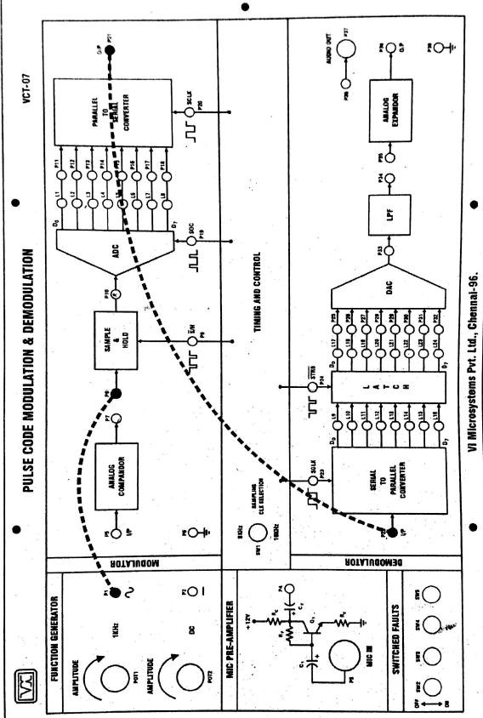

TABULATION:

SIGNAL | AMPLITUDE(V) | TIMEPERIOD(ms)
Sine Input
PCM Modulated Output
PCM Demodulated Output

RESULT:
Thus the pulse code modulation process was demonstrated and the required waveform was obtained using pulse code modulation training kit.

EXP.NO:5 DELTA MODULATION AND ADAPTIVE MODULATION

AIM:
To demonstrate the delta modulation & Adaptive modulation and obtain the required waveform
Using delta modulation & demodulation trainer kit.

APPARATUS REQUIRED:
  - Delta modulation trainer kit and Adaptive modulation trainer kit
  - Patch cords
  - CRO

THEORY:
Delta modulation is simply, one bit DPCM with two level quantize. DPCM used correlation between samples for encoding. This concept has been further enhanced which means correlation between samples are exploited at higher level or maximum level in delta modulation. The correlation between the adjacent samples is increased by over sampling the input signal. This over sampled signal is provided with staircase approximation. The difference between the original input signal and approximated signal is quantized.

PROCEDURE:
- Collect the DM trainer kit and CRO initially keep all the knobs in minimum position and make the necessary connections
- Now increase the sine wave generator and frequency knob such a way that sine wave of 4v is obtained at T1 point
- Then measured the integrated output at the respective knob
- Also Obtained the modulated output at the last knob
- Connect the delta modulated output to the demodulated input and obtain its waveform
- The obtained input waveform integrated output modulated output and the demodulated output is plotted in the graph.

TABULATION:

SIGNALS | AMPLITUDE(V) | TIMEPERIOD(ms)
Sine Input
Integrate or Signal
Delta Modulated Output
Delta Demodulated Output
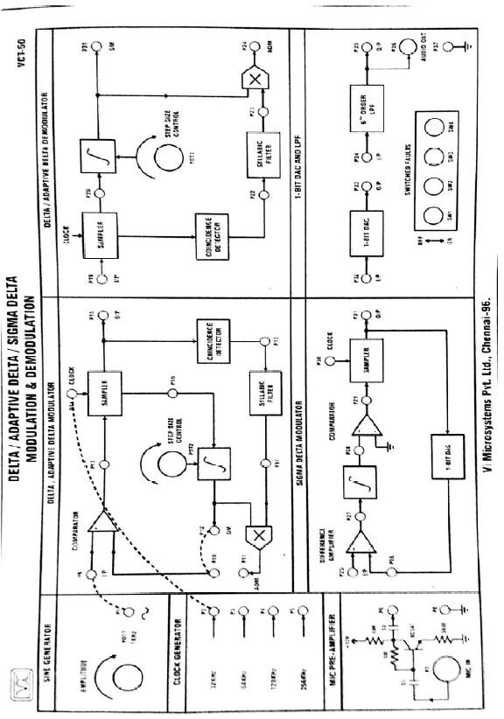

RESULT:
Thus the Delta modulation & Adaptive modulation was demonstrated and the required waveform was obtained using delta modulation trainer kit.

EXP.NO: 6 TDM AND FDM AIM:
To demonstrate the time division multiplexing and obtained the required waveform using time division multiplexing kit.

APPARATUS REQUIRED:
- TDM trainer kit
- FDM trainer kit
- CRO
- Connecting wires.

THEORY:
PAM signal occupies the channel for fraction of sampling interval on a periodic basis Time interval between the adjacent pulses can be utilized by other messages in time shared basis
Hence TDM (Time Division Multiplexing) process utilize the channel efficiently with independent message signal without mutual interferences.

ADVANTAGE:
- Full available channel bandwidth can be utilized for each channel
- Inter modulation distortion is absent
- TDM circuitry is not very complex
- The problem of cross talk is not severe.

DISADVANTAGES:
- Channel dispersion
- Cross talk.

PROCEDURE:
- Collect the required components and made primary components.
- Turn on the trainer kit to the power supplyof+5V.
- Connect the negative pin of CRO probe to the ground pin in the kit.
- Then the positive pin of CRO probe is connected to the channel 1 in the kit. We get the output waveform i.e. Square wave.
- Note the ON time and OFF time for the waveform and tabulated it in tabular column.
- Similarly the positive pin of CRO probe is connected to the channel 2,channel 3,synchronous pin we can get the respective wave forms like square wave and synchronous pulses with different ON time and OFF time.
- Finally the positive pin is connected to output pin in IC555 present in kit i.e simply to the 3rd pin of IC555 we get the required TDM waveform as the output.
- Repeat the step 5 and finally all the readings are plotted in graph.

TABULATION:

SIGNAL | Amplitude(V) | Timeperiod(ms)
Channel 1 |  | On time
Channel 1 |  | Off time
Channel 2 |  | On time
Channel 2 |  | Off time
Channel 3 |  | On time
Channel 3 |  | Off time
Synchronous pulse |  | On time
Synchronous pulse |  | Off time
TDM output |  | On time
TDM output |  | Off time

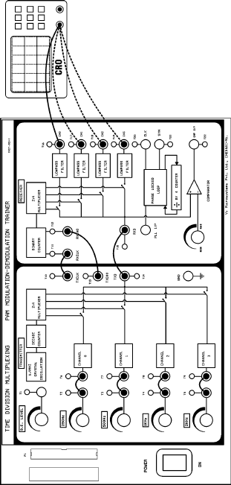

250Hz SINEWAVE (T2) & PAM O/P (T14)
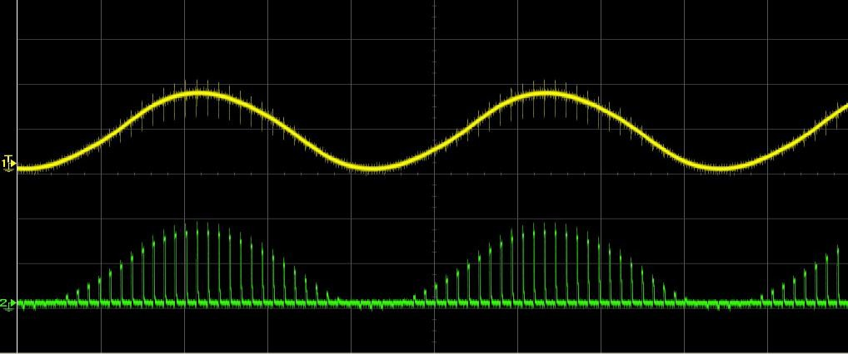
500Hz SINEWAVE (T3) & PAM O/P(T14)
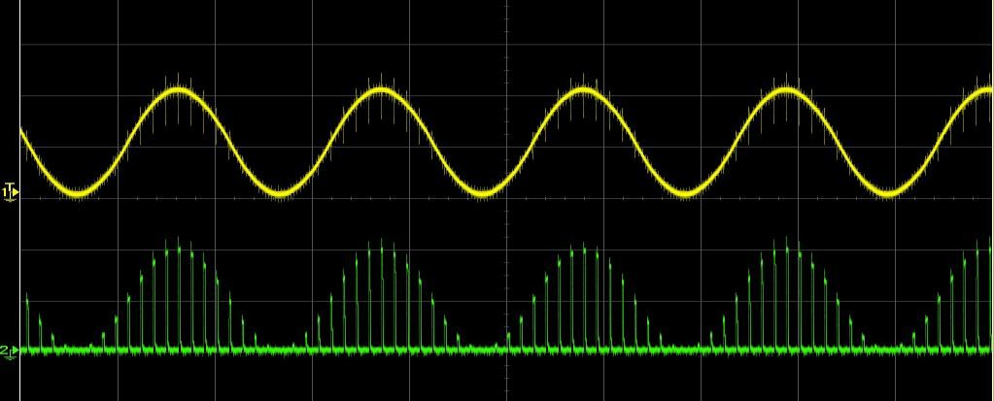
1KHz SINEWAVE (T4)& PAM O/P(T14)
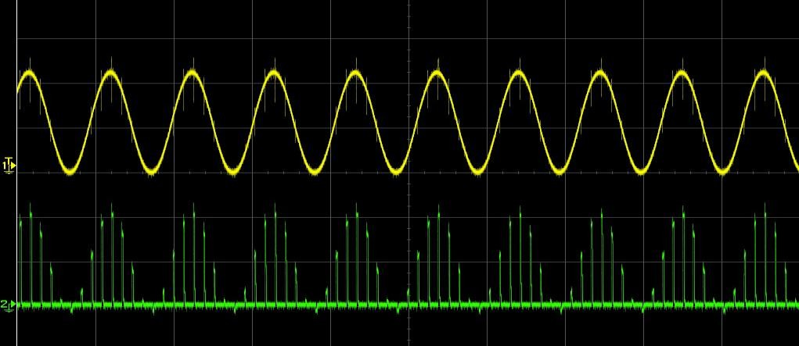

2KHz SINEWAVE (T5) & PAM O/P (T14)
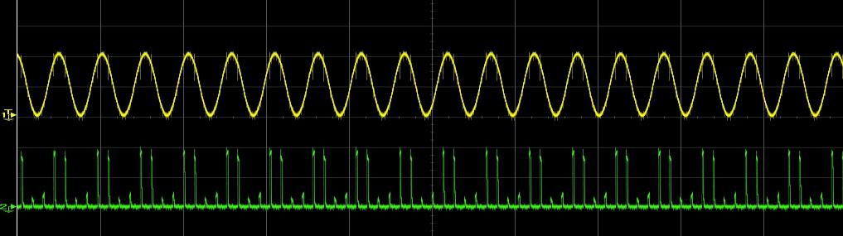

TDM OUTPUT
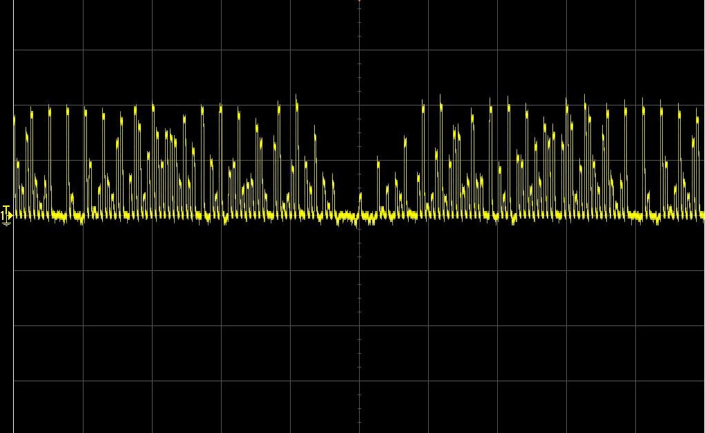
INPUT 250Hz SINE WAVE (T2) & OUTPUT (T16)
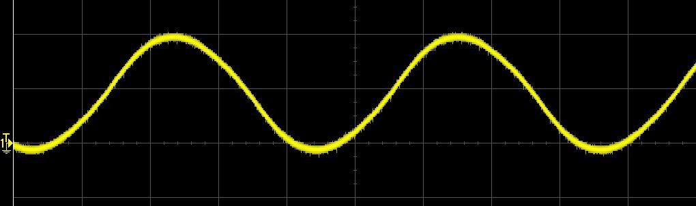

RESULT:
Thus the time division multiplexing was done and the required wave form is obtained with which the graph is plotted.

EXP.NO:7 LINE CODING SCHEMES

AIM:
To demonstrate the line code schemes process and obtain the waveform using frequency
Modulator and demodulator kit

APPARATUS REQURIED:
  - Line code schemes trainer kit
  - Patch cards
  - CRO

THEORY:
In a baseband data transmission system the signal gets transmitted through formatter block, source coder block and channel coder block the output of the channel encoder block will be in the digital symbol form which has to be transmitted through the channel when the digital data are transmitted through the band limited channel dispersion in the channel causes an overlap in time between successive symbol know as inter symbol interference which is a form of distortion
Hence these symbol are sent as analog waveform to be existing over the symbol interval only for which symbol digits has to be mapped to particular waveform so we can define the process of mapping the digits to a pulse waveform as line code this waveform is denoted as line codes.

PROCEDURE:
- Collect the line code schemes trainer kit, CRO
- Set pulse is switched to change the random input data bits.
- PRBS and the clock pin is connected to the various line coding encoder inputs as present in the circuit.
- Connect the coded output to the corresponding decoding input.
- Obtain the decoded waveform.
- Thus the data bits are encoded by line coding and the graph is plotted for various line coding technique.

LINECODETYPESANDREPRESENTATION:

UNI POLAR FORMAT | Symbols/digits | Waveform nature
UNI POLAR FORMAT | 0 | pulse off
UNI POLAR FORMAT | 1 | pulse transmitted
POLAR FORMAT | Symbols/digits | Waveform nature
POLAR FORMAT | 0 | Negative pulse get transmitted
POLAR FORMAT | 1 | Positive pulse get transmitted
BIPOLARFORMAT | Symbols/digits | Waveform nature
BIPOLARFORMAT | 0 | Alternative positive and negative  transmitted
BIPOLARFORMAT | 1 | No pulse
MANCHESTER FORMAT | Symbols/digits | Waveform nature
MANCHESTER FORMAT | 0 | Pulse for one half of symbol duration and negative pulse for positive remaining half of symbol duration
MANCHESTER FORMAT | 1 | Transmission in reverse order

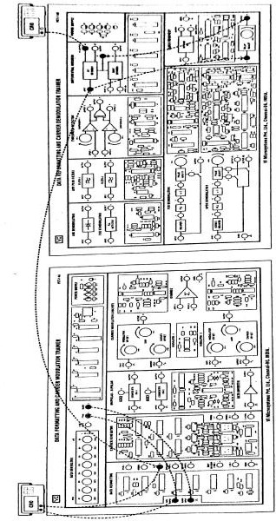

RESULT:
Thus the line coding scheme was demonstrated and the waveform was obtained and graph is plotted.

EXP.NO:8 SIMULATIONS OF BFSK MODULATION AND DEMODULATION

8.A. BINARY FREQUENCY SHIFT KEYING

AIM:
To generate and demodulate frequency shift keyed (FSK) signal using MATLAB

THEORY:
Generation of FSK
Frequency-shift keying (FSK) is a frequency modulation scheme in which digital information is transmitted through discrete frequency changes of a carrier wave. The simplest FSK is binary FSK (BFSK). BFSK uses a pair of discrete frequencies to transmit binary (0s and 1s) information. With this scheme, the "1" is called the mark frequency and the "0" is called the space frequency.
In binary FSK system, symbol 1 & 0 are distinguished from each other by transmitting one of the two sinusoidal waves that differ in frequency by a fixed amount.
Si(t)=√2E/Tbcos2πf1t0≤t≤Tb 0 elsewhere
Where i=1, 2 & Eb=Transmitted energy/bit
Transmitted freq =ƒi (nc+i)/Tb, and n=constant(integer),Tb= bit interval Symbol 1 is represented by S1 (t)
Symbol 0 is represented byS0 (t)
BFSK Transmitter
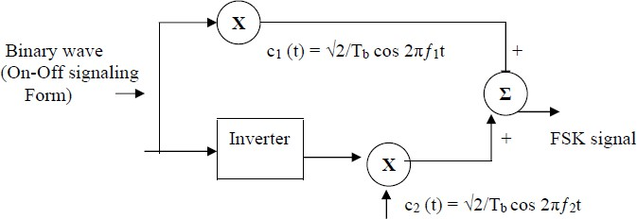

The input binary sequence is represented in its ON-OFF form, with symbol 1 represented by constant amplitude of √Eb with & symbol 0 represented by zero volts. By using inverter in the lower channel, we in effect make sure that when symbol 1is at the input, The two frequency f1& f2 are chosen to be equal integer multiples of the bit rate 1/Tb. By summing the upper & lower channel outputs, we get BFSK signal.

ALGORITHM:

Initialization commands

FSK MODULATION:
- Generate two carriers signal.
- Start FOR loop
- Generate binary data, message signal and inverted message signal
- Multiply carrier1with message signal and carrier 2 with inverted message signal
- Perform addition to get the FSK modulated signal
- Plot message signal and FSK modulated signal.
- End FOR loop.
- Plot the binary data and carriers.

PROGRAM
clc;clearall; closeall;
%GENERATE CARRIER SIGNAL Tb=1;
fc1=2;fc2=5; t=0:(Tb/100):Tb;
c1=sqrt(2/Tb)*sin(2*pi*fc1*t); c2=sqrt(2/Tb)*sin(2*pi*fc2*t);
%generate message signal N=8;
m=rand(1,N); t1=0;t2=Tb for i=1:N
t=[t1:(Tb/100):t2]
ifm(i)>0.5 m(i)=1;
m_s=ones(1,length(t)); invm_s=zeros(1,length(t)); else
m(i)=0;
m_s=zeros(1,length(t)); invm_s=ones(1,length(t)); end
message(i,:)=m_s;
%Multiplier fsk_sig1(i,:)=c1.*m_s; fsk_sig2(i,:)=c2.*invm_s; fsk=fsk_sig1+fsk_sig2;
%plotting the message signal and the modulated signal subplot(3,2,2);
axis([0 N -22]);
plot(t,message(i,:),'r'); title('messagesignal'); xlabel('t>');

ylabel('m(t)'); grid on;
hold on; subplot(3,2,5); plot(t,fsk(i,:)); title('FSKsignal'); xlabel('t >');
ylabel('s(t)'); grid on;holdon;
t1=t1+(Tb+.01); t2=t2+(Tb+.01);
endholdoff
%Plotting binary data bits and carrier signal subplot(3,2,1);
stem(m); title('binarydata'); xlabel('n >');
ylabel('b(n)'); grid on; subplot(3,2,3);
plot(t,c1);
title('carriersignal-1'); xlabel('t >');
ylabel('c1(t)'); grid on; subplot(3,2,4);
plot(t,c2);
title('carriersignal-2'); xlabel('t >');
ylabel('c2(t)'); grid on; subplot(3,2,6); stem(m);
title('demodulateddata'); xlabel('n >');
ylabel('b(n)'); grid on;

OUTPUT:
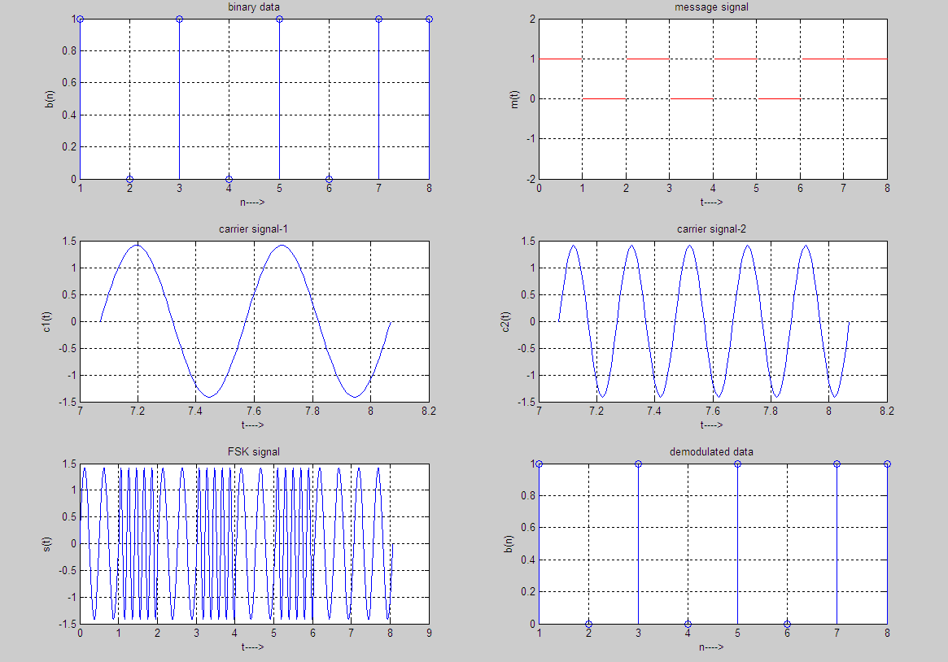

RESULT:

plotted.

The program for FSK modulation has been simulated in MATLAB and necessary graphs are

EXP.NO:9 BINARY PHASE SHIFT KEYING

AIM:
To generate and demodulate Binary phase shift keyed(BPSK)signal using MATLAB

GENERATIONOFPSK SIGNAL:
PSK is a digital modulation scheme that conveys data by changing, or modulating, the phase of a reference signal (the carrier wave). PSK uses a finite number of phases, each assigned a unique pattern of binary digits. Usually, each phase encodes an equal number of bits. Each pattern of bits forms the symbol that is represented by the particular phase. The demodulator, which is designed specifically for the symbol-set used by the modulator, determines the phase of the received signal and maps it back to the symbol it represents, thus recovering the original data.
In a coherent binary PSK system, the pair of signal S1 (t) and S2 (t) used to represent binary symbols 1 & 0 are defined by
S1(t)=√2Eb/ Tb Cos2πfct
S2(t)=√2Eb/Tb(2πfct+π)=-√2Eb/TbCos2πfctwhere0≤t<Tb and
Eb = Transmitted signed energy for bit
The carrier frequency fc=n/Tb for some fixed integer n.

ANTI PODAL SIGNAL:
The pair of sinusoidal waves that differ only in a relative phase shift of 180°are called anti podal signals.

BPSK Transmitter

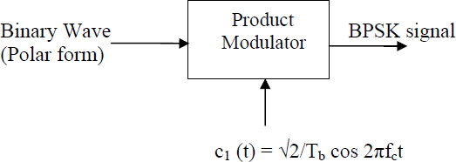

The input binary symbols are represented in polar form with symbols 1 & 0 represented by constant amplitude levels √Eb& -√Eb. This binary wave is multiplied by a sinusoidal carrier in a product modulator. The result in a BSPK signal.

PSKMODULATION:
- Generate carrier signal.
- Start FOR loop
- Generate binary data, message signal in polar form
- Generate PSK modulated signal.
- Plot message signal and PSK modulated signal.
- End FOR loop.
- Plot the binary data and carrier.

PROGRAM
clc;clearall; closeall;
%GENERATE CARRIER SIGNAL Tb=1;
t=0:Tb/100:Tb;
fc=2; c=sqrt(2/Tb)*sin(2*pi*fc*t);
%generate message signal N=8;
m=rand(1,N); t1=0;t2=Tb for i=1:N t=[t1:.01:t2]
ifm(i)>0.5 m(i)=1;
m_s=ones(1,length(t)); else
m(i)=0;
m_s=-1*ones(1,length(t)); end
message(i,:)=m_s;
%product of carrier and message signal bpsk_sig(i,:)=c.*m_s;
%Plot the message and BPSK modulated signal subplot(5,1,2);
axis([0 N -22]);
plot(t,message(i,:),'r');
title('messagesignal(POLARform)'); xlabel('t--->');
ylabel('m(t)'); grid on;
hold on; subplot(5,1,4); plot(t,bpsk_sig(i,:)); title('BPSKsignal'); xlabel('t--->');
ylabel('s(t)'); grid on;

holdon;
t1=t1+1.01;t2=t2+1.01;
endholdoff
%plot the input binary data and carrier signal subplot(5,1,1);
stem(m);
title('binarydatabits'); xlabel('n--->');
ylabel('b(n)'); grid on; subplot(5,1,3);
plot(t,c); title('carriersignal'); xlabel('t--->');
ylabel('c(t)'); grid on;

OUTPUT:

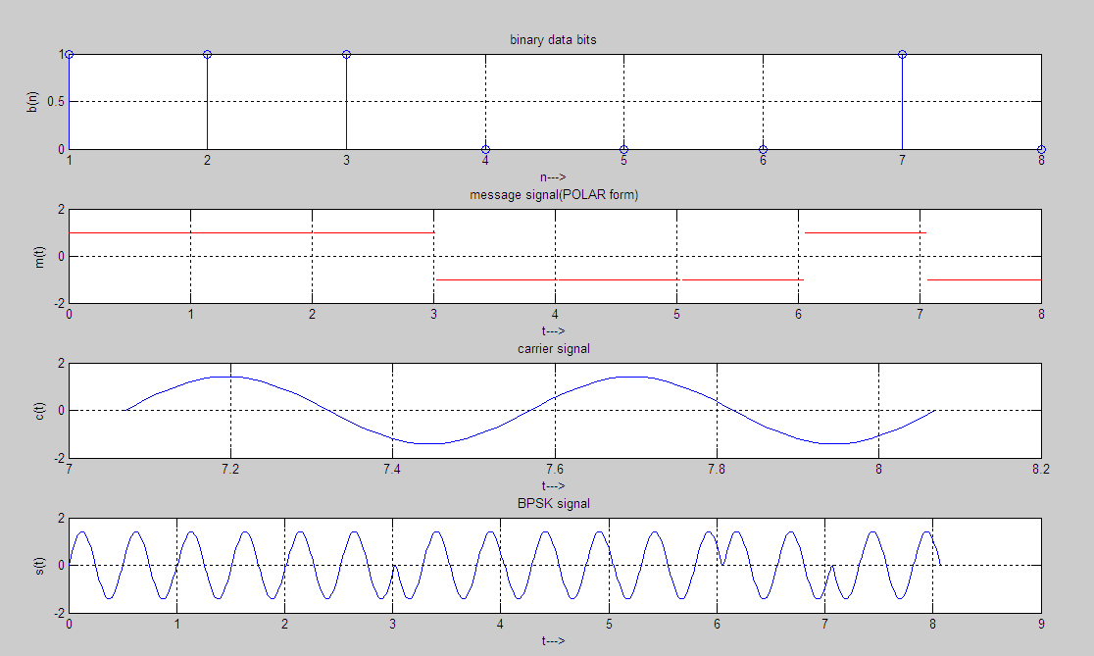

RESULT:
The program for PSK modulation has been simulated in MATLAB and necessary graphs are plotted.

EXP.NO: 10 SIMULATIONS OF FSK, QPSK,AND DPSK SCHEMES

10.A. SIMULATION OF FREQUENCY SHIFT KEYING

AIM:
To generate and demodulate frequency shift keyed (FSK) signal using MATLAB

THEORY:
Generation of FSK
Frequency-shift keying (FSK) is a frequency modulation scheme in which digital information is transmitted through discrete frequency changes of a carrier wave. The simplest FSK is binary FSK (BFSK). BFSK uses a pair of discrete frequencies to transmit binary (0s and 1s) information. With this scheme, the "1" is called the mark frequency and the "0" is called the space frequency. In binary FSK system, symbol 1 & 0 are distinguished from each other by transmitting one of the two sinusoidal waves that differ in frequency by a fixed amount.
Si(t) =√2E/Tb cos2πf1t 0≤ t ≤Tb
0 elsewhere
Where i=1, 2 & Eb=Transmitted energy/bit
Transmittedfreq=ƒi=(nc+i)/Tb,andn=constant(integer),Tb=bitinterval Symbol 1 is represented by S1 (t)
Symbol0is represented byS0 (t)
BFSK Receiver

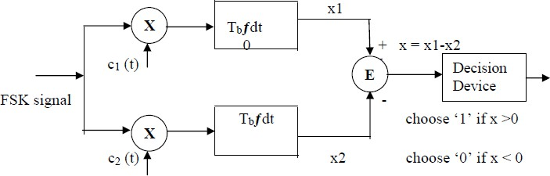

The receiver consists of two correlators with common inputs which are supplied with locally generated coherent reference signals c1(t) and c2 (t). The correlator outputs are then subtracted one from the other, and the resulting difference x is compared with a threshold of zero volts. If x >0, the receiver decides in favour of symbol 1 and if x <0, the receiver decides in favour of symbol 0.

ALGORITHM:
Initialization commands

FSK demodulation
- Start FOR loop
- Perform correlation of FSK modulated signal with carrier 1 and carrier2 to get two decision variables x1 and x2.
- Make decision on x=x1-x2 to get demodulated binary data. If x>0, choose ‘1’elsechoose‘0’.
- Plot the demodulated binary data.

PROGRAM
clc;
clear all; close all;
%GENERATE CARRIER SIGNAL Tb=1;
fc1=2;fc2=5; t=0:(Tb/100):Tb;
c1=sqrt(2/Tb)*sin(2*pi*fc1*t); c2=sqrt(2/Tb)*sin(2*pi*fc2*t);
% generate message signal N=8;
m=rand(1,N); t1=0;t2=Tb for i=1:N
t=[t1:(Tb/100):t2]
ifm(i)>0.5 m(i)=1;
m_s=ones(1,length(t)); invm_s=zeros(1,length(t)); else
m(i)=0;
m_s=zeros(1,length(t)); invm_s=ones(1,length(t)); end
message(i,:)=m_s;
%Multiplier fsk_sig1(i,:)=c1.*m_s; fsk_sig2(i,:)=c2.*invm_s; fsk=fsk_sig1+fsk_sig2;
% plotting the message signal and the modulated signal subplot(3,2,2);
axis([0 N -22]);
plot(t,message(i,:),'r'); title('messagesignal'); xlabel('t>');
ylabel('m(t)'); grid on;

hold on; subplot(3,2,5); plot(t,fsk(i,:)); title('FSKsignal'); xlabel('t >');
ylabel('s(t)'); grid on;holdon;
t1=t1+(Tb+.01); t2=t2+(Tb+.01);
endholdoff
% Plotting binary data bits and carrier signal subplot(3,2,1);
stem(m); title('binarydata'); xlabel('n >');
ylabel('b(n)'); grid on; subplot(3,2,3);
plot(t,c1);
title('carriersignal-1'); xlabel('t >');
ylabel('c1(t)'); grid on; subplot(3,2,4);
plot(t,c2);
title('carriersignal-2'); xlabel('t >');
ylabel('c2(t)'); grid on; subplot(3,2,6); stem(m);
title('demodulateddata'); xlabel('n >');
ylabel('b(n)'); grid on;

OUTPUT:

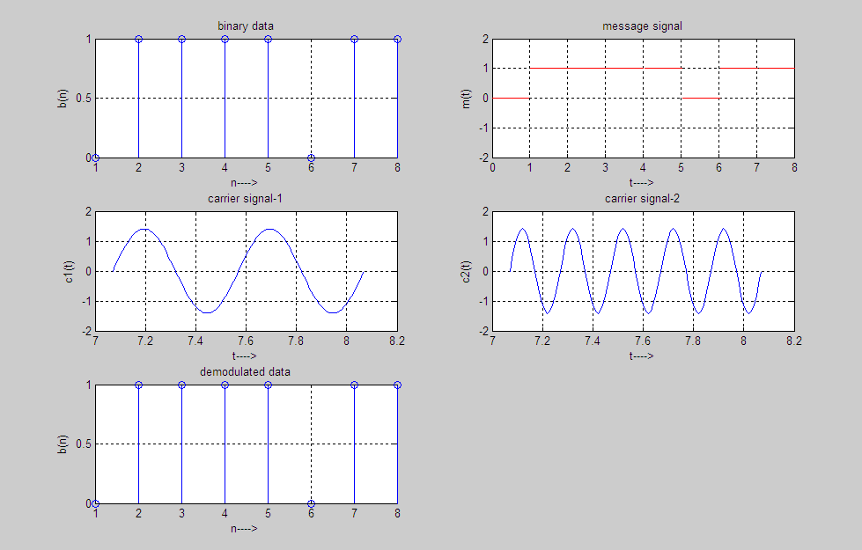

RESULT:
The program for FSK modulation and demodulation has been simulated in MATLAB and necessary graphs are plotted

10. B. QUADRATURE PHASE SHIFT KEYING(QPSK)

AIM:
To generate and demodulate quadrature phase shifted (QPSK) signal using MATLAB

THEORY:
Generation of Quadrature phase shift keyed(QPSK) signal
QPSK is also known as quaternary PSK, quadriphasePSK,4-PSK,or4-QAM.It is a phase modulation technique that transmits two bits in four modulation states.
Phase of the carrier takes on one off our equally spaced values such as π/4,3π/4,5π/4 and7π/4.
Si(t)=√2E/Tcos{2πƒct+(2i–1)π/4},0≤t≤T 0 , elsewhere
Where i=1,2,3,4,&E=Tx signal energy per symbol
T= symbol duration
Each of the possible value of phase corresponds to a pair of bits called di bits. Thus the gray encoded set of di bits: 10,00,01,11
Si(t)=√2E/Tcos[(2i–1)π/4]cos(2πfct)-√2E/Tsin[(2i–1)π/4)]sin(2πfct),0≤t≤Tb 0 , else where
There are two or three normal basis function c1 (t) = √2/T cos 2πƒct, 0≤ t ≤Tb c2 (t) = √2/T sin 2πƒct, 0≤ t ≤Tb
There are four message points
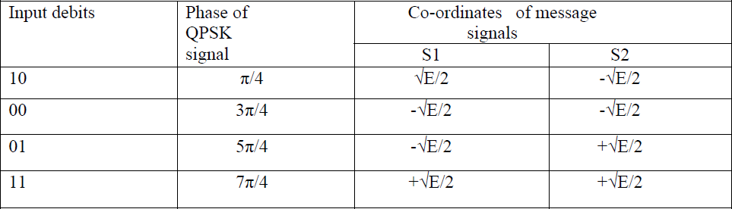

Block diagram of QPSK Transmitter
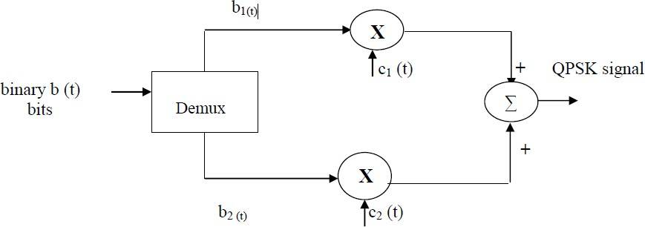

The I/p binary sequence b(t) is represented in polar from with symbols1 &0 represented as
+√E/2 and -√E/2. This binary wave is de multiplexed into two separate binary waves consisting of odd &even numbered I/Pbitsdenotedbyb1 (t)&b2(t).b1(t)&b2(t)are used to modulate a pair of quadrature carrier. The result is two PSK waves .These two binary PSK waves are added to produce the desired QPSK signal
QPSK Receiver:

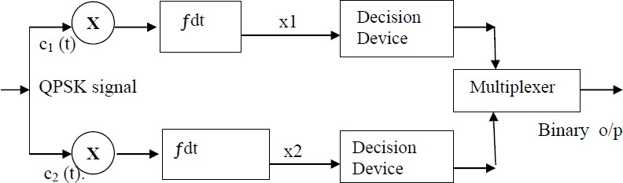

QPSK receiver consists of a pair of correlators with common I/P & supplied with locally generated signal c1 (t) & c2 (t). The correlator output, x1, & x2 are each compared with a threshold of zero volts. If x1 > 0, decision is made in favor of symbol ‘1’ for upper channel and if x1 > 0, decision is made in favor of symbol 0. Parallely if x2 >0, decision is made in favor of symbol 1 for lower channel & if x2 <0, decision is made in favor of symbol 0. These two channels are combined in a multiplexer to get the original binary output.

ALGORITHM:
Initialization commands

QPSK MODULATION:
- Generate quadrature carriers.
- Start FOR loop
- Generate binary data, message x signal(bipolar form)
- Multiply carrier 1with odd bits of message signal and carrier 2with even bits of message signal
- Perform addition of odd and even modulated signals to get the QPSK modulated signal
- Plot QPSK modulated signal.
- End FOR loop.
- Plot the binary data and carriers.
QPSK demodulation
- Start FOR loop
- Perform correlation of QPSK modulated signal with quadrature carriers to get two decision variables x1 and x2.
- Make decision on x1 andx2 and multiplex to get demodulated binary data.
Ifx1>0andx2>0,choose‘11’.Ifx1>0andx2<0,choose‘10’.Ifx1<0andx2>0,choose‘01.If x1<0and x2<0, choose ‘00’.
End FOR loop
Plot demodulated data
Program
clc; clearall; closeall;
%GENERATE QUADRATURE CARRIER SIGNAL Tb=1;t=0:(Tb/100):Tb;fc=1;
c1=sqrt(2/Tb)*cos(2*pi*fc*t); c2=sqrt(2/Tb)*sin(2*pi*fc*t);
%generate message signal N=8;m=rand(1,N); t1=0;t2=Tb
fori=1:2:(N-1)
t=[t1:(Tb/100):t2]
ifm(i)>0.5 m(i)=1;
m_s=ones(1,length(t)); else
m(i)=0;
m_s=-1*ones(1,length(t)); end
% odd bits modulated signal odd_sig(i,:)=c1.*m_s;

ifm(i+1)>0.521 m(i+1)=1;
m_s=ones(1,length(t)); else
m(i+1)=0;
m_s=-1*ones(1,length(t)); end
% even bits modulated signal
even _sig (i,:)=c2.*m_ s;
% qpsk signal qpsk=odd_sig+even_sig;
%Plot the QPSK modulated signal subplot(3,2,4);
plot(t,qpsk(i,:)); title('QPSKsignal'); xlabel('t >');
ylabel('s(t)'); grid on; holdon;
t1=t1+(Tb+.01);t2=t2+(Tb+.01);
endholdoff
% Plot the binary data bits and carrier signal subplot(3,2,1);
stem(m);
title('binarydatabits'); xlabel('n >');
ylabel('b(n)'); grid on; subplot(3,2,2);
plot(t,c1);
title('carriersignal-1'); xlabel('t >');
ylabel('c1(t)'); grid on; subplot(3,2,3);
plot(t,c2);
title('carriersignal-2'); xlabel('t >');
ylabel('c2(t)'); grid on;

OUTPUT:
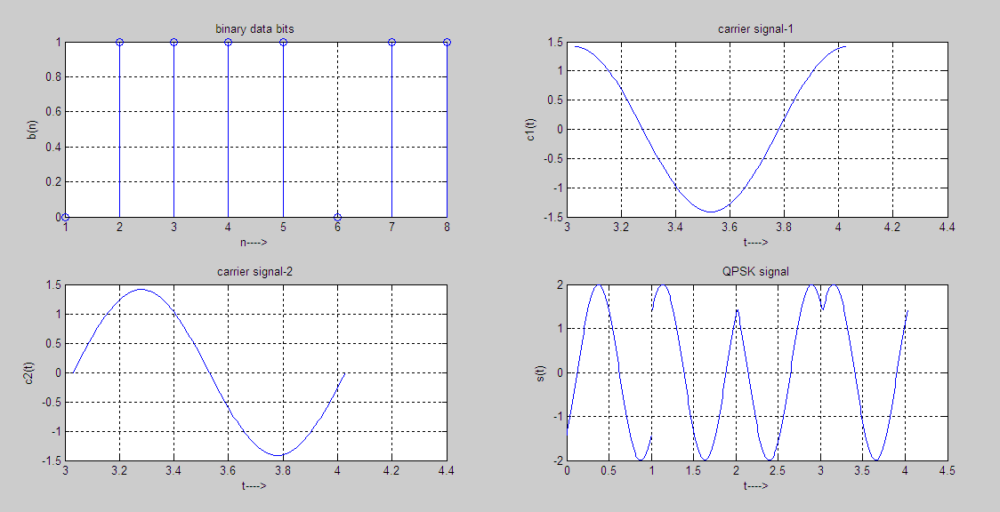

RESULT:
The program for QPSK modulation and demodulation has been simulated in MATLAB and necessary graphs are plotted.

C. DIFFERENTIAL PHASE SHIFT KEYING(DPSK) AIM:
To perform the simulation of DPSK modulation and demodulation using MATLAB.

EQUIPMENTSREQUIRED:
  - Operating system: Windows XP
  - Software :MATLAB

THEORY:
Differential phase shift keying (DPSK),a common form of phase modulation conveys data By changing the phase of carrier wave. In DPSK, there is no absolute carrier phase reference, Instead transmitted signal itself used as phase reference. For example, in differentially
Encoded BPSK a binary '1' may be transmitted by adding 180° to the current phase and a Binary '0' by adding 0° to the current phase. For a signal that has been differentially encoded, Thereisanobviousalternativemethodofdemodulation.Insteadofdemodulatingasusualand Ignoring carrier-phase ambiguity, the phase between two successive received symbols is Comparedandusedtodeterminewhatthedatamusthavebeen.Whendifferentialencodingis Used in this manner, the scheme is known as differential phase-shift keying (DPSK).

ALGORITHM:
- Define the number of input samples.
- Generate the binary input sequence.
- Generate the carrier signal with frequency f1
- Generate DPSK signal.
- Re construct the original message signal
- Plot the message , carrier ,modulated and demodulated signal.

PROGRAM:
clc; clearall; closeall; n=100;
x=[ones(1,20)zeros(1,20)ones(1,20)zeros(1,20)ones(1,20)]; subplot(4,1,1);
plot(x);
title('input signal'); xlabel('number of samples'); ylabel('amplitude'); f=1*10^6;
fs=10*10^6; for i=0:n-1
d(i+1)=sin(2*pi*(f/fs)*i); end
subplot(4,1,2); plot(d);

title('carrier signal'); xlabel('number of samples'); ylabel('amplitude');
fori=0:n-1 if(x(i+1)==0)
x(i+1)=sin(2*pi*(f/fs)*i);else x(i+1)=sin(2*pi*(f/fs)*i+pi); end
endsubplot(4,1,3); plot(x);
title('PSK Signal'); xlabel('number of samples'); ylabel('amplitude');
fori=0:n-1 if(x(i+1)==sin(2*pi*(f/fs)*i)) x(i+1)=0;
elsex(i+1)=1;
endend
subplot(4,1,4); plot(x);
title('demodulated Signal'); xlabel('number of samples'); ylabel('amplitude');

OUTPUT:

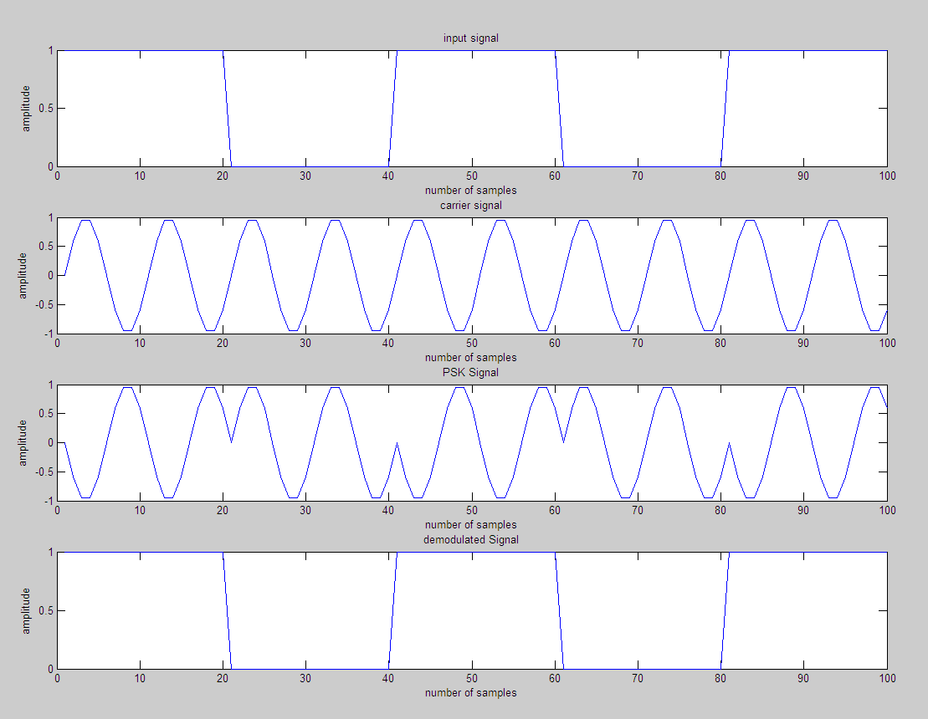

RESULT:
Thus the simulation of DPSK was performed in MATLAB and corresponding waveforms were plotted successfully.

EXP.NO:11.A.SIMULATIONS OF LINEAR BLOCK CODES USING MATLAB

AIM:
To perform the simulation of Linear Block coding scheme using MATLAB.

EQUIPMENTSREQUIRED:
- Operating system :Windows XP
- Software :MATLAB

THEORY:
Linear block coding involves encoding of block of source information bits into another block of bits with addition of error control bits to combat channel errors induced during transmission. An (n,k) linear block code encodes k information data bits into n bit code word. The information data sequence is divided into sequential information data blocks. Each information data block is k bits long. The error control bits (n-k) are derived from a block of k information data bits where n is total number of bits in encoded data block(n>k). The encoder adds (n-k) error control bits to each k bit information data block. A block of n encoded bits at any instance depends only on the block of data consisting of k information bits present at that time. So there is no inbuilt memory. When the k information data bits appear at the beginning of the code word, the code is called as systematic code. The n bit data block is called as code word.

ALGORITHM:
- Define the code length and message length
- Create a binary message having length k.
- Create a cyclic generator polynomial. Then, create a parity-check matrix and convert it Into a generator matrix.
- Encode the message sequence by using the generator matrix.
- Introduce an error in the3rd bit of the encoded sequence.
- Decode the corrupted sequence. Observe that the decoder has correctly recovered the Message.

PROGRAM:

clc; clearall; closeall;
n=7;
% Code length
k = 3;
data = randi([0 1],k,1); pol = cyclpoly(n,k); parmat=cyclgen(n,pol);
genmat= gen2par(parmat);
encData=encode(data,n,k,'linear/binary',genmat); encData(3) = ~encData(3);
decData=decode(encData,n,k,'linear/binary',genmat); numerr = biterr(data,decData);

OUTPUT:
Single-error patterns loaded in decoding table. 8rows remaining.
- Error patterns loaded.1rows remaining.
- Error patterns loaded.0rows remaining.
>>data data =0
1
1
>>genmatgenmat =
1 | 0 | 1 | 1 | 1 | 0 | 0
1 | 1 | 1 | 0 | 0 | 1 | 0
0 | 1 | 1 | 1 | 0 | 0 | 1
>>parmatparmat =
1 | 0 | 0 | 0 | 1 | 1 | 0
0 | 1 | 0 | 0 | 0 | 1 | 1
0 | 0 | 1 | 0 | 1 | 1 | 1
0 | 0 | 0 | 1 | 1 | 0 | 1

>>encDataencData =

1
0
1
1
0
1
1
>>dec Datadec Data =
0
1
1
>>numer r numer r =0
>>

RESULT:
Thus the simulation of Linear Block Coding scheme was performed in MATLAB successfully

EXP.NO: 11 B SIMULATION OF CYCLIC ERROR CONTROL CODING SCHEMES AIM:
To simulate linear block coding techniques for cyclic code using MATLAB.

THEORY:

CYCLIC CODES

Cyclic codes form as class of linear block codes. A binary code is said to be cyclic code, if it exhibits two fundamental properties.

  - LINEARITY PROPERTY

The sum of two code word is also a code word.

  - CYCLIC PROPERTY

Any cyclic shift of code word is also called a code word.

CYCLICCODE

STEP1: Start the program.

STEP 2: Assign the block length n=7. STEP3:Assign the message bits,k=4. STEP 4: The cyclic code is (7, 4) STEP 5: Generate the polynomial.
STEP 6: Obtain the input message randomly. STEP7:The input message Is in binary format.
STEP8:The code word is formed by appending the parity bits with the message bits. STEP 9: The parity bits are calculated from the generation polynomial.
STEP10: The code word formed is transmitted through AWGN channel.

STEP11: The received signal is then decoded with the help of generator polynomial

PROGRAM

clc; clearall; closeall; n=7; k=4;
genpoly=cyclpoly(n,k,'max'); berf=[];
fori=1:10 b=0;
forj=1:50
msg=randint(500,k,[0,1]); code=encode(msg,n,k,'cyclic/binary',genpoly); t=0:0.1:10;
snr=0; y=awgn(code,i); y(find(y>0))=1;
y(find(y<0))=1; msgop=decode(y,n,k,'cyclic/binary',genpoly); [number,b1]=biterr(msgop,msg);
b=b+b1;
end
berf(i)=b/50; end
semilogy(1:10,berf);
title('performance analysis in awgn for cyclic codes'); xlabel ('snr (db)');
ylabel('BER');

OUTPUT:
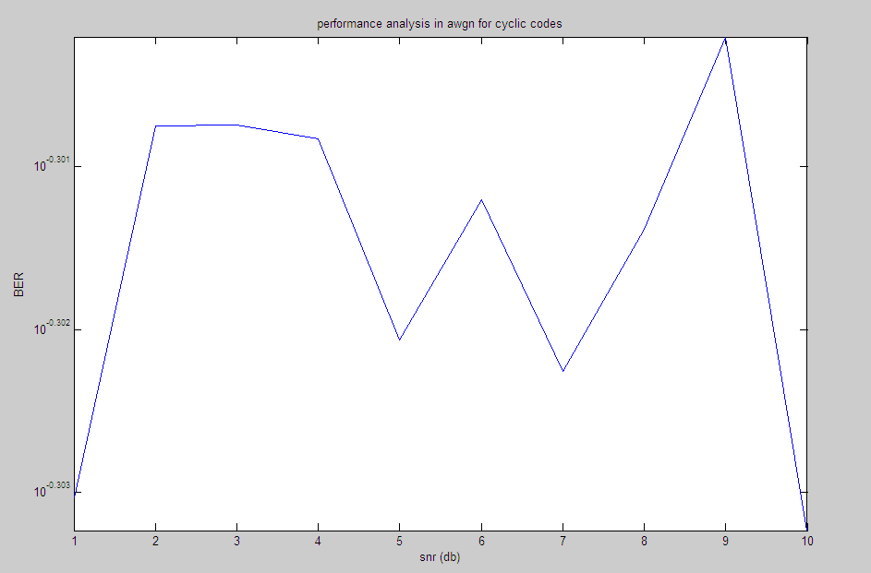

RESULT:

Thus the cyclic code has been simulated using MATLAB.

EXP.NO:11.C. SIMULATION OF CONVOLUTIONAL CODING SCHEMES USING MATLAB

AIM:
To perform the simulation of convolutional coding scheme using MATLAB.

EQUIPMENTS REQUIRED:
- Operating system: Windows XP
- Software: MATLAB

THEORY:
Convolutional Code:
Convolutional codes are commonly described using two parameters: the code rate and the constraint length. The code rate, k/n, is expressed as a ratio of the number of bits into the convolutional encoder (k) to the number of channel symbols output by the convolutional encoder (n) in a given encoder cycle. The constraint length parameter, K, denotes the "length" of the convolutional encoder, i.e. how many k-bit stages are available to feed the combinatorial logic that produces the output symbols. Closely related to K is the parameter m, which indicates how many encoder cycles an input bit is retained and used for encoding after it first appears at the input to the convolutional encoder. The m parameter can be thought of as the memory length of the encoder. Convolutional codes are widely used as channel codes in practical communication systems for error correction. The encoded bits depend on the current k input bits and a few past input bits. The main decoding strategy for Convolutional codes is based on the widely used Viterbi algorithm. As a result of the wide acceptance of convolutional codes, there have been several approaches to modify and extend this basic coding scheme. Trellis coded modulation (TCM) and turbo codes are two such examples. The operation of a convolutional encoder can be explained in several but equivalent ways such as, by a) state diagram representation, b) tree diagram representation and c) trellis diagram representation.

ALGORITHM:
Convolutional Code:
- Define the length of the message
- Define the input binary message
- Define the code word length
- Convert the convolutional polynomial to trellis structure.
- Finally encode the binary data convolutionally.
- Obtain the code word for a given message.

PROGRAM:
Convolutional Codes
clc; clearall; closeall;
k=input('Enter the message length'); n=input('Enterthecodewordlength'); x=input('Enter the input'); t=poly2trellis(3,[n,k]); code=convenc(x,t);

OUTPUT:
Convolutional Codes:
Enter the input[1 0 0 1 1] Enterthecodewordlength7 Enter the message length5
>>code=1 1 1 0 1 1 1 10 1

RESULT:
Thus the simulation of convolutional coding scheme was performed in MATLAB successfully.

EXP.NO:12 COMMUNICATIONLINK SIMULATIONS

AIM:
To study Digital Modulation techniques using Matlab (Simulink).

SOFTWAREREQUIRED:
MATLAB (SIMULINK)

PROCEDURE:
- Open Matlab version R2014a.
- And click the start button.
- Now select the Simulink library browser.
- Open new file for an project and fix the tools from the Simulink library browser, the connect the all tools and save it.
- Now press run button for to simulate communication link.
- Note down the output.

DIAGRAM:

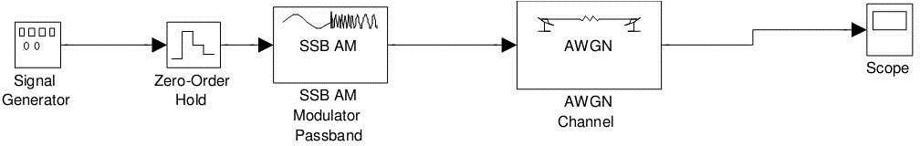

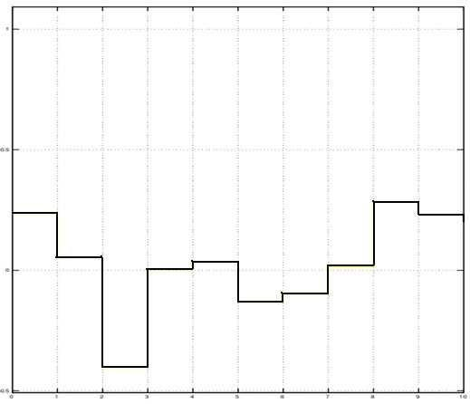
OUTPUT:

RESULT:
Thus a communication link simulation using digital circuit (use timing simulation)was studied that the sampled data at the receiver side is the same as the transmitted data.

