
U23ECT31 / DIGITAL SYSTEM DESIGN
Question Bank (Two marks with answer)
Year/Sem: II/III

UNIT I

State Demorgan’s Theorem.[April/May-2010,2011,May/June-2013,Nov/Dec-2019]
DeMorgan suggested two theorems that form important part of Boolean algebra. They are,
  - The complement of a product is equal to the sum of the complements. (AB)'=A'+B'
  - The complement of a sum term is equal to the product of the complements.(A+B)'=A'B'

Define‘minterm’and‘maxterm’. [April/May-2015]
- A product term containing all the variables of the function in either complemented or un complemented form is called a min term.
- Asumtermcontainingallthevariablesofthefunctionineithercomplementedor un complemented form is called a max term.

What is a karnaugh map? State its limitations[May/June-2020]
A karnaugh map or k map is a pictorial form of truth table, in which the map diagram is made up of squares, with each squares representing one minterm of the function.
Limitations:
- Generally it is limited to six variable map (i.e.) more than six variable involving expressions are not reduced.
- The map method is restricted in its capability since they are useful for simplifying only Boolean expression represented in standard form.

- Find the minterm of the logical expressionY=A'B'C'+A'B'C+A'BC+ABC' and Write the maxterms corresponding to the logical expression [May/June-2018]

Y=(A+B+ C’)(A+ B'+C')(A'+B' +C)
Y=A'B'C'+A'B'C+A'BC+ABC'
=m0+m1+m3+m6
=∑m(0,1,3,6)-Minterm
Y=(A+B+C’) (A+B'+C')(A' + B'+ C)
=(A+ B+C’) (A+B'+ C')(A' +B'+C)
=M1.M3.M6
=∏M(1, 3,6)–Maxterm

What are Don’tcare terms? [May/June-2013]
In some logic circuits certain input conditions never occur, therefore the corresponding output never appears. In such cases the output level is not defined, it can be either high or low. These output levels are indicated by ‘X’ or ‘d’ in the truth tables and are called don’t care conditions or incompletely specified functions.

What is Prime Implicant?[Nov/Dec-2013]
A prime implicant is a product term obtained by combining the maximum possible number of adjacent squares in the map. They cannot be reduced further.

What is a Logic gate? Which gates are called as the universal gates? What are its advantages?
Logic gates are the basic elements that make up a digital system. The electronic gate is a circuit that is able to operate on a number of binary inputs in order to perform a particular logical function.
The NAND and NOR gates are called as the universal gates. These gates are used to perform any type of logic application

Simplify the following Boolean expression in to one literal. W′X(Z′+YZ)+X(W+ Y′Z) [Nov/Dec-2014]
F=W′X(Z′+YZ)+X(W+Y′Z)
=W′XZ′+W′XYZ+WX+XY′Z
=X(W′Z′+W′YZ+W+Y′Z)
=X(W′Z′+W+Z(Y′+W′Y))
=X(W′Z′+W+Z(Y′+Y)(Y′+W′))
=X(W′Z′+W+Z(Y′+W′))
=X(W′Z′+W+ZY′+W′Z)
=X(W′(Z′+Z)+W+ZY′)
=X(W′+W+ZY′)
=X(1+ZY′)=X.1

F=X

Apply De-Morgan’s theorem to[(A+B)+C]′.[May/June-2014]
Given[(A+B)+C] ′ =(A+B) ′.C′
=(A′.B′).C′
[(A+B)+C]′= A′B′C′

Convert 0.35toequivalent hexadecimalnumber.[May/June-2014]
Given(0.35)10=0.35x16=5.60
=0.60x 16=9.60
=0.60x 16=9.60
(0.35)10=(0.599)16

Convert Y=A+BC′+AB+A′BC in to canonical form.[April/May-2015]
Given Y=A+BC′+AB+A′BC
Y=A(B+B′)(C+C′)+(A+A′)BC′+AB(C+C′)+A′BC
Y=ABC+ABC′+AB′C+AB′C′+ABC′+A′BC′+ABC+ABC′+A′BC
Y=ABC+ABC′+AB′C+AB′C′+A′BC′+A′BC

Prove that the logical sum of all minterms of a Boolean function of 2 variables is 1.[Nov/Dec-2009]
Consider two variables as A and B. For two variables A and B minterms are: A′B′,A′B,AB′,AB. The logical sum of these minterms are given by
F=A′B′+A′B+AB′+AB
=A′(B′+B)+A(B′+B) (B′+B=1)
=A′(1)+A(1) (A′+A=1)

F=1
Hence it is to be proved.

Simplify the following Boolean Expression to a minimum number of literals. (BC′+A′D)(AB′+CD′)[Nov/Dec-2011]
F= (BC′+A′D)(AB′+CD′)
=BC′AB′+BC′CD′+A′DAB′+A′DCD′(A.A′=0)
=ABB′C′+BCC′D′+AA′ B′D+A′CDD′

F=0

Simplify the given Boolean Expression F=x′+xy+xz′+xy′z′.[Nov/Dec-2012]
F=x′+xy+xz′+xy′z′
=x′+x(y+z′+y′z′)(A+A′B=A+B)
=x′+y+z′+y′z′
=x′+y+z′(1+y′)(1+A′=1)
F=x′+y+z′

- State Distributive Law. [Nov/Dec-2013] Distributive law of dot(.)over plus(+)is given by a.(b+c) = a.b + a.c
Distributive law of plus(+)overdot(.)is given by
a+b.c= (a+b).(a+c)

Convert 0.640625 decimal numbers to its octal equivalent.
0.640625x8= 5.125
0.125x 8=1.0
=(0.640625)10=(0.51) 8

Convert the given expression in canonical SOP formY=AC+AB+BC[May/June-2018]
Y=AC+ AB+BC=AC(B+B’)+AB(C+C’)+(A +A') BC
=ABC+ ABC'+AB'C +AB'C'+ABC+ABC'+ABC
=ABC+ABC'+AB'C+AB'C'[A+A=1]

Reduce A(A+B)
A(A+B)=AA+ AB
=A(1+B)[1+B=1]
=A.

Prove that ABC+ABC'+AB'C+A'BC=AB +AC+BC[Nov/Dec-2017]
ABC+ABC'+AB'C +A'BC
=AB(C+C')+AB'C+A'BC=AB +AB'C+A'BC
=A(B+ B'C)+A'BC
=A(B+ C) + A'BC
=AB+AC+A'BC
=B(A+ C) + AC
=AB+BC+AC
=AB+AC+BC

- ImplementthegivenfunctionusingNANDgatesF(x,y,z)=Σm(0,6).[Nov/Dec-2012] F(x,y,z)=x′y′z′+xyz′
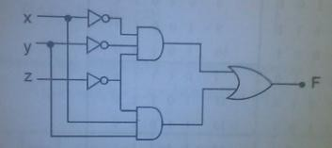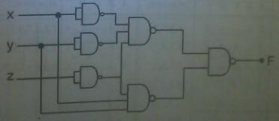

UNIT II

Explain the design procedure for combinational circuits [Nov/Dec-2018]
  - The problem definition
  - Determinethenumberofavailableinputvariables&requiredO/Pvariables.
  - Assigning letter symbols to I/O variables
  - Obtain simplified Boolean expression for each O/P.
  - Obtain the logic diagram

What is an encoder?[May/June-2012]
Encoder is a combinational circuit which is designed to perform the inverse operation of the decoder. An encoder has 2n input lines and n output lines

List few applications of multiplexer.[May/June-2012,Nov/Dec-2019]
  - Data Selector.
  - Implement combinational logic circuit.
  - Time multiplexing systems
  - Frequency multiplexing systems.
  - D/A and A/D converter
  - Data acquisition systems.

Designahalfsubtractorusingbasicgates.[May/June-2013,Nov/Dec-2020]
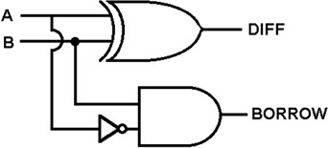
Difference=A′B+AB′=A⊕B Borrow=A′B

Drawthelogicdiagramofa4lineto1 linemultiplexer.[May/June-2018]
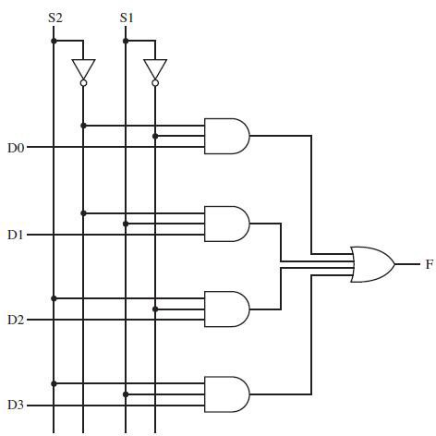

- What is priority Encoder?[May/June-2014]
A priority encoder is an encoder circuit that includes the priority function. In priority encoder, if 2 or more inputs are equal to 1 at the same time, the input having the highest priority will take precedence

Giveexamplesforcombinationalcircuit.[April/May-2015,Nov/Dec-2019]

- Adders
- Subtractors
- Multiplexers
- Demultiplexers
- Encoders
- Decoders

- Writedownthedifferencebetweendemultiplexeranddecoder.[April/May-2018]
 | Demultiplexer | Decoder
Definition | 1datainput 2^noutputs | It has n inputs 2^n outputs  It has n control inputs
Characteristic | Connects the data input to the data output | Selects one of the 2^n outputs by decoding the binary value on the basis of n inputs
Reverse of | Multiplexer | Encoder

- Drawthelogiccircuitofa2-bitcomparator.[April/May-2015,2018]
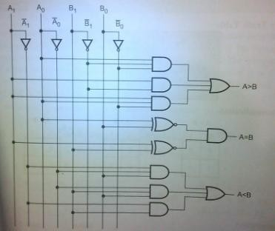

- Comparetheperformanceofbinaryserialandparalleladders.[Nov/Dec-2019] Serial Adder:
  - Serial adder uses shiftregisters
  - The serial adder requires only one fulladder circuit
  - The serial adder is a sequential circuit
  - Time required for addition depends on the number of bits
  - It is slower

Parallel adder:
  - Parallel adder uses registers with parallel load capacity
  - It is faster
  - Time required for addition does not depend on number of bits
  - Excludingtheregisters,theparalleladderisapurelycombinationalcircuit

Construct a two-4-bit parallel adder/subtractor using FullAdders and XOR gates.[Nov/Dec-2016]
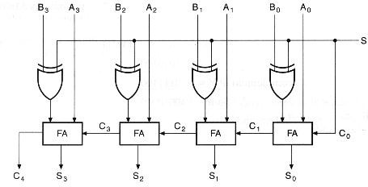

- Define halfadder and fulladder[Nov/Dec 2015]
The logic circuit that performs the addition of two bits is a half adder. Full adder performs the addition operation on three binary inputs and produces outputs as carry and sum bit.

What is meant by lookahead carry?[Nov/Dec2011]
A carry look ahead adder is a adder which is used to reduce the amount of time required and improves the speed of addition operation by predicting the carry of nthbit.

Give the logical expression for sum output and carry output of a fulladder.[Nov/Dec 2011]
Sum=A⊕B⊕C Carry=AB+BC+CA

Write an expression for borrow and difference in a full subtractor circuit.[April/May-2019]
Difference=A′B+AB′=A⊕B Borrow=A′B

Suggest a solution to overcome the limitation on the speed of an adder.[Nov/Dec-2019]
It is possible to increase speed of adder by eliminating inter-stage carry delay. This method utilizes logic gates to look at the lower-order bits of the augend and addend to see if a higher-order carry is to be generated.

What is a combinational circuit? Give an example[Nov/Dec-2012]
Combinational logic circuits are circuits in which the output at any time depends upon the combination of the input signals present at that instant only and does not depend upon the past conditions
Example:
- Decoder
- Multiplexer
- Implement the full subtractor using demultiplexer [Nov/Dec-2016]
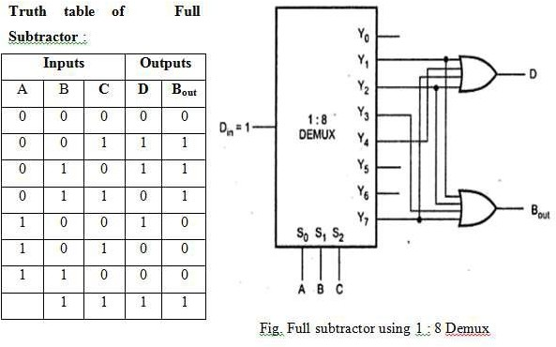
- Draw a 2to1multiplexer circuit.[Nov/Dec-2018]
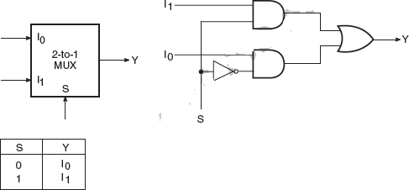

- Define carry propagation delay.[APR/MAY-2017]
The sum and carry outputs of any stage cannot be produced until the input carry occurs, this leads to a time delay in the addition process. This delay is knows as carry propagation delay.

UNIT III

What are the classifications of sequential circuits?[Nov/Dec-2017]
The sequential circuits are classified on the basis of timing of their signals into two types. They are, 1) Synchronous sequential circuit. 2) Asynchronous sequential circuit.

Define Flip flop.
The basic unit for storage is flip flop. A flip-flop maintains its output state either at 1 or0 until directed by an input signal to change its state.

Define sequential circuit?
In sequential circuits the output variables dependent not only on the present input variables but they also depend up on the past history of these input variables.

Define racearound condition.[APR/MAY-2017]
In JK flip-flop output is fed back to the input. Therefore change in the output results change in the input. Due to this in the positive half of the clock pulse if both J and K are high then output toggles continuously. This condition is called ‘race around condition’.

What is edge-triggered flip-flop?
The problem of race around condition can solved by edge triggering flip flop. The term edge triggering means that the flip-flop changes state either at the positive edge or negative edge of the clock pulse and it is sensitive to its inputs only at this transition of the clock.

Define shift registers.[Nov/Dec-2019]
The binary information in a register can be moved from stage to stage within the register or into or out of the register upon application of clock pulses. This type of bit movement or shifting is essential for certain arithmetic and logic operations used in microprocessors. This gives rise to group of registers called shift registers.

Mention any two differences between the edge triggering and level triggering. [April/May-2010]
LevelTriggering:1)The input signal is sampled when the clock signal is either HIGHorLOW.
2)It is sensitive to Glitches. Example: Latch.
Edge Triggering: 1) The input signal is sampled at the RISING EDGE or FALLING EDGE of the clock signal. 2) It is not-sensitive to Glitches. Example: Flipflop.

What is meant by programmable counter? Mention its application.[April/May-2010]
  - A counter that divides an input frequency by a number which can be programmed into decades of synchronous down counters.
  - Decades, with additional decoding and control logic,give the equivalent of a divide-byN
Counter system, where Ncan be made equal to any number.
Application:
  - Microprocessor.
  - Traffic light controller.
  - Streetlight controller.

Write the characteristic equation of a JKflip-flop.[April/May-2011,Nov/Dec-2009]
The characteristic equation of a JKflip-flop is given by Q(next)= JQ' + K'Q

How many flip-flops are required to build a binary counter that counts from 0to1023? [April/May-2019]
If the number of flip-flops required is n, then 2n-1=1023
n=10since 210=1024

- Realise T-FF from JK-FF.[April/May-2012]
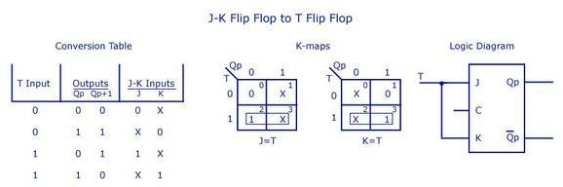

- Convert JK flip-flop toT flip-flop.[April/May-2013,2012]
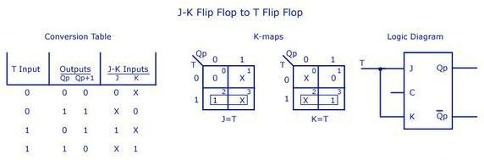

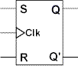
- Sketch the logic diagram of a clocked SRflip-flop.[April/May-2018]

- Compare the logics of synchronous counter and ripple counter. [April/May-2014, Nov/Dec-2009]
Asynchronous counter:
- In this type of counter flipflop are connected in such a way that output of first flip-flop drives the clock for next flip-flop.
- All the flip-flop are not clocked simultaneously.
- Logic circuit is very simple even for more number of states.

Synchronous counter:
- In this type there is no connection between output of first flip-flop and clock input of the next flip-flop.
- All the flip-flop are clocked simultaneously.
- Design involves complex logic circuit as number of states increases.

How do you eliminate the race around condition in a JKflip-flop?[Nov/Dec-2010]
  - When the input to the JK flip-flop is j=1 and k=1, the race around condition occurs, i.e it occurs when the time period of the clock pulse is greater than the propagation delay of the flip flop.
  - The output changes or toggles in a single clock period. If it toggle seven number of times the output is same but if it toggles odd number of times then the output is complimented.
  - Toavoidracearoundconditionwecantmaketheclockpulsesmallerthanthepropagation delay so we use 1. Master slave JK flip flop 2. Positive or negative edge triggering

- Draw the state table and excitation table of Tflip-flop.[Nov/Dec-2010]
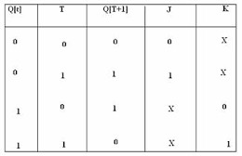

- Realize JKflip-flop using D flip-flop.[Nov/Dec-2011]
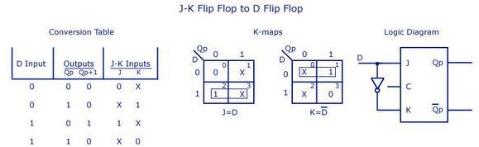

- Define latches.[Nov/Dec-2013]
Latch is a simple memory element, which consists of a pair of logic gates with their inputs and outputs inter connected in a feedback arrangement, which permits a single bit to be stored.

Write short notes on Digital Clock.[Nov/Dec-2019]
A digital clock is a simplified logic diagram of a digital clock that displays seconds, minutes, and hours. First, a 60 Hz sinusoidal ac voltage is converted to a 60 Hz pulse waveform and divided own to a 1Hz pulse waveform by a divide-by-60 counter formed by a divide-by-10 counter allowed by a divide-by-6 counter. Both the seconds and minutes counts are also produced by divide-by-60 counters.

What is synchronous sequential circuit?[Nov/Dec-2018]
  - In synchronous circuits the input are pulses (or levels and pulses) with certain restrictions on pulse width and circuit propagation delay. Therefore synchronous circuits can be divided into clocked sequential circuits and unclocked or pulsed sequential circuits.
  - In a clocked sequential circuit which has flip-flops or, in some instances, gated latches, for its memory elements there is a (synchronizing) periodic clock connected to the clock inputs of all the memory elements of the circuit, to synchronize all internal changes of state

UNIT-IV

What is fundamental mode sequential circuit? [Nov/Dec-2013]
-Input variables changes if the circuit is stable
-Inputs are levels, not pulses
-Only one input can change at a given time

What is pulse mode circuit?
-Inputs are pulses
-Width of pulses are long for circuit to respond to the input
-Pulsewidthmustnotbesolongthatitisstillpresentafterthenewstateisreached

What are the significance of state assignment?[Nov/Dec-2011]
In synchronous circuits-state assignments are made with the objective of circuit Reduction. Asynchronous circuits-its objective is to avoid critical races

What is non critical race?
-final stable state does not depend on the order in which the state variable changes (verify class notes)

Define Asynchronous sequential circuit?[Nov/Dec-2017]
In asynchronous sequential circuits change in input signals can affect memory element at any instant of time.

Comparison between synchronous & Asynchronous sequentialcircuits?[April/May-2014, Nov/Dec-2009]

Synchronous sequentialcircuits | Asynchronous sequential circuits
Memory elements are clocked flipflops | Memory elements are either  unlocked flip - flops or time delay elements.
Easier to design. | More difficult to design.

- What is fundamental mode sequential circuit?
Input variables changes if the circuit is stable-inputs are levels, not pulses-only one input can change at a given time.

What is the significance of stateassignment?[Nov/Dec-2020]
In synchronous circuit s-state assignments are made with the objective of circuit reduction. Asynchronous circuits-its objective is to avoid critical races.

When do race conditions occur?
Two or more binary state variables change their value in response to the change in input variable.

Writeshortnoteonsharedrowstateassignment.[Nov/Dec-2014]
Races can be avoided by making a proper binary assignment to the state variables.Here, the state variables are assigned with binary numbers in such a way that only one state variable can change at any one state variable can change at any one time when a statetransition occurs.To accomplish this, it is necessary that states between which transitions occur be given adjacent assignments. Two binary are said to be adjacent if they differ in only one variable.

What are the different techniques used in state assignment?
xsharedrowstateassignment
one hot state assignment

Write short note on one hot state assignment.[May/Jun-2019]
The one hot state assignment is another method for finding a race free state assignment. In this method, only one variable is active or hot for each row in the original flow table, i.e., it requires one state variable for each row of the flow table. Additional row are introduced to provide single variable changes between internal state transitions.

What are the steps for the design of asynchronous sequential circuit?
Construction of primitive flow table -reduction of flow table -state assignment is made -realization of primitive flow table

What are the steps for the design of asynchronous sequential circuit?
  - Construction of a primitive flow table from the problem statement.
  - Primitive flow table is reduced by eliminating redundant states using the state reduction
  - State assignment is made
  - The primitive flow table is realized using appropriate logic elements.

What is hazard?[MAY/JUNE-2019][Nov/Dec-2019]
Hazard is an unwanted switching transient.

Give the comparison between state Assignment Synchronous circuit and state assignment asynchronous circuit. [MAY/JUNE-2011]
In synchronous circuit, the state assignments are made with the objective of circuit reduction. In asynchronous circuits, the objective of state assignment is to avoid critical races.

What are races?
When 2 or more binary state variables change their value in response to a change in an input variable, race condition occurs in an asynchronous sequential circuit. In case of unequal delays, a race condition may cause the state variables to change in an unpredictable manner.

Define flowtable in asynchronous sequential circuit.[Nov/Dec-2018]
In asynchronous sequential circuit state table is known as flow table because of the behavior of the asynchronous sequential circuit. The stage changes occur in independent of a clock, based on the logic propagation delay, and cause the states to flow from one to another.

Define merger graph.[Apr/May-2019]
The merger graph is defined as follows. It contains the same number of vertices as the state table contains states. A line drawn between the two state vertices indicates each compatible state pair. It two states are incompatible no connecting line is drawn.

What is fundamental mode?[Nov/Dec-2016]
A transition from one stable state to another occurs only in response to a change in the input state. After a change in one input has occurred, no other change in any input occurs until the circuit enters astable state. Such a mode of operation is referred to as a fundamental mode.

UNITV

List basic types of programmable logic devices.
.Read only memory
.Programmable logic Array
.Programmable Array Logic

What is programmable logic array?How it differs from ROM?[N/D−19]
In some cases the number of don’t care conditions is excessive, it is more economical to use a second type of LSI component called a PLA. A PLA is similar to a ROM in concept; however it does not provide full decoding of the variables and does not generates all the minterms as in the ROM.

Explain ROM
A read only memory (ROM) is a device that includes both the decoder and the OR gates within a single IC package. It consists of n input lines and m output lines. Each bit combination of the input variables is called an address. Each bit combination that comes out of the output lines is called a word.

State the types of ROM
  - Masked ROM.
  - Programmable Read only Memory
  - Erasable Programmable Read only memory.
  - Electrically Erasable Programmable Read only Memory.

How to detect double error and correct single error?[N/D−16]
Hamming code with an additional parity bit can detect double error and correct single error. For example, for a 8-bit data rod, four parity bits are added in Hamming code to form 12 bits. In this if P13 is added, it can detect double error and correct single error.

Define address and word
In a ROM, each bit combination of the input variable is called on address. Each bit combination that comes out of the output lines is called a word.

Give the comparison between EPROM and PLA.[N/D−16]
In EPROM, AND array is fixed and OR array is programmable. It produces full decoding and generates all the min-terms. It is cheaper and simple. In PLA, both AND & OR arrays are programmable.ItiscostlyandcomplexthanEPROM.AnyBooleanfunctioninstandardSOPformcan be implemented using PLA.

List out the major differences between PLA and PAL.[A/M –17]
PAL | PLA
Both AND & OR arrays are programmable. | AND array is programmable and OR array is fixed.
Costliest &complex than PAL&ROMs. | Cheaper and simpler.
AND array and OR array can be  Programmed to get desired minterms. | AND array can be programmed to get desired min-terms

- What is memory decoding?[A/M–17][N/D–17]
Memory decoding is the process of selecting the memory word specified by the input address using decoding circuits. The lower bits of the address from the CPU go directly to the memory chip address pins and the address from the CPU directly to the memory chip pins and the upper ones are used to activate the chip select (CS) pin of the memory chip.

What is programmable logic array?How it differs from the ROM?[N/D–17]
In some cases the number of don’t care conditions is excessive, it is more economical to use a second type of LSI component called a PLA. A PLA is similar to a ROM concept, however does not generates all the min-terms as in the ROM.

What is an MROM?
An MROM is a ROM which has its storage locations written into (programmed) by the manufacturer during the last fabrication process of the unit according to the customer’s specification. A major disadvantage of MROM is that it cannot be reprogrammed in the event of a design change requiring modification of stored data.

What is a PROM?
A PROM is a field programmable ROM. It is not programmed during the manufacturing processes but is custom programmed by the user. Once programmed, the date cannot be altered. PROMs are manufactured with fusible links.

Is the PROM volatile or Non-volatile?
It is Non-volatile similar to the ROM.

What are the technologies used for the fabrication?[N/D–20]
ROMs MROMs and PROMs can be fabricated sung bipolar or MOS technologies, but EPROMs and EEPROMs are possible only with MOS technology.

What happens to the information stored in memory location after it has been read?
The reading operation is non-destructive, which means the stored information remains intact after it has been read and can be read any number of times.

Explain the programming of ROM.
A ROM is programmed at the time of manufacturing. The information be entered is supplied by the user. The contents of this are fixed at the time of its fabrication and these can never be changed. That means it cannot be erased.

Is the ROM a volatile memory? Explain.[A/M –19]
Programming of ROM involves making of the required interconnections at the time of fabrication and, therefore, its contents are unaffected even when the power is off. Thus it is a non-volatile memory.

What is an EEPROM? What are the two major disadvantages of EPROM?[A/M–19]
An EEPROM or EAROM is a ROM whose contents can be electrically erased and reprogrammed enabling the device to be used repeatedly. Selective erasure is possible.
The two major disadvantages of EPROM areas follows:(a)They have to be removed from their sockets in order to be erased and reprogrammed. (b) The erasure remove the complete memory contends. This necessitates complete reprogramming even when one memory word has to be changed.

What is a combinational PLD?
A combinational PLD is an IC with programmable gates divided into an AND array and an OR array to provide an AND-OR sum of products implementation.

What are the advantages and disadvantages of using a PROM as a PLD?[N/D–18]
The advantages of using a PROM as a PLD are as follows:
  - Ease of design since no simplification or minimization of logic function is required.
  - Design can be changed, modified rapidly
  - It is usually faster than discrete SSI/MSI circuit
  - Cost is reduced.
The disadvantages of using ROM based circuits as PLDs areas follows:
  - Non-utilization of complete circuit.
  - Increaseofpowerrequirementandenormousincreaseinsizewithincreaseinthe number of input variables making it impractical.

U23ECT31 / DIGITAL SYSTEM DESIGN
Year/Sem:II/III

PART B QUESTIONS
UNIT–I
- What are universal gates? Construct any four basic gates using only NOR gates and using only NAND. (Nov / Dec 2019)
- i)Convert the following numbers into decimal(11011.101)2& (5432)6.
- Perform the following arithmetic operation using 2’s complement arithmetic (11011100)2–(10011011)2.
- Express the following functions in sum of minterms and product of maxterms F(ABCD) =A’B + BD + AC’. (May / June 2019)
- i)Demonstrate by means of truthtables the validity of the DeMorgan’s theorem for three variables: (XYZ)’ = X’ + Y’ + Z’.
- Simplify the Following Boolean functions by means of a 4 variable map F(A,B,C,D) = Σm(0, 2, 4, 5, 8, 10, 14, 15).
- Implement the following Boolean function only with NAND gates, using a minimum number of gates inputs F(A,B,C,D) = AB + CD. (May / June 2019)
- WriteshortnotesonDemorgan’stheorem,AbsorptionlawandConsensuslaw.(Nov/Dec 2018)
- i)ConvertthefollowingBooleanexpressionintostandardSOPform:AB’C+A’B’+ABC’D
ii)ExpresstheBooleanfunctionF=A+B’CinaSumofminterms(SOP).(Nov/Dec 2018)
- DeclareamodulethatdescribeacircuitthatisspecifiedwiththefollowingtwoBoolean expressions: E = A + BC + B’D & F = B’C + BC’D. (Nov / Dec 2018)
- Simplifythefollowingexpressionsandimplementthemwithtwo–levelNANDgate circuits
  - AB’+ABD +ABD’+A’C’D’+ A’BC’
  - BD+BCD’ +AB’CD’(Nov/Dec 2017)
- Simplifythefollowingexpressionsini)Sumofproductsandii)Productofsums
  - x'z’+y’z’+yz’+xy
  - AC’+B’D +A’CD +ABCD(May/June 2015)
iii) (A’+B’+D’)(A+B’+C’)(A’+B+D’)(B+C’+D’)(Nov/Dec 2017)
- Simplify the following functions using K-Map technique i) G= πM (0,1,3,7,9,11)
ii) F(w,x,y,z)=Σm(0,7,8,9,10,12)+Σd(2,5,13) (May/June 2014)
- Minimize the expression using QuineMcCluskey(Tabulation)method F = Σm(0,1,9,15,24,29,30) + Σd(8,11,31).(May / June 2014)
- UsingtabulationmethodsimplifytheBooleanfunctionF(w,x,y,z)=Σ(1,2,3,5,9,12,14,15)which has the don’t care conditions d(4,8,11). (May / June 2017)
- Simplify the following expressions: y=m1+m3+m4+m7+m8+m9+m10+m11+m12+m14using i) karnaugh map, ii) Quine McCluskey method. (May / June 2017)

- i)Minimize the following expression usingK-Map:Y=A’BC’D’+A’BC’D+ABC’D’+A’B’CD’. (Nov / Dec 2016)
ii)State and Prove Demorgan’s theorem.(Nov/ Dec 2016)
- i) Implement the switching function f(w,x,y,z) = Σm(0,1,3,4,12,14,15) with NAND gates. (Nov / Dec 2016)
ii) Minimize the following expression using Quine McCluskey method. Y = A’BC’D’ + A’BC’D +ABC’D + ABC’D’ + AB’C’D + A’B’CD’. (Nov / Dec 2016)
- Simplify the function F(w,x,y,z) = Σm(2,3,12,13,14,15) using tabulation method. Implement the simplified function using gates. (Nov / Dec 2014)
- i)SimplifytheBooleanfunctioninsumofproductsandproductofsumsF(A,B,C,D)= Σm(0,1,2,5,8,9,10) (Nov / Dec 2014) (Nov / Dec 2019)
ii)PlotthefollowingBooleanfunctioninKarnaughmapandsimplifyitF(w,x,y,z)=Σm(0,1,2,4,5,6,8,9,12,13,14) (Nov / Dec 2014)

UNIT–II
- What is BCD adder? Design an adder to perform arithmetic addition of two decimal digits in BCD. (Nov / Dec 2019)
- i)Design a 4bit adder/ subtractor circuit and explain.
ii)ImplementBooleanfunctionF(x,y,z)=Ʃ(1,2,6,7)usingmultiplexer.(Nov/Dec 2019)
- i) Design of 4 bit binary adder–subtractor circuit.
ii) Design a combinational circuit that accepts a 3 bit number and generates a 6 bit binary number output equal to the square of the input number. Write a high level behaviour VHDL description for the circuit. (May / June 2019)
- i) Explain the logic diagram of a 4input Priority Encoder.
ii) Implement the following Boolean function with an 8 to 1 line multiplexer and an inverter. F(A,B,C,D) = Ʃ(2, 4, 6, 9, 10, 11, 15). (May / June 2019)
- Design32to1multiplexerusingfour8to1multiplexerand2to4decoder.(Nov/Dec2018)
- Design and implement binary to gray code converter.(Nov/Dec2014)(Nov/Dec2016)(Nov
/Dec 2017)
- Implement the switching function F(A,B,C,D)=Σm(0,1,3,4,12,14,15)using 8:1multiplexer. (Nov / Dec 2017)
- ConstructaBCDordercircuitandwriteaHDLprogrammoduleforthesame.(May/June 2017)
- Implement the Boolean function using 8:1 multiplexer F(W,X,Y,Z) = WXZ’ + WYZ + XYZ + WYZ. (May / June 2017)
- Compareandcontrastbetweenencoderandmultiplexer.(Nov/Dec2016)(Nov/Dec 2018)
- i) Design a combinational circuit that converts 8421 BCD code to excess 3 codes. (May / June2014) (Nov / Dec 2016)
ii) With neat diagram explain the 4 bit adder with carry look ahead. (May / June 2015) (Nov / Dec 2016)
- Design a full adder with inputs x,y,z and two outputs S and C . The circuits perform x+y+z, z is the input carry, C is the output carry and S is the Sum. (May / June 2016)
- Designalogiccircuitthatacceptsa4bitGraycodeandconvertsitinto4bitbinarycode.(May
/June2016) (Nov/Dec2019)
- Implement the following Boolean function with a 4X1 multiplexer and external gates. Connect inputs A and B to be selection lines. The input requirements for the four data lines will be a function of variables C and D these values are obtained by expressing F as a function of C and D

For each of the four cases when AB=00,01,10and11.These functions may have to be implemented with external gates. F(A,B,C,D) = Σ(1,2,5,7,8,10,11,13,15). (May / June 2016)
- Design a full subtractor and derive expression for difference and borrow. Realize using gates.(Nov / Dec 2015)
- Designacodeconverterthatconvertsan8421 to BCD code. (Nov/Dec 2015)

UNIT–III
- i) What are registers? Construct a 4 bit registers using D FF and explain the operations on the register.
ii) With neat diagram explain how two binary numbers are added serially using shift registers. (Nov / Dec 2019)
- A sequential circuit with two D FF A and B, two inputs x and y; and one output z is specified by the following next state and output equations: A(t+1) = xy’ + xB, B(t+1) = xA + xB’ & z = A. i) Draw the logic diagram of the circuit, ii) List the state table for the sequential circuit, iii)Draw the corresponding state diagram. (Nov / Dec 2019)
- i)Describe the operations of RSFF with a neat sketch.
ii) Design a sequential circuit with two D FF A and B and one input X. When X = 0, the state of the circuit remains same. When X = 1, the circuit goes through the state transitions from 00 to 10 to 11 to 01, back to 00 and then repeats. (May / June 2019)
- i) Construct a clocked Master Slave JKFF and explain.
ii) A sequential circuit with two D FF A and B, two inputs X and Y and one output Z is specified by the following input functions: A(t+1) = x’y + xA, B(t+1) = x’B + xA, Z = B. Draw the logic diagram of the circuit. Derive the state table and state diagram and state whether it is a Mealy or a Moore machine. (May / June 2019)
- Design and implementation of SRFF using NOR gate.(Nov/Dec2018)
- Explainindetailabout4bit Johnson counter.(Nov/Dec 2018)
- DesignadecadecounterusingJKFFusingIC74LS112D.(Nov/Dec2018)
- ExplaintheoperationofJK-FF,SR-FF,T-FFandD-FFwithaneatdiagram.Alsodiscusstheir characteristic equation and excitation table. (Nov / Dec 2017)
- DesignMod-7counterusingJKflip flop.(Nov/Dec2017)
- ImplementTflipflopandJKflipflopusingDflipflop.(May/June2014)(May/June2017)
- Design and implement mod-5 synchronous counter using JK flip flop and also draw the timing diagram. (May / June 2016) (May / June 2017)
- i)Implement JKFF using DFF.(Nov/Dec 2016)
ii)How the race condition can be avoided in a FF? (Nov/Dec 2014) (Nov/Dec 2016)
- Considerthedesignofa4-bitBCDcounterthatcountsinthefollowingway:0000,0001,0010,
...., 1001 and back to 0000. Draw the logic diagram of this circuit. (May/ June 2015) (Nov / Dec 2016)
- Design a binary counter using TFF to count in the following sequences: i) 000,001,010,011,100,101,111,000
ii) 000,100,111,010,011,000(May/June2016)
- Design a sequence detector that detects a sequence of three or more consecutive 1’s in a string of bits coming through an input line and produces an output whenever this sequence is detected. (Nov / Dec 2015)
- Design a three bit synchronous counter with T FF and draw the diagram. (Nov / Dec 2015) (Nov / Dec 2019)

- DesignasynchronouscounterusingJKFFtocountthefollowingsequence7,4,3,1,5,0,7.....
(Nov/Dec 2014)
- Reduce the number of states in the following state diagram. Tabulate the reduced state table and draw the reduced state diagram. (May / June 2015)
Present State | Next State |  | Output
Present State | X=0 | X=1 | X=0 | X=1
a | a | b | 0 | 0
b | c | d | 0 | 0
c | a | d | 0 | 0
d | e | f | 0 | 1
e | a | f | 0 | 1
f | g | f | 0 | 1
g | a | f | 0 | 1

UNIT–IV
- An asynchronous sequential circuit is described by the following excitation and output functions: Y = x1x2’ + (x1 + x2’)y & Z = y. i) Draw the logic diagram of the circuit, ii) Derive the transition table and output map. (Nov / Dec 2019)
- Find the circuit that has no static hazards and implement the Boolean function F(A,B,C,D) = Σm(1,5,6,7). (Nov / Dec 2018)
- Explain about the designing and procedure of Asynchronous sequential circuits with example (or) Draw the block diagram of a typical asynchronous sequential circuit and explain. Also write the procedure for obtaining transition table from circuit diagram of an asynchronous sequential circuit. (May / June 2017) (Nov / Dec 2017) (May / June 2019) (Nov / Dec 2019)
- What are hazards and its types? How can you design a hazard free circuit, explain with example? (Nov / Dec 2016) (Nov / Dec 2017)
- Discussindetailtheprocedureforreducingtheflowtablewithanexample.(May/June2016)
- Explain the different types of hazards that occur in sequential circuits and combinational circuits. (May / June 2015) (May / June 2017)
- Explain the steps for design of asynchronous sequential circuits. (May / June 2014) (Nov / Dec 2016)
- Design an asynchronous sequential circuit with 2 inputs X and Y and with one output Z wherever Y is 1, input X is transferred to Z. When Y is 0, the output does not change for any change in X. Use SR latch for implementation of the circuit. (May / June 2016)
- An asynchronous sequential circuit is described by the following excitation and output function. Y = X1X2+ (X1+X2)Y & Z = Y.
  - Draw the logic diagram of the circuit.
  - Derive the transition table and output map.
  - Describe the behavior of the circuit.(Nov/Dec2014)
- ImplementtheswitchingfunctionF=Σm(1,3,5,7,8,9,14,15)byastatichazardfreetwolevel AND OR gate network. (May / June 2014)
- i) Discuss about the possible hazards and methods to avoid them in combinational circuits.
- Discussaboutthepossiblehazardsinsequentialcircuits.(Nov/Dec2017)(May/June 2019)

UNIT–V
- What is ROM and why is it necessary to use ROM in a computer? Explain various types of ROM in detail. (Nov / Dec 2019)
- Illustrate with neat sketch and describe the categories of RAM.(Nov/ Dec2018)
- Explainabouterrordetectionandcorrectionusinghammingcodes.(Nov/Dec2017)
- Explain in detail about the Programmable Logic Array, Programmable Array Logic. (Nov / Dec 2017) (Nov / Dec 2018)
- Design a 16 bit RAM array(4X4RAM)and explain the operation. (May/June 2017)
- Explain the following :i)ASIC and ii)FPGA.(May/June2017)
- Implement the following using PLA. i) A(x,y,z) = Σm(1,2,4,6)
ii) B(x,y,z)=Σm(0,1,6,7)
- C(x,y,z)=Σm(2,6)(May/June2014)(Nov/Dec 2016)
- Discuss on the concept of working and applications of semiconductor memories.(Nov/Dec 2014) (Nov / Dec 2016)
- Draw a neat sketch showing implementation of Z1 = ab’d’e + a’b’c’d’e’ + bc + de, Z2 = a’c’e, Z3 = bc + de + c’d’e + bd and Z4 = a’c’e + ce using a 5*8*4 PLA. (May / June 2016)
- Design a combinational circuit using ROM that accepts a three bit binary number and outputs a binary number equal to the square of the input number. (Nov / Dec 2015)
- i)Write short notes on address multiplexing.(May/June2015)
ii) Briefly discuss the sequential programmable devices.(May/June 2015)
- i) Implement the following two Boolean functions with a PLA. F1 = AB’ + AC + A’BC’
F2=(AC +BC)’(May/June 2015)(May/June 2019)(Nov/Dec 2019)
ii)Give the internal block diagram of4X4RAM.(May/June2015)

